**Repos**: we can also create repositories within Databricks that can be integrated with an external git repo.

**Libraries**: We can set up and install on the various clusters in a workspace

**MLflow experiments:** can be used to keep track of executions of ML pipelines

**Jobs:** for example, the code in a notebook can be executed as a job

**Logs:** Generated by Spark itself, though we can also set our own code to write to logs

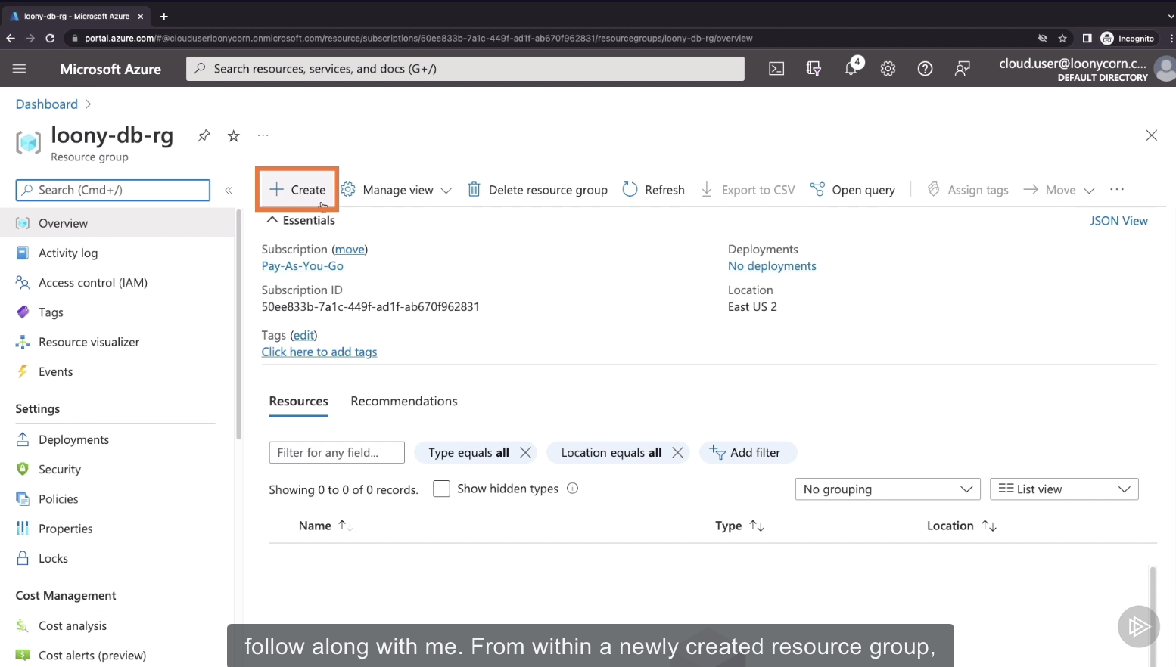

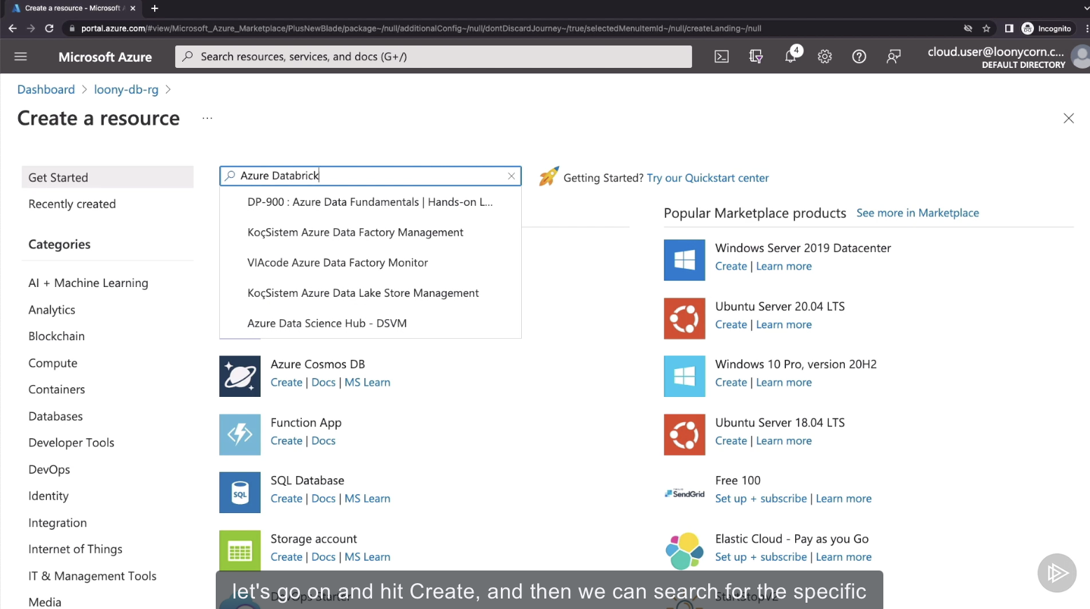

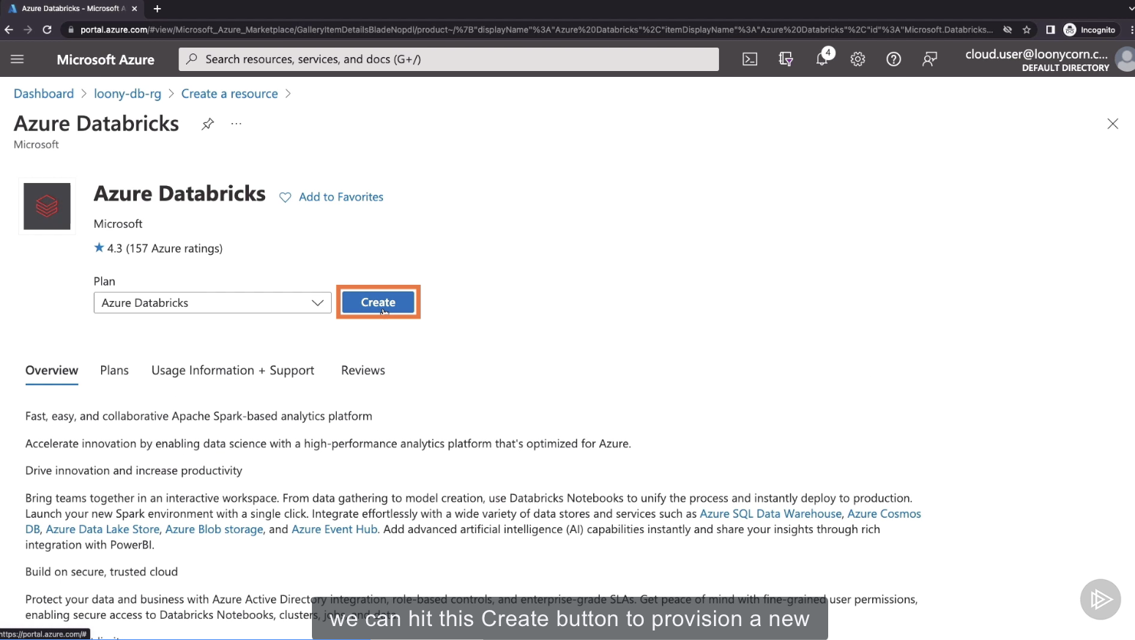

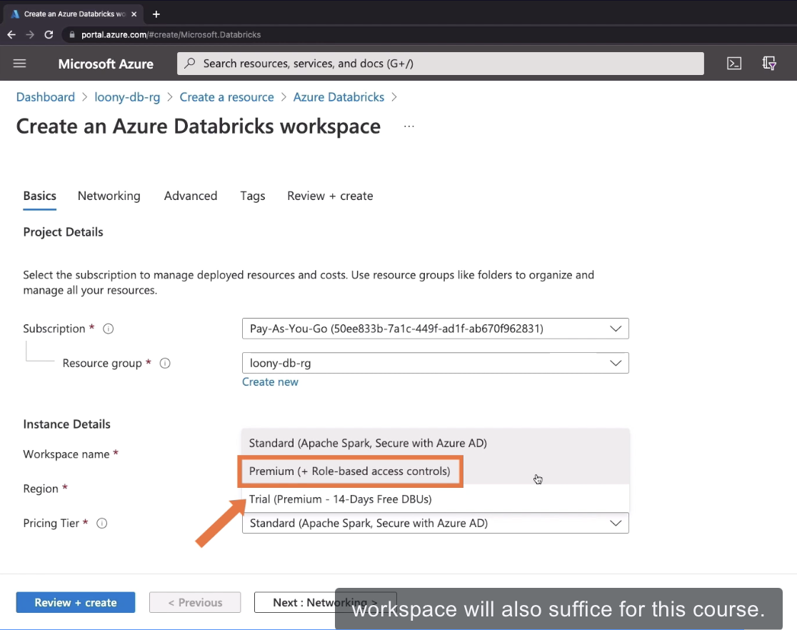

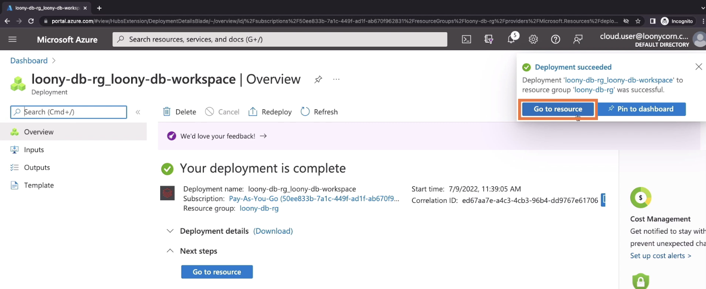

**Creating a Databricks Cluster**

1. **Head over to the Compute Section**
   1. This is as opposed to a job cluster, which is managed by the execution of a job
   2. 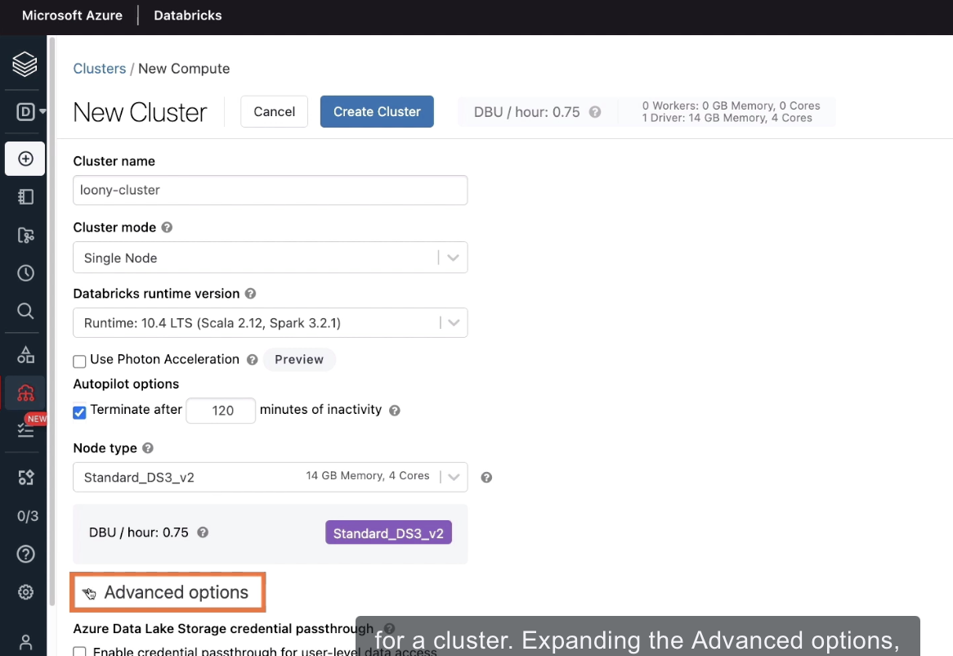
   3. 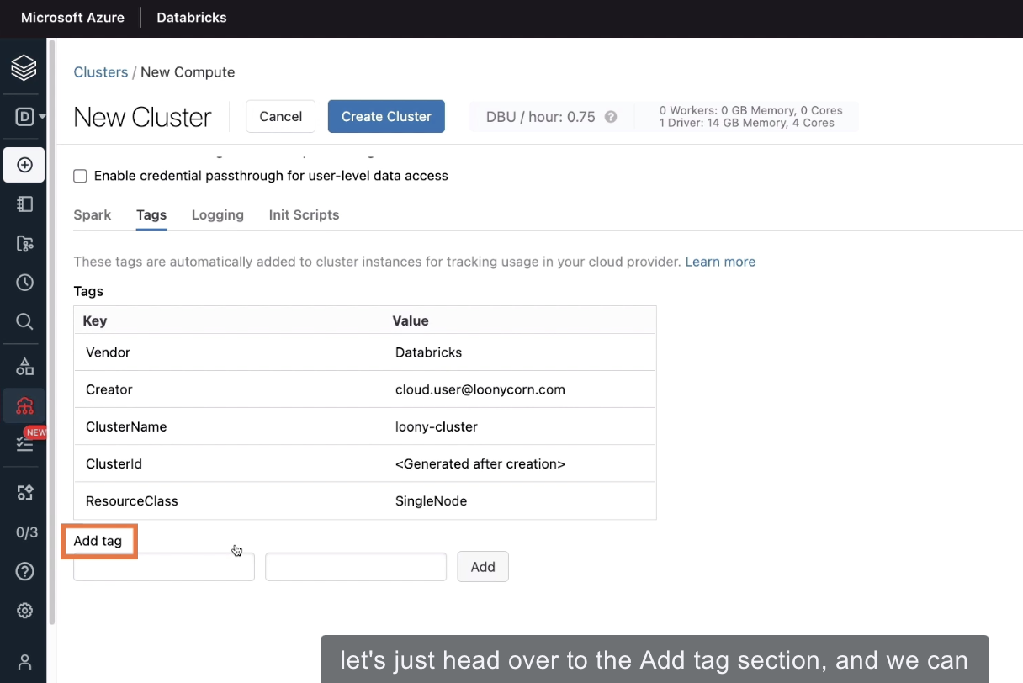
   4. 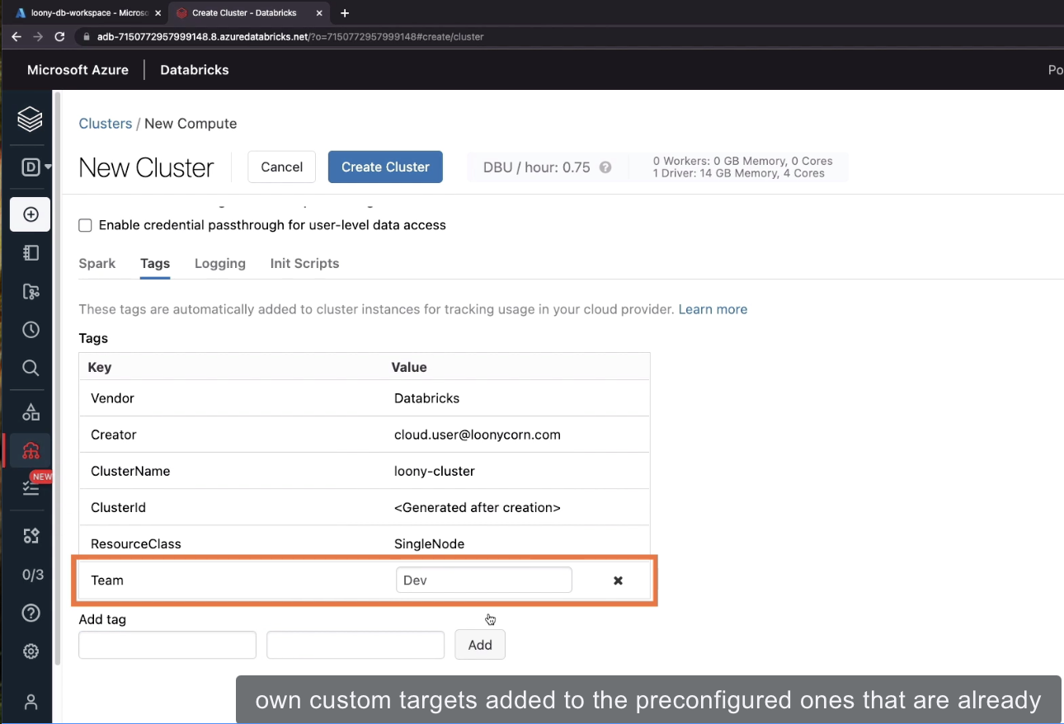

**Provisioning a Delta Table**

1. Out of the contents of a CSV file, which we upload into the Databricks File System
2. 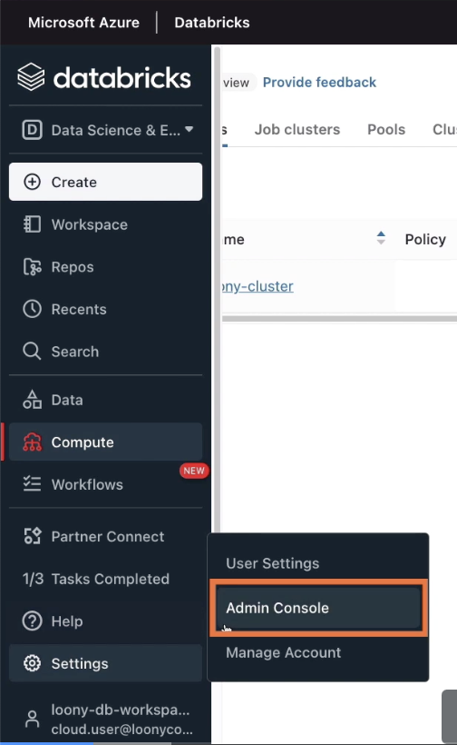
3. Enabling the DBFS UI
   1. 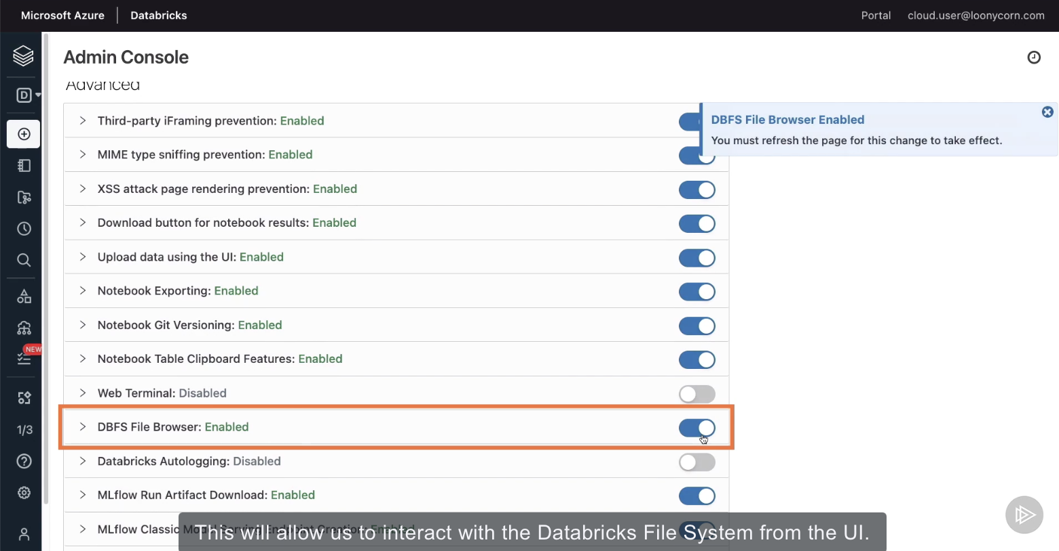
   2. This will allow us to interact with the Databricks File System from the UI
   3. For this change to take effect, we will need to reload the page
4. Click Data
   1. 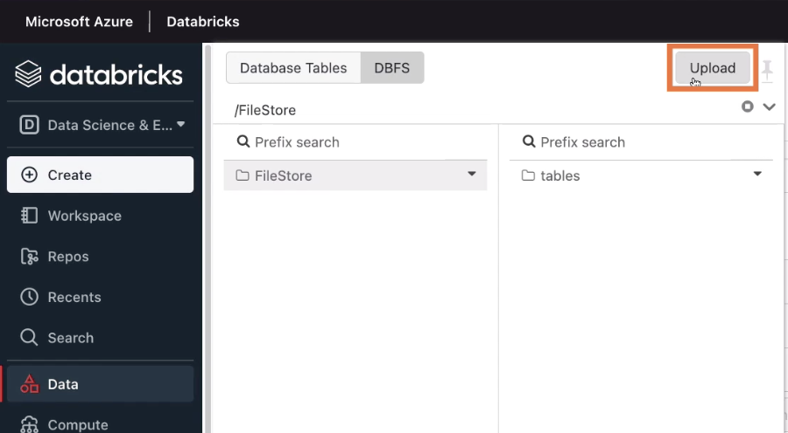
   2. 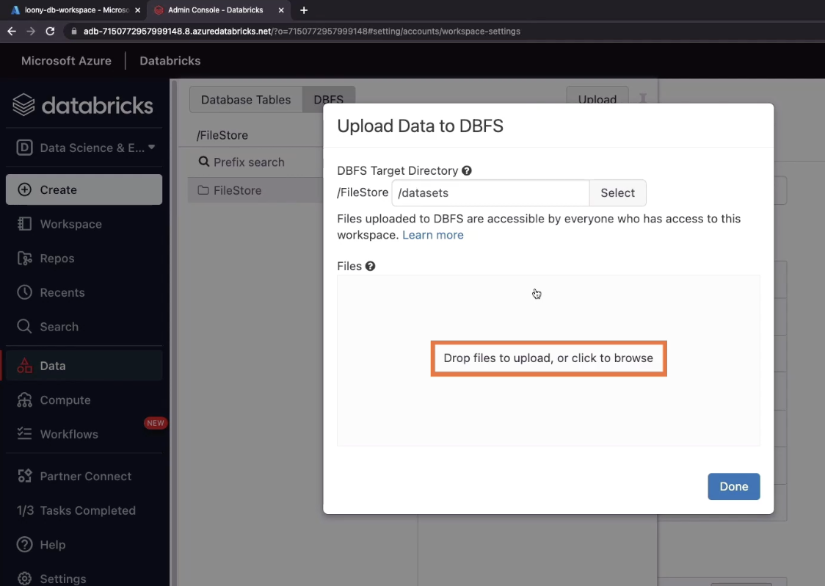
   3. 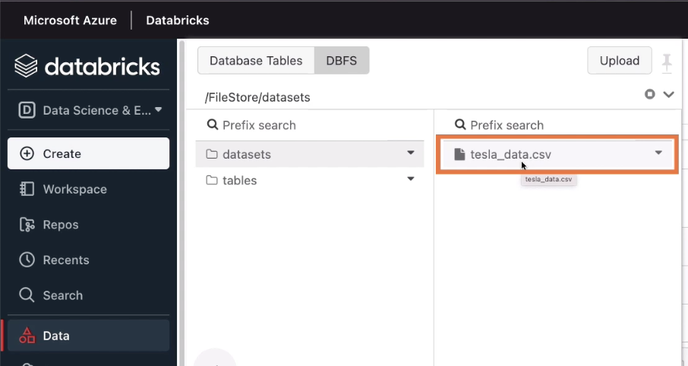
   4. 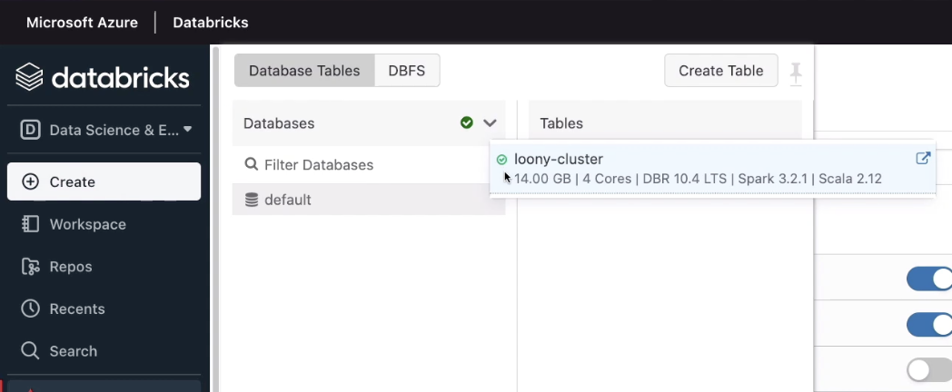
   5. 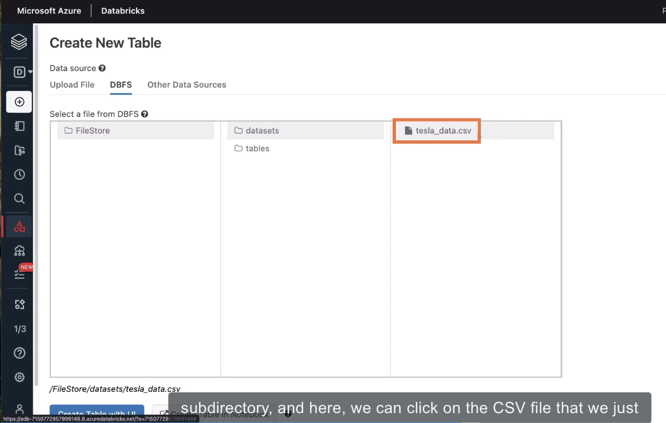
   6. Option 1: Create Table with UI, which means we don’t need to write any code or SQL queries. This may be more than enough for most use cases
   7. Option 2: Create Table in Notebook, if you’d like fine-grained control over the setting up of the table
   8. 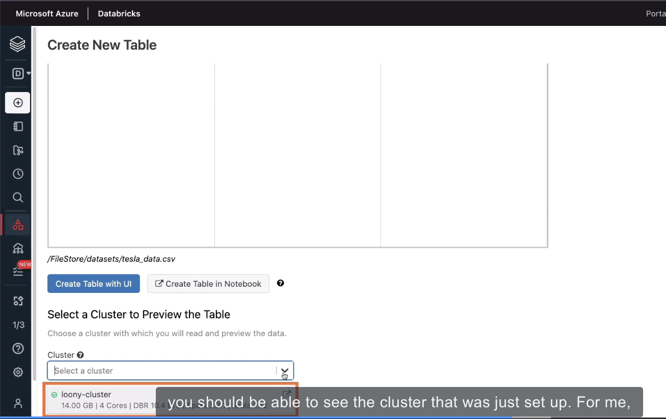
   9. 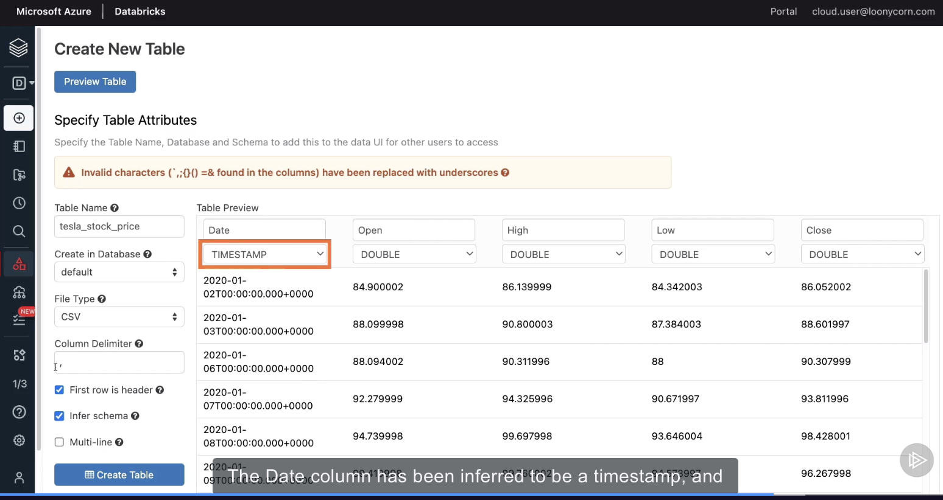

**Creating and Running Code From a Notebook**

Location of the data:

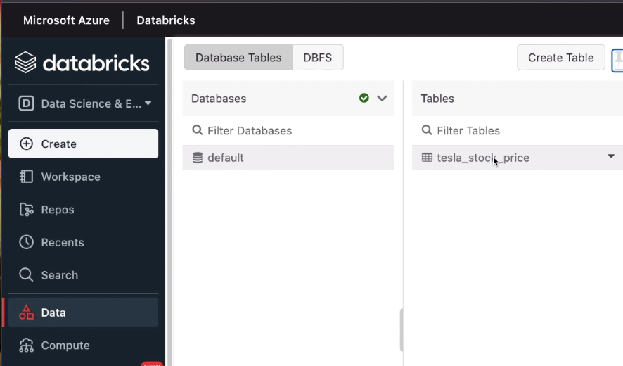

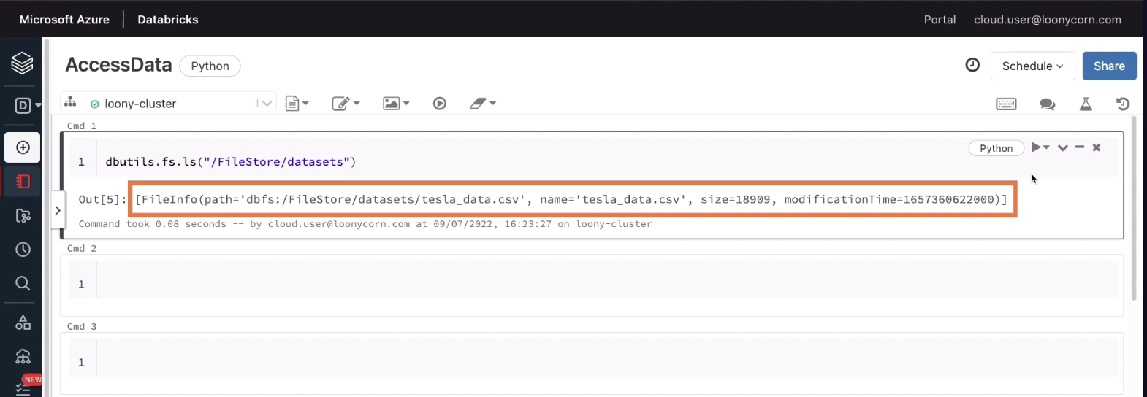

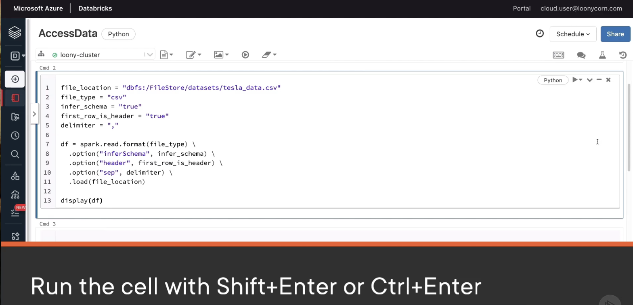

# Loading from a Delta Table into a Spark DataFrame

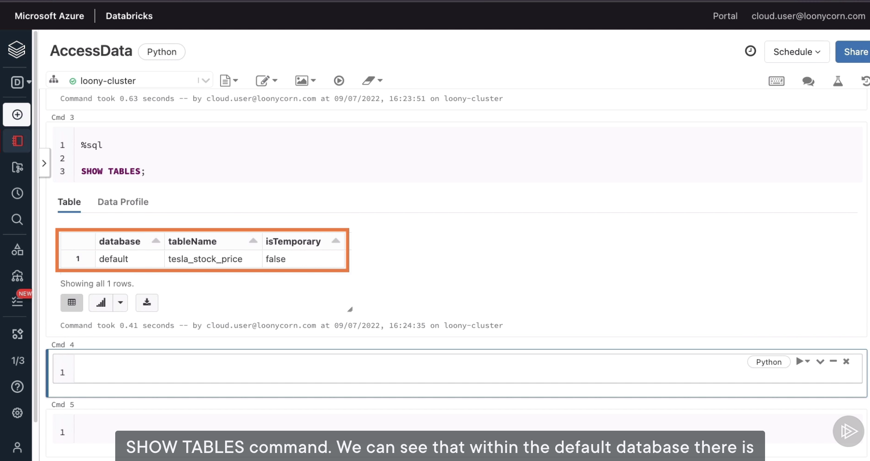

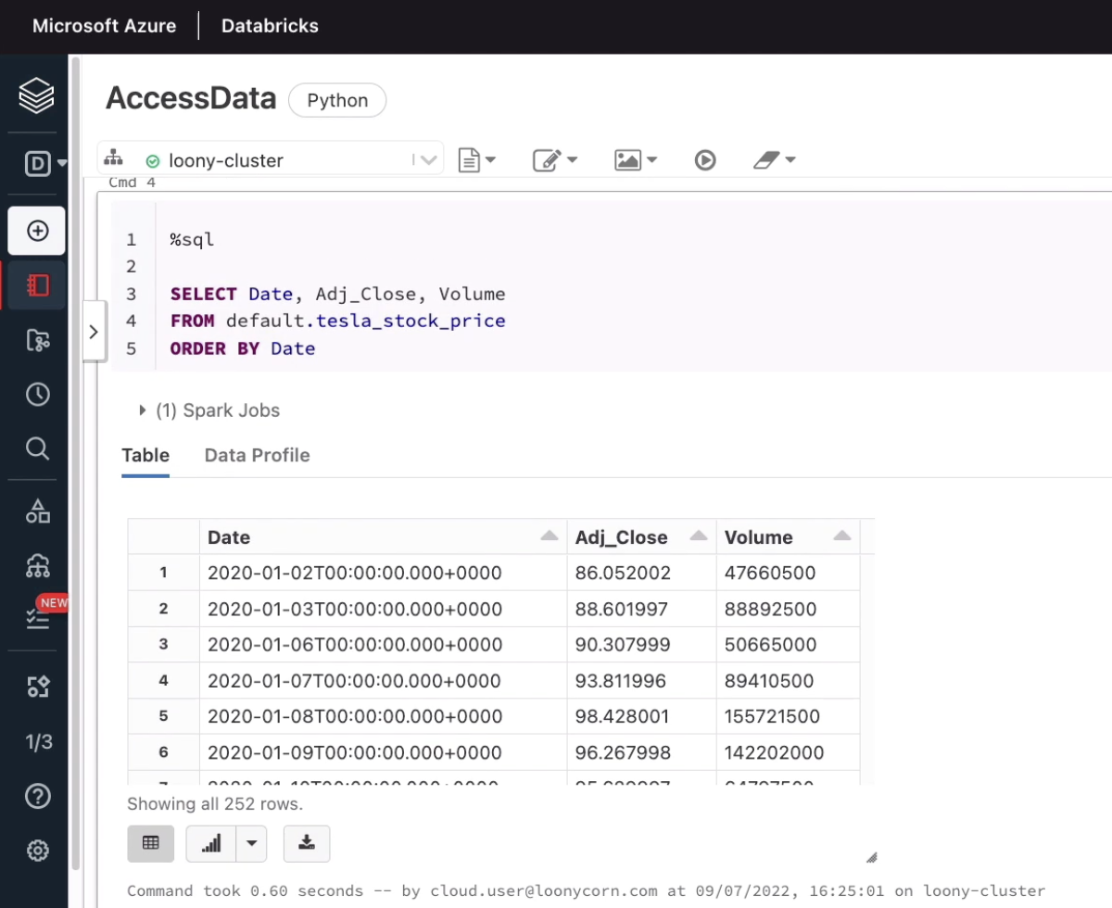

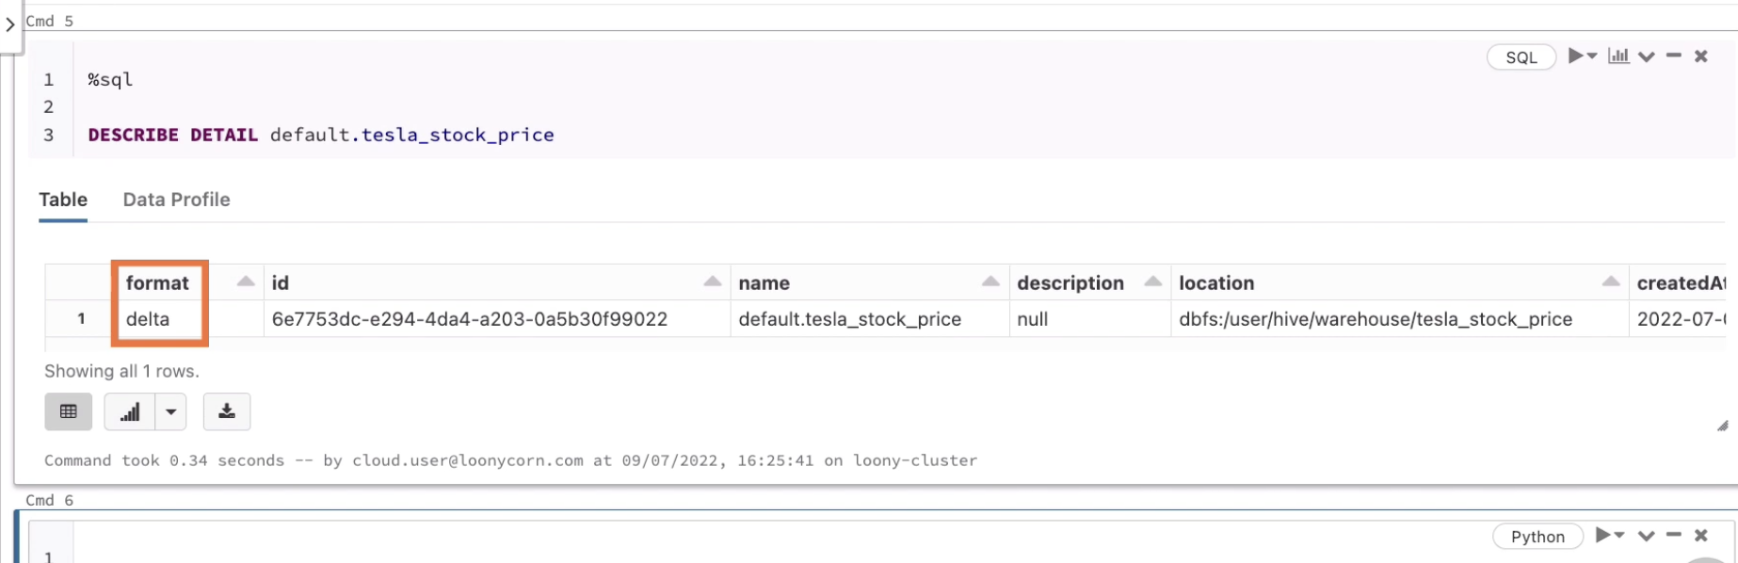

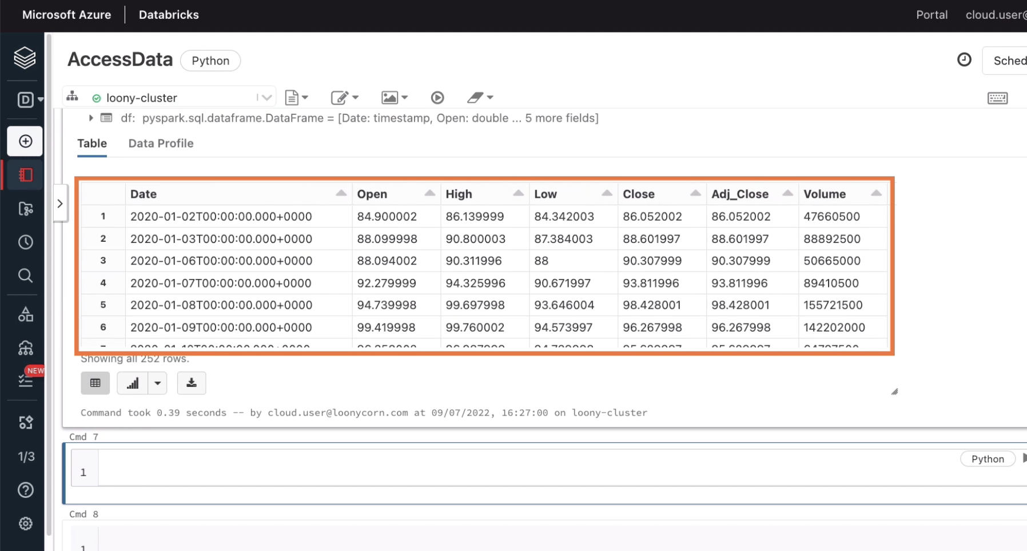

# **Installing a Python Module on a Cluster**

Click compute-> cluster you just created->Libraries

We can make use of the Install New option available here in order to set up the network module, but then the library will only be available on this specific cluster.

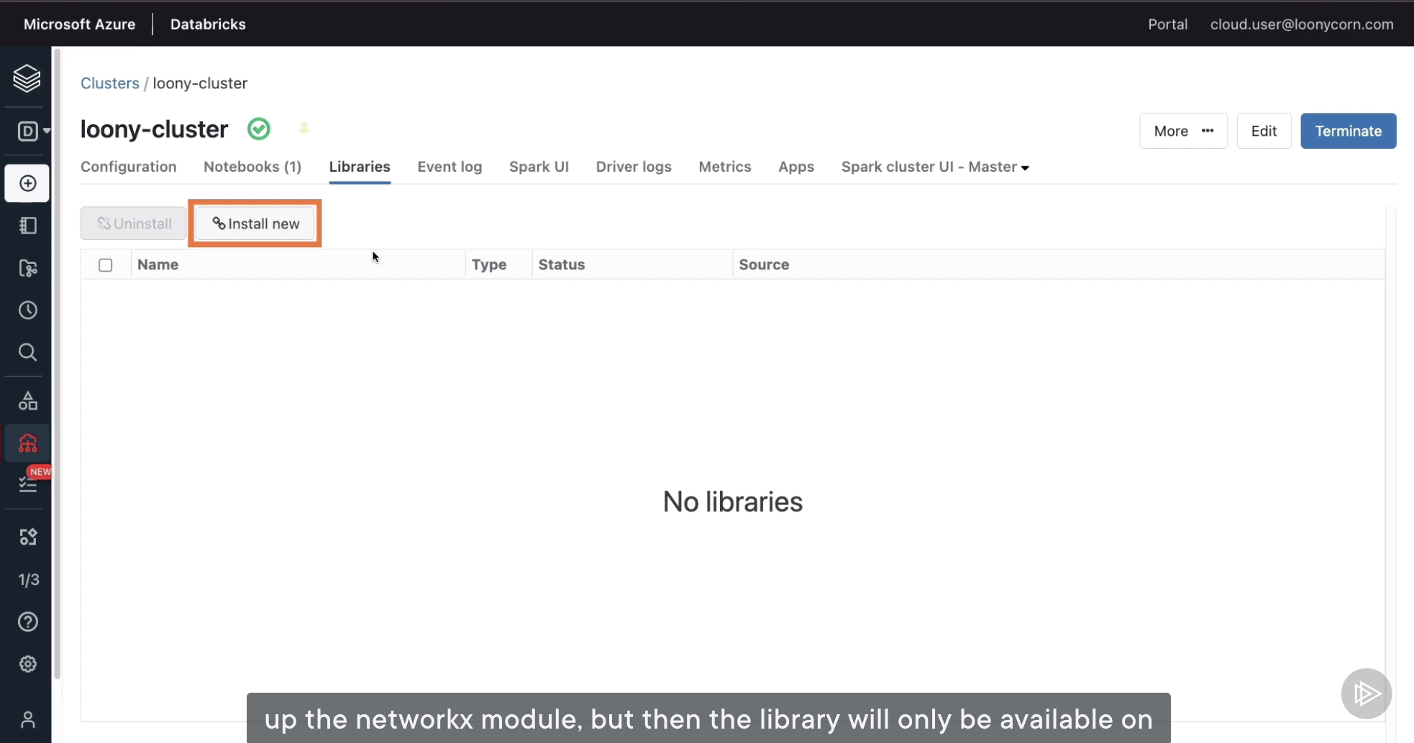

For a more general solution, which can be applied to multiple clusters, we should head over workspace->click left arrow button:

Users corresponds to the folders for individual users of the workspace, and then are Shared resources.

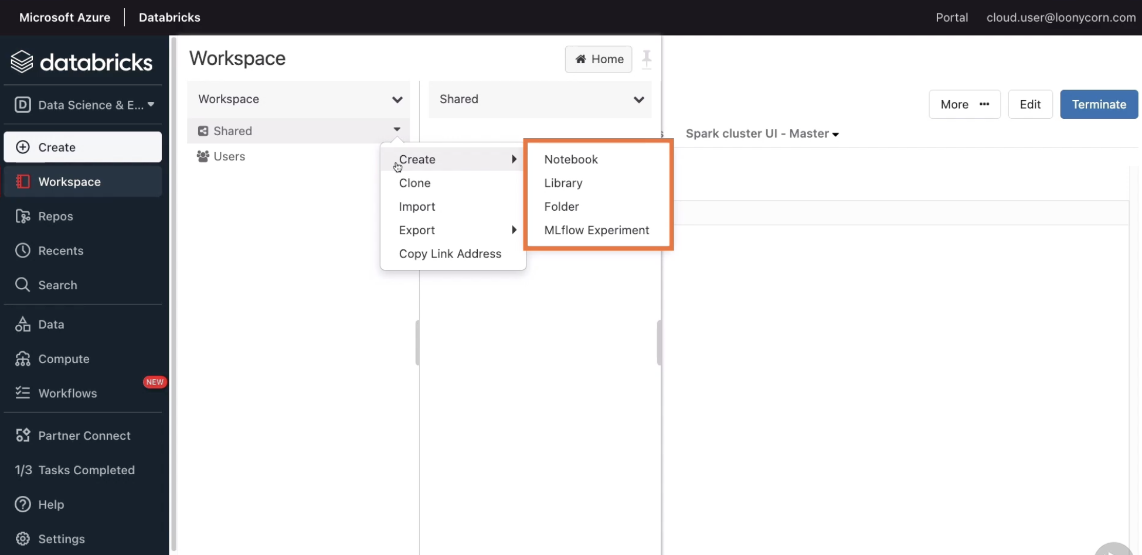

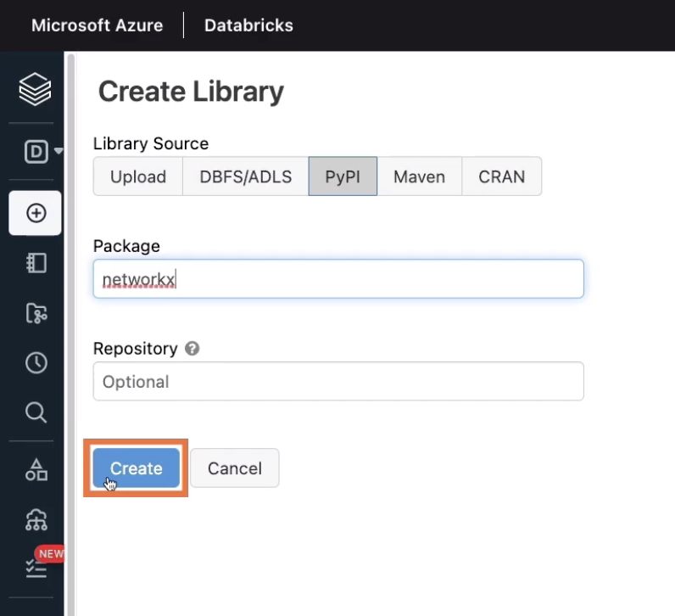

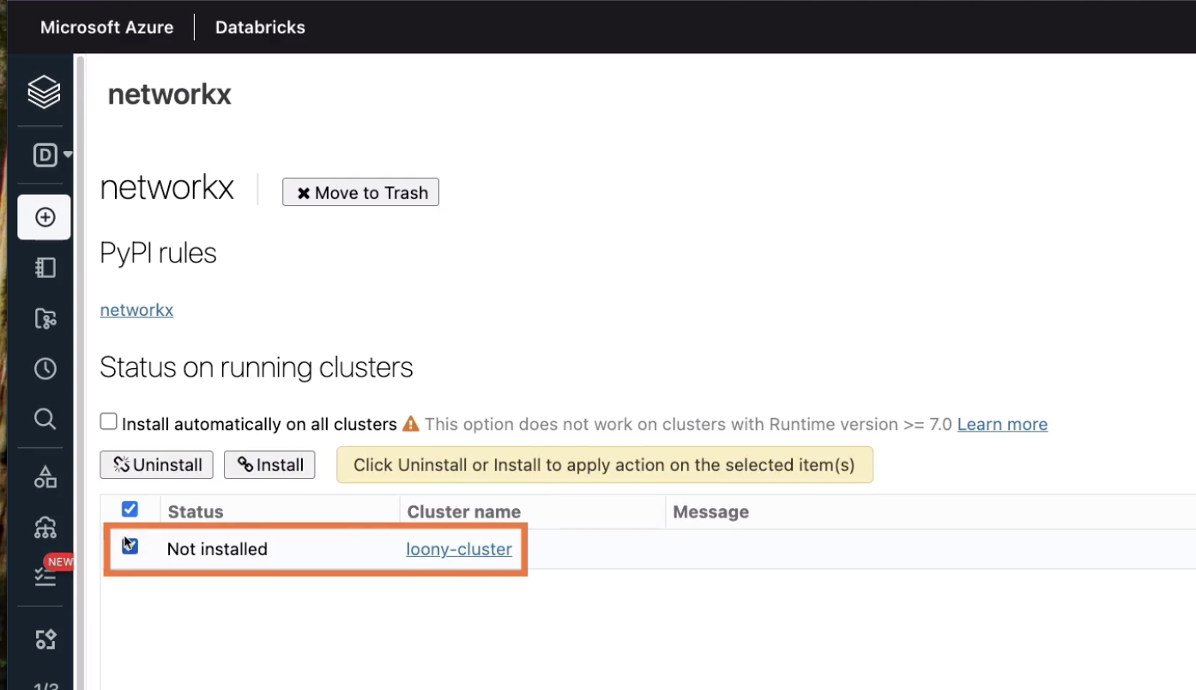

Hit Install button, confirm by heading to cluster libraries

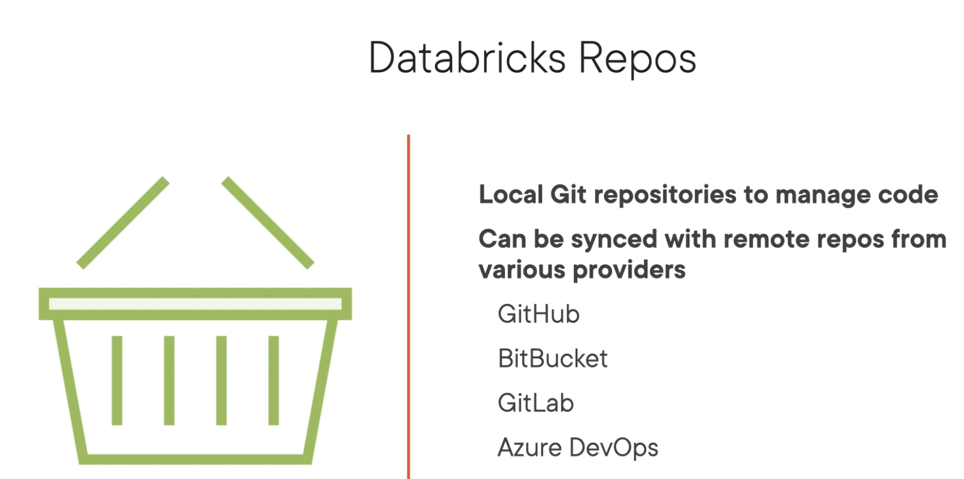

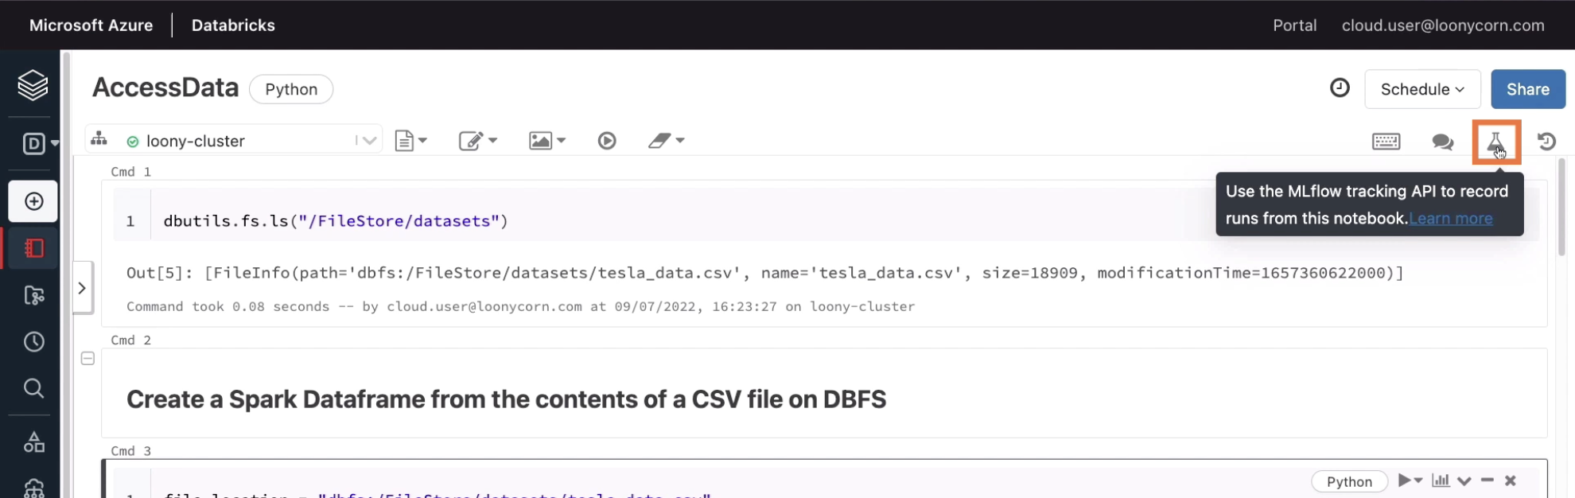

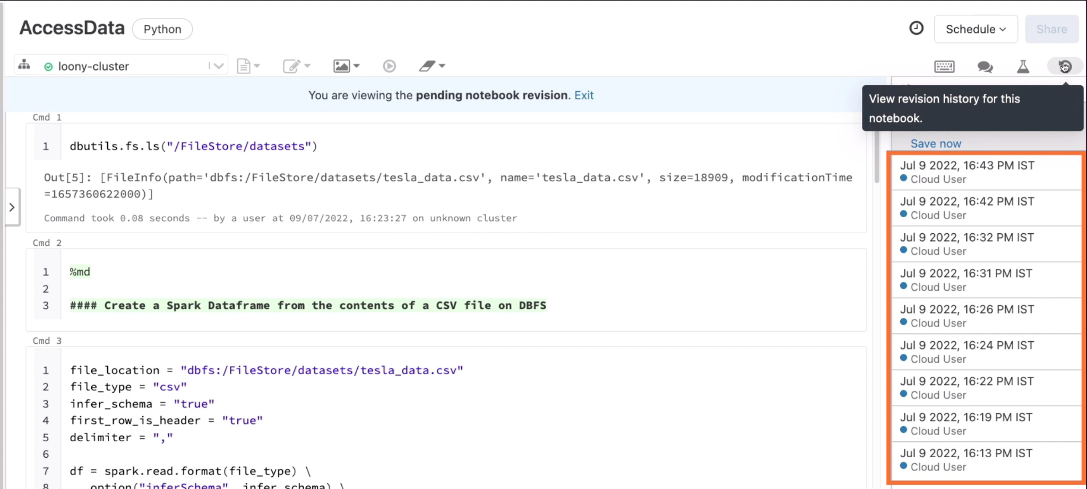

There is a revision history

# **Creating Local and Remote Repositories**

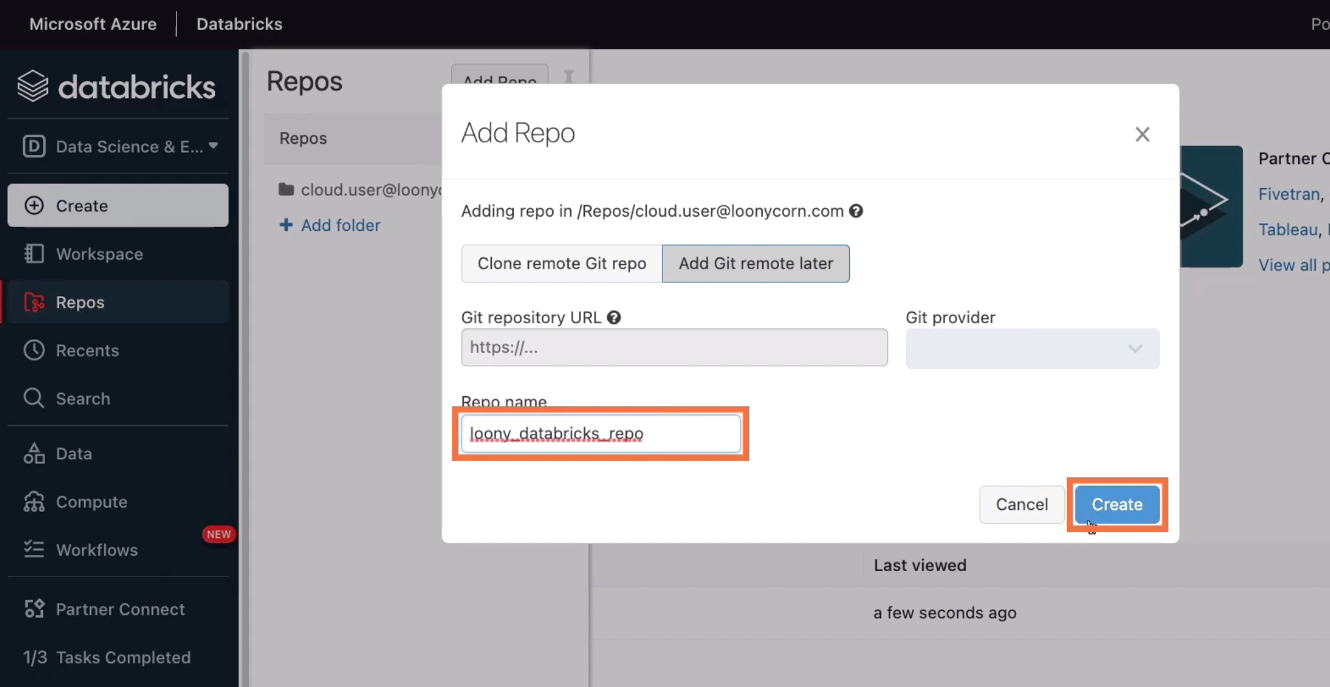

In GitHub, set up Personal access tokens

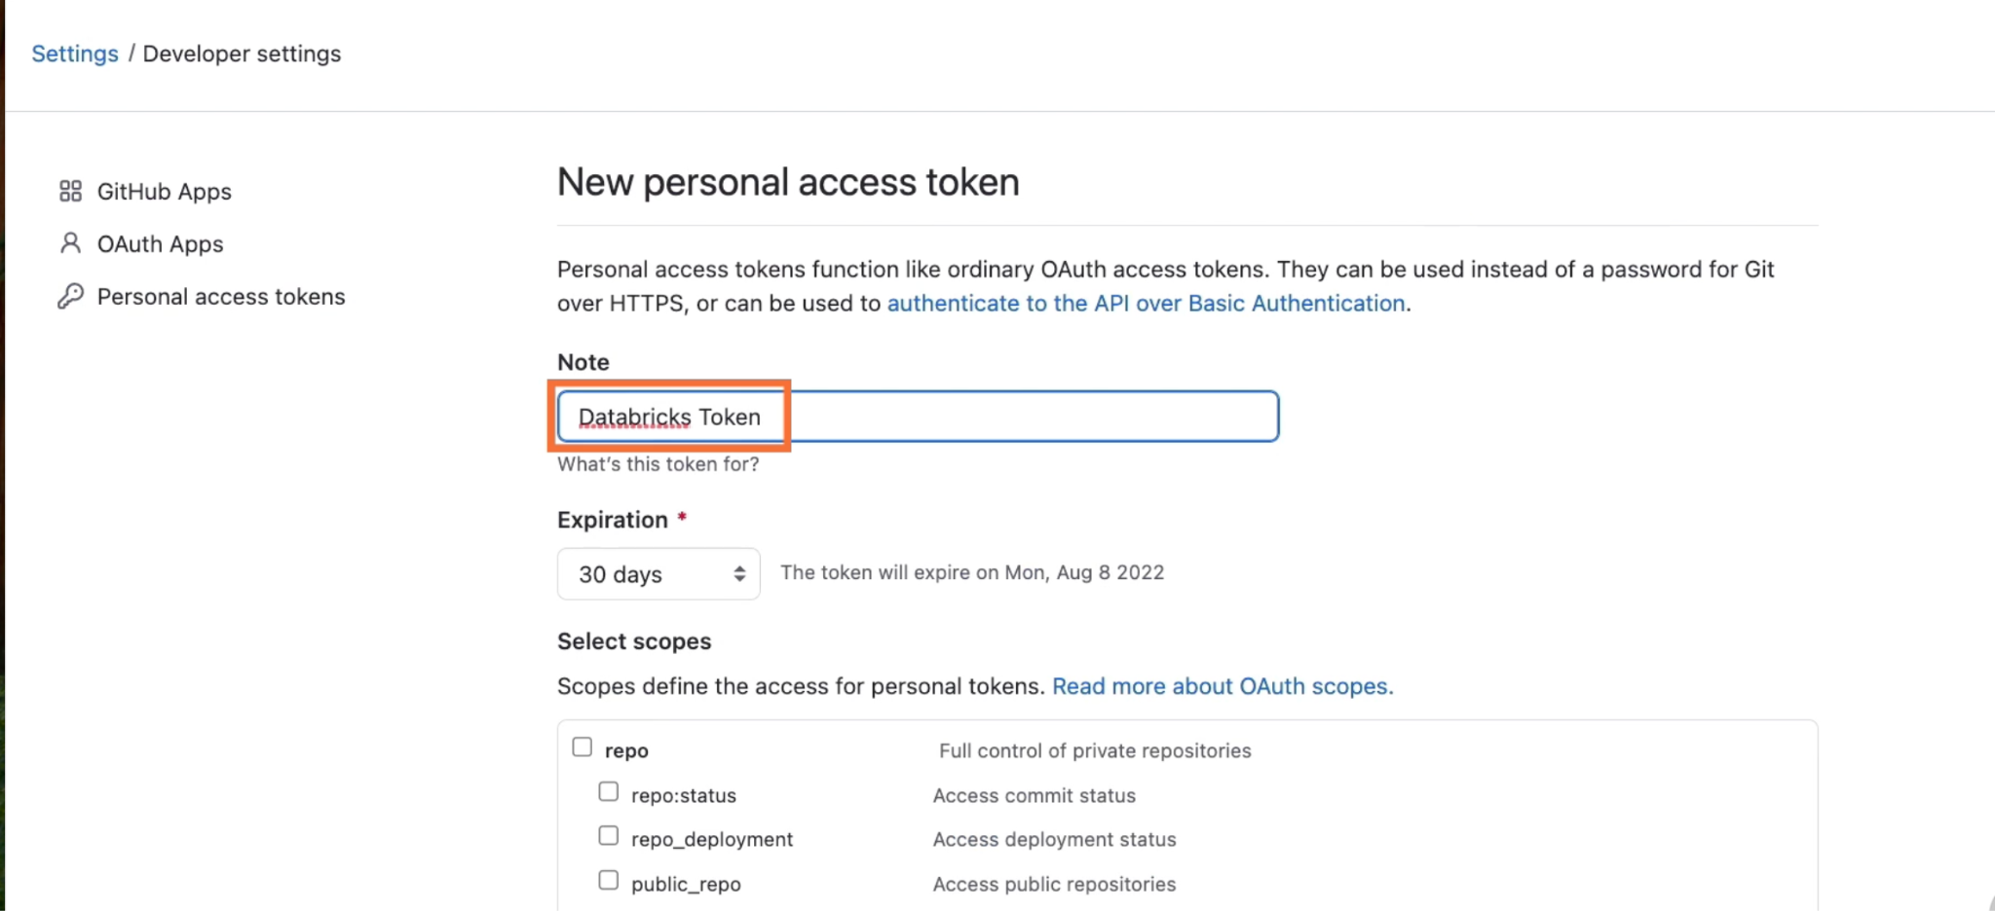

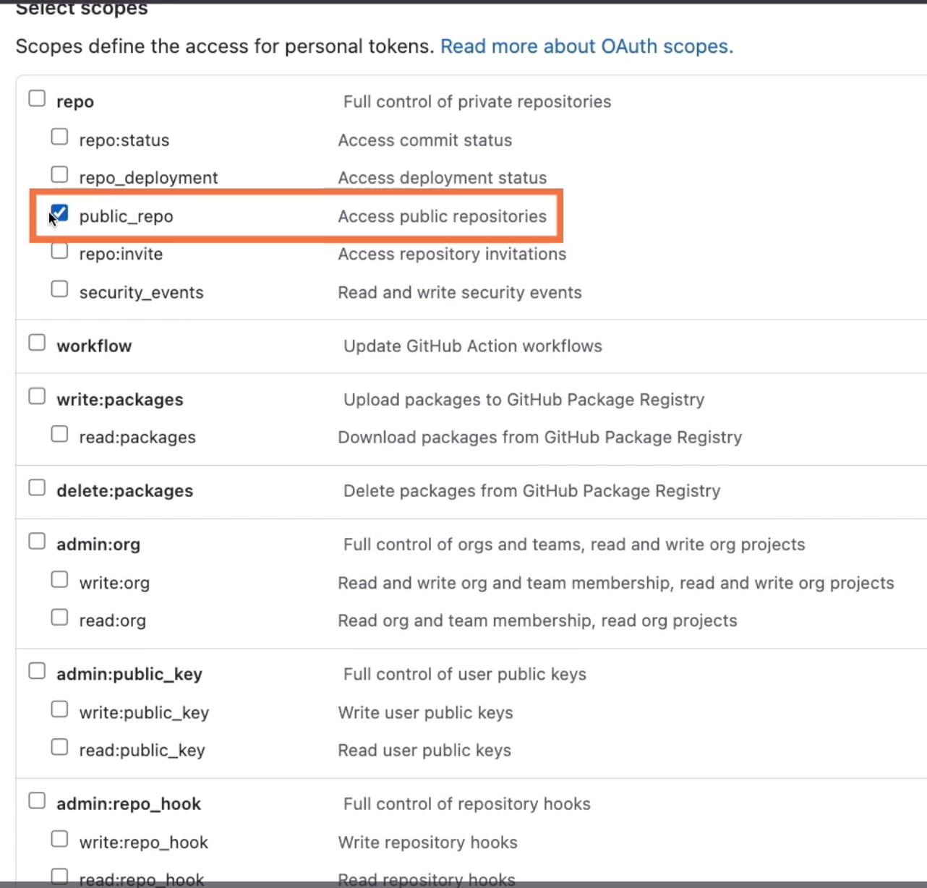

Then move on to Generate token

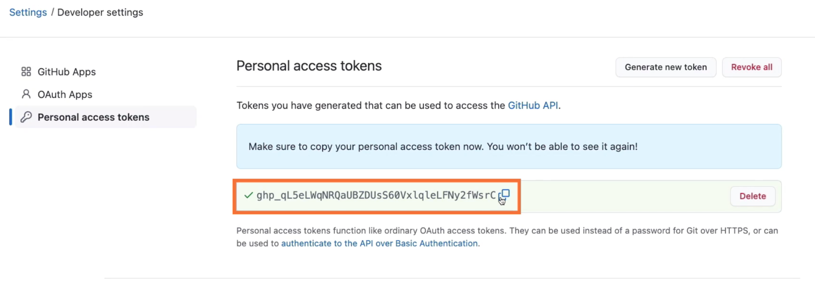

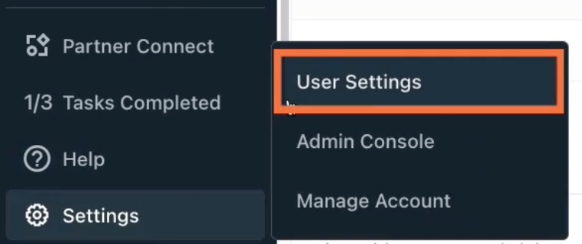

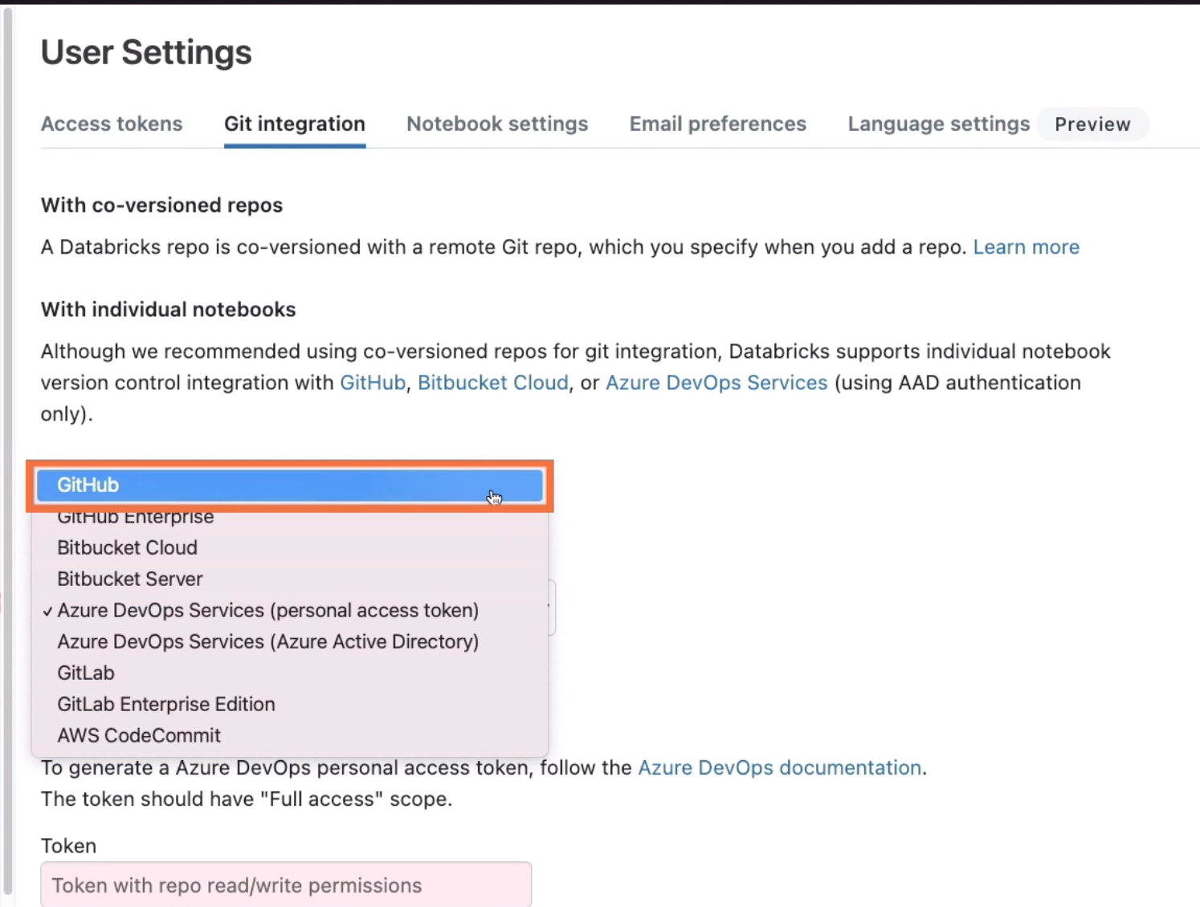

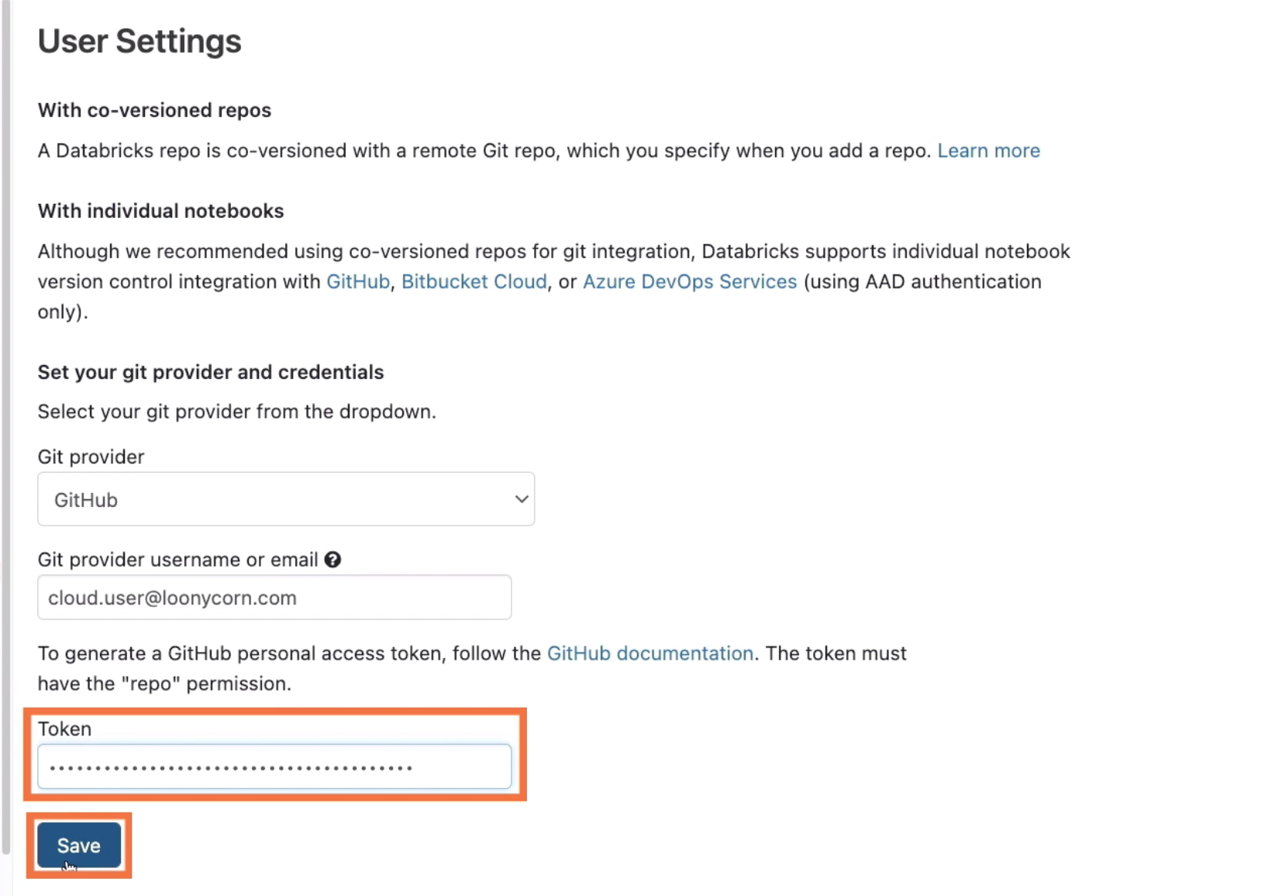

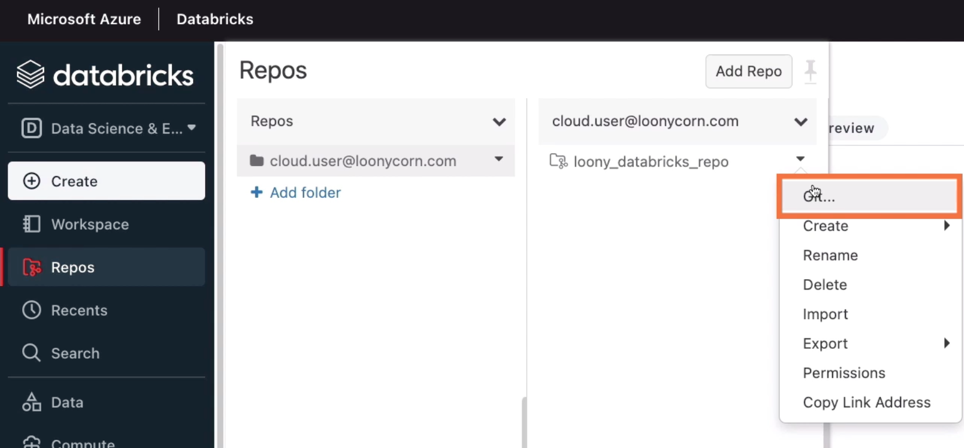

This is where Git integration can be defined

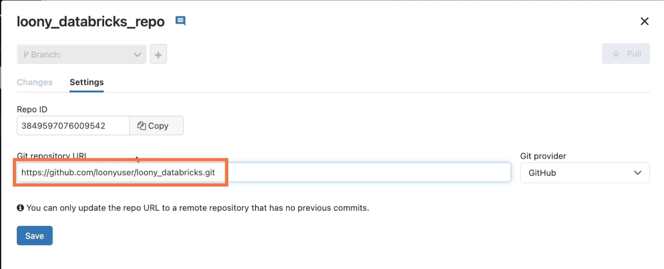

# **Committing and Pushing Code to a Repo**

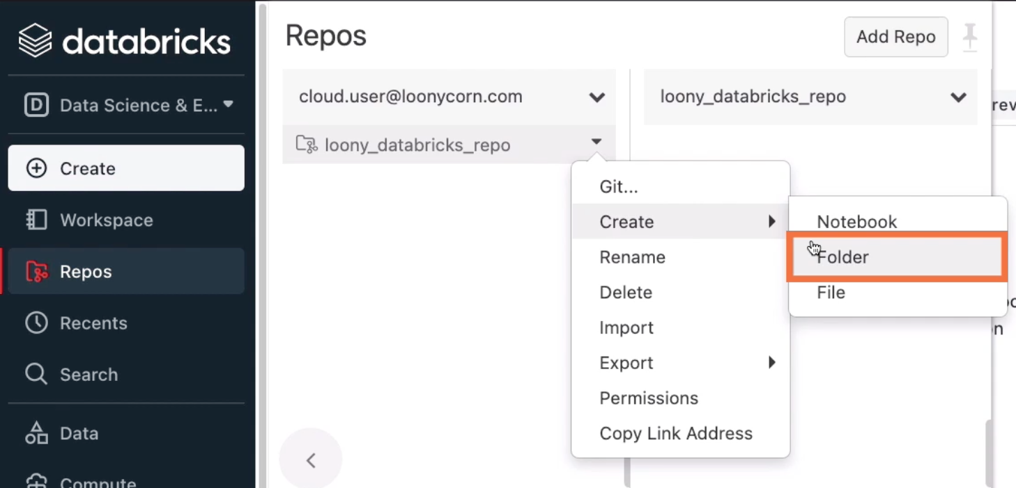

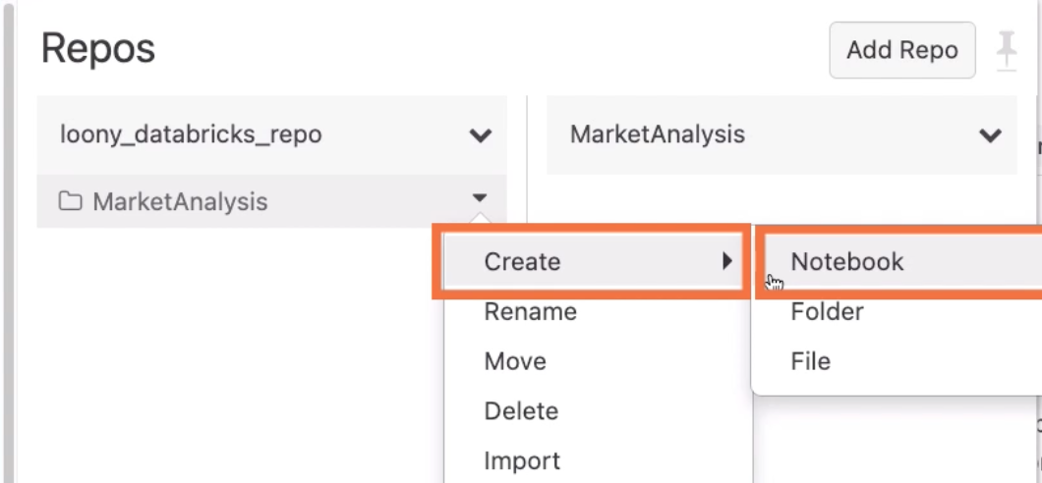

Notebook will run on the cluster we created earlier

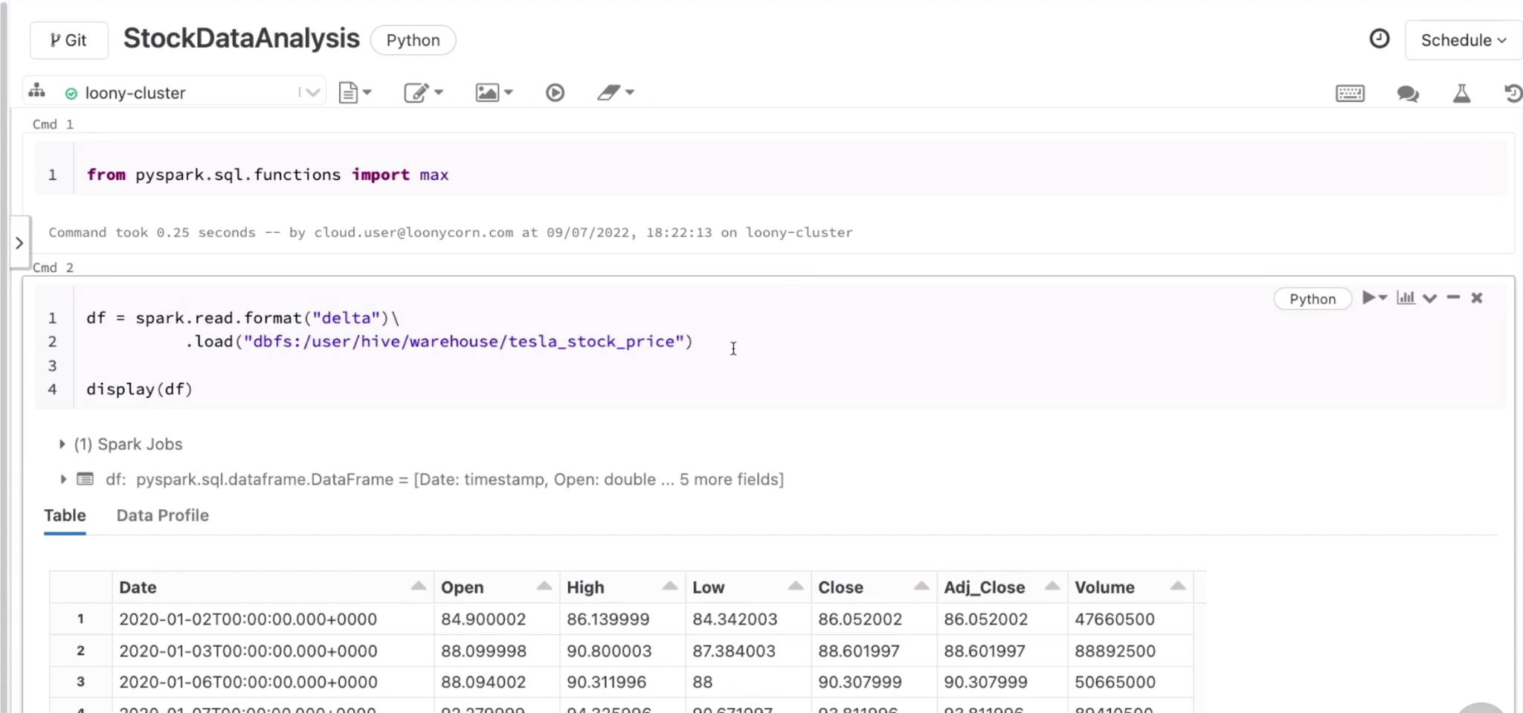

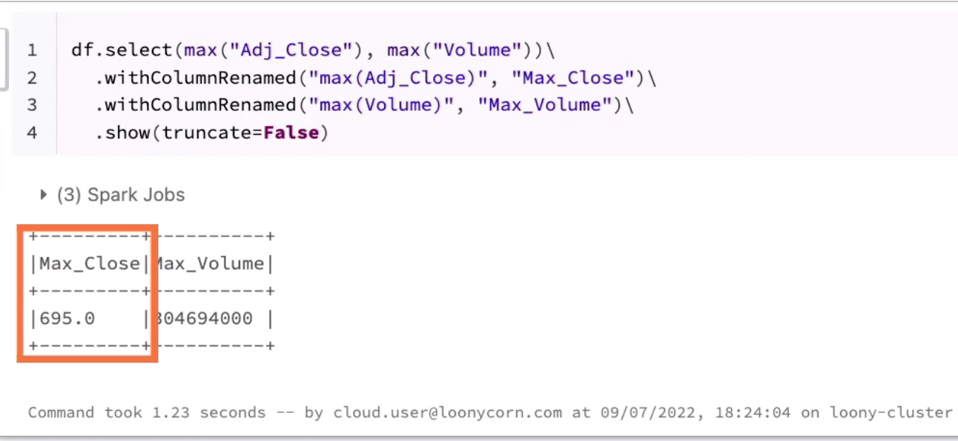

Hit Git button:

What will be committed to GitHub is a Python source rather than a notebook version, so the notebook will have .py instead of .ipynb

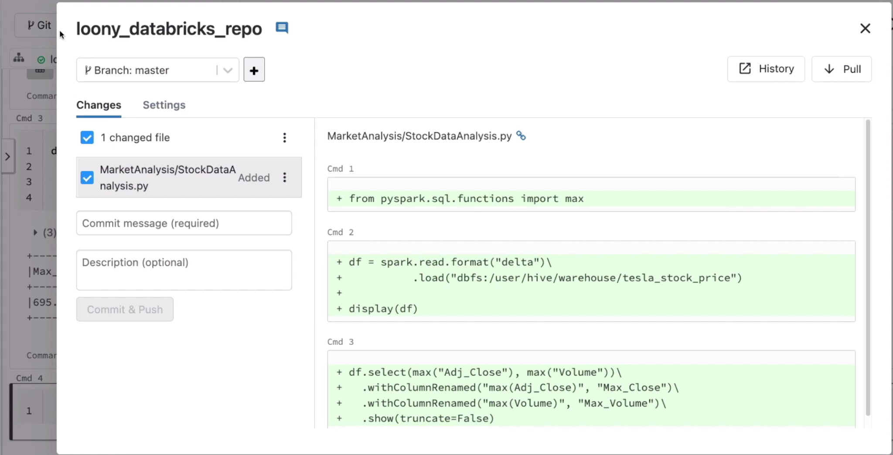

Commit&Push will update this file to both local and remote repos

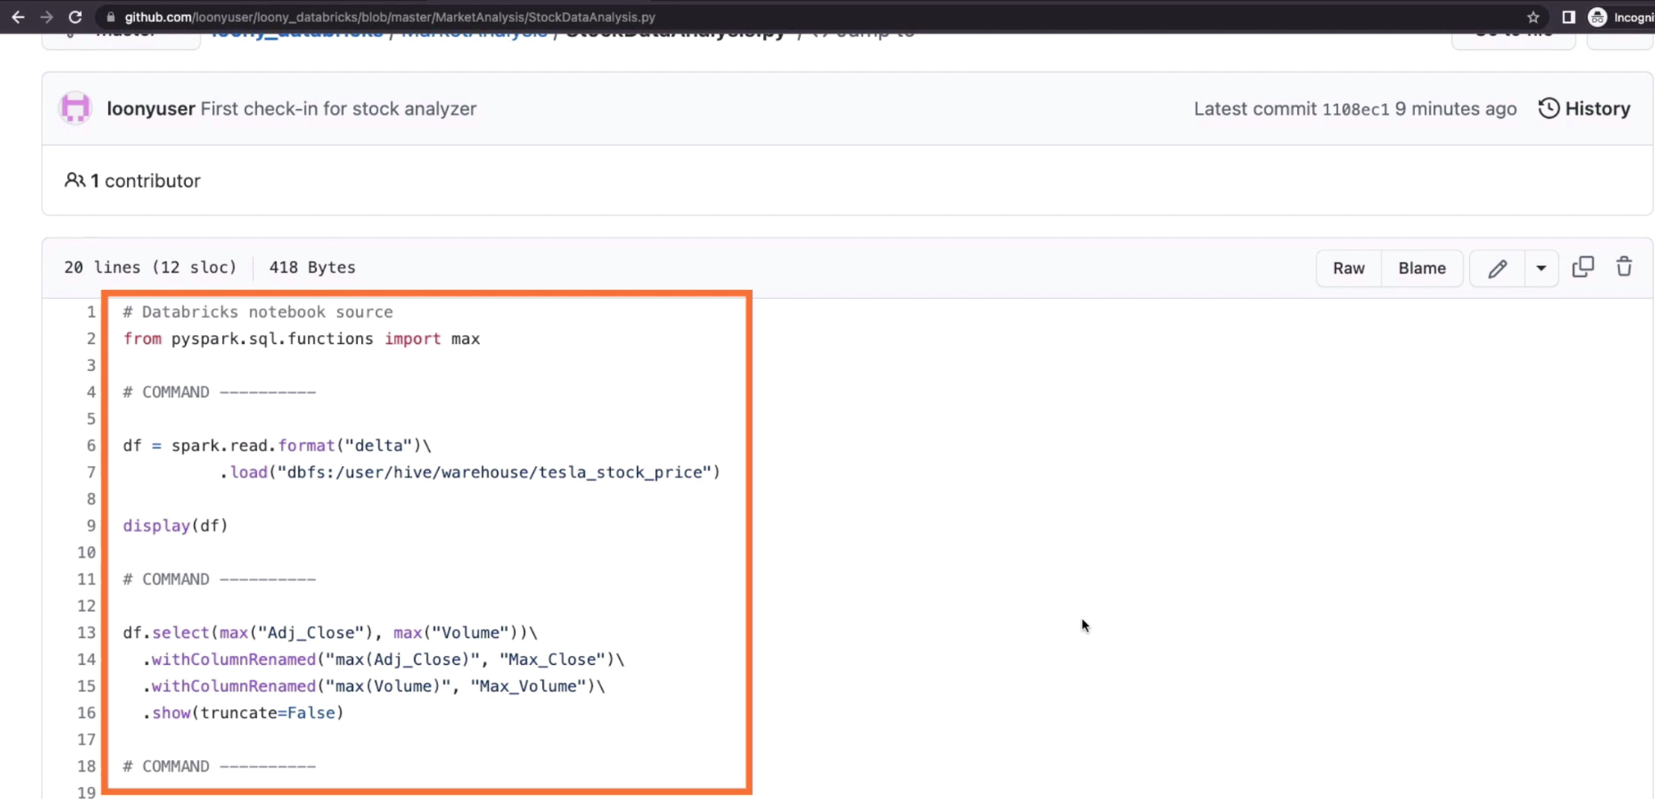

# **Pulling Changes from a Remote Repo**

Let’s edit this file from within this interface on GitHub:

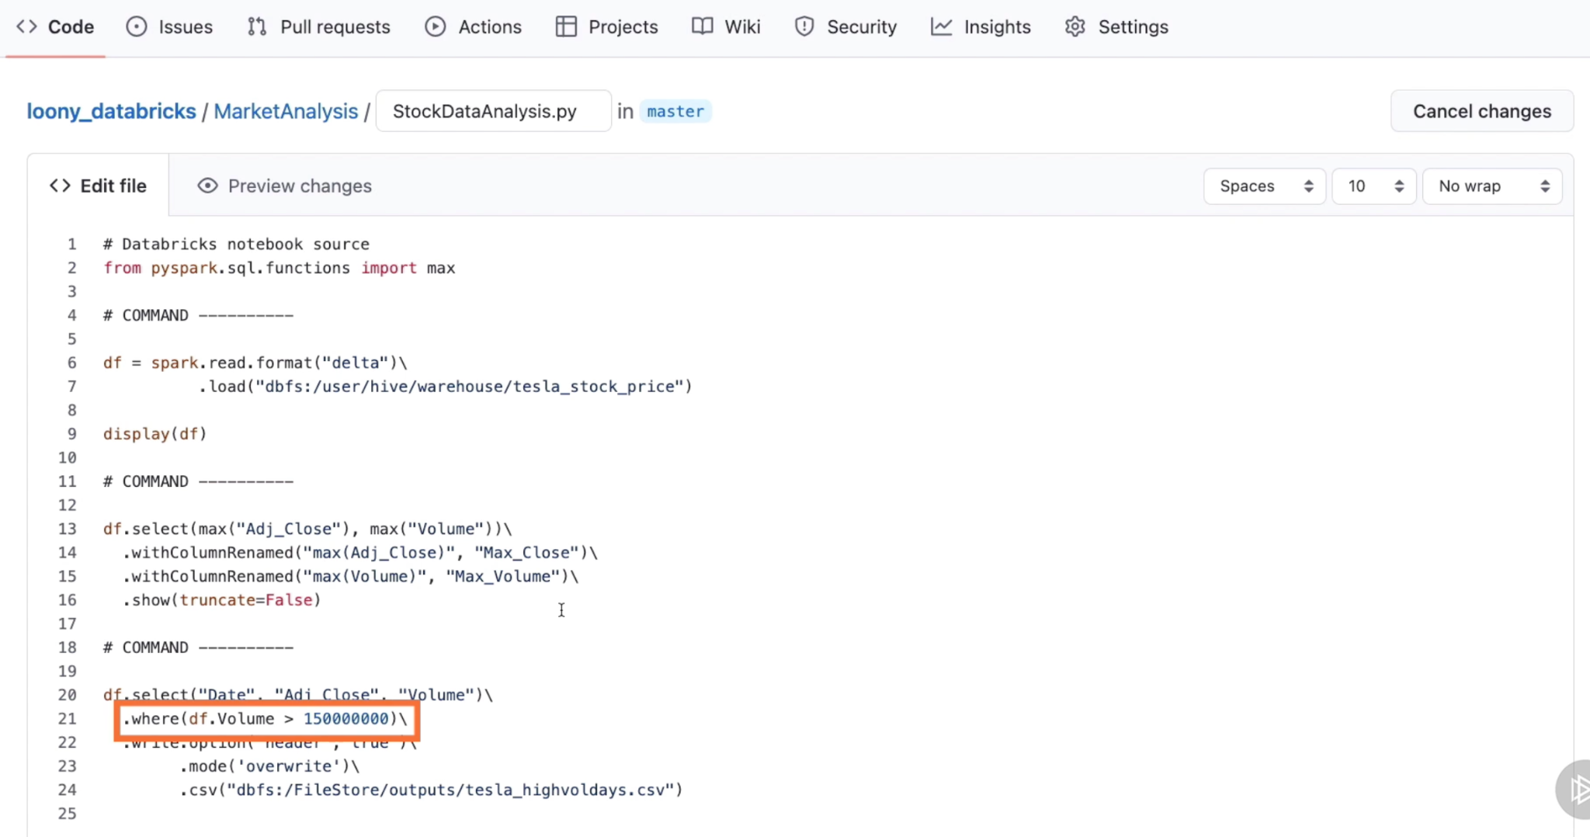

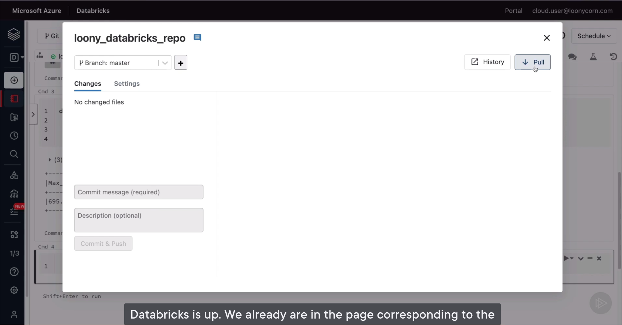

# **Deleting a Notebook from local and remote**

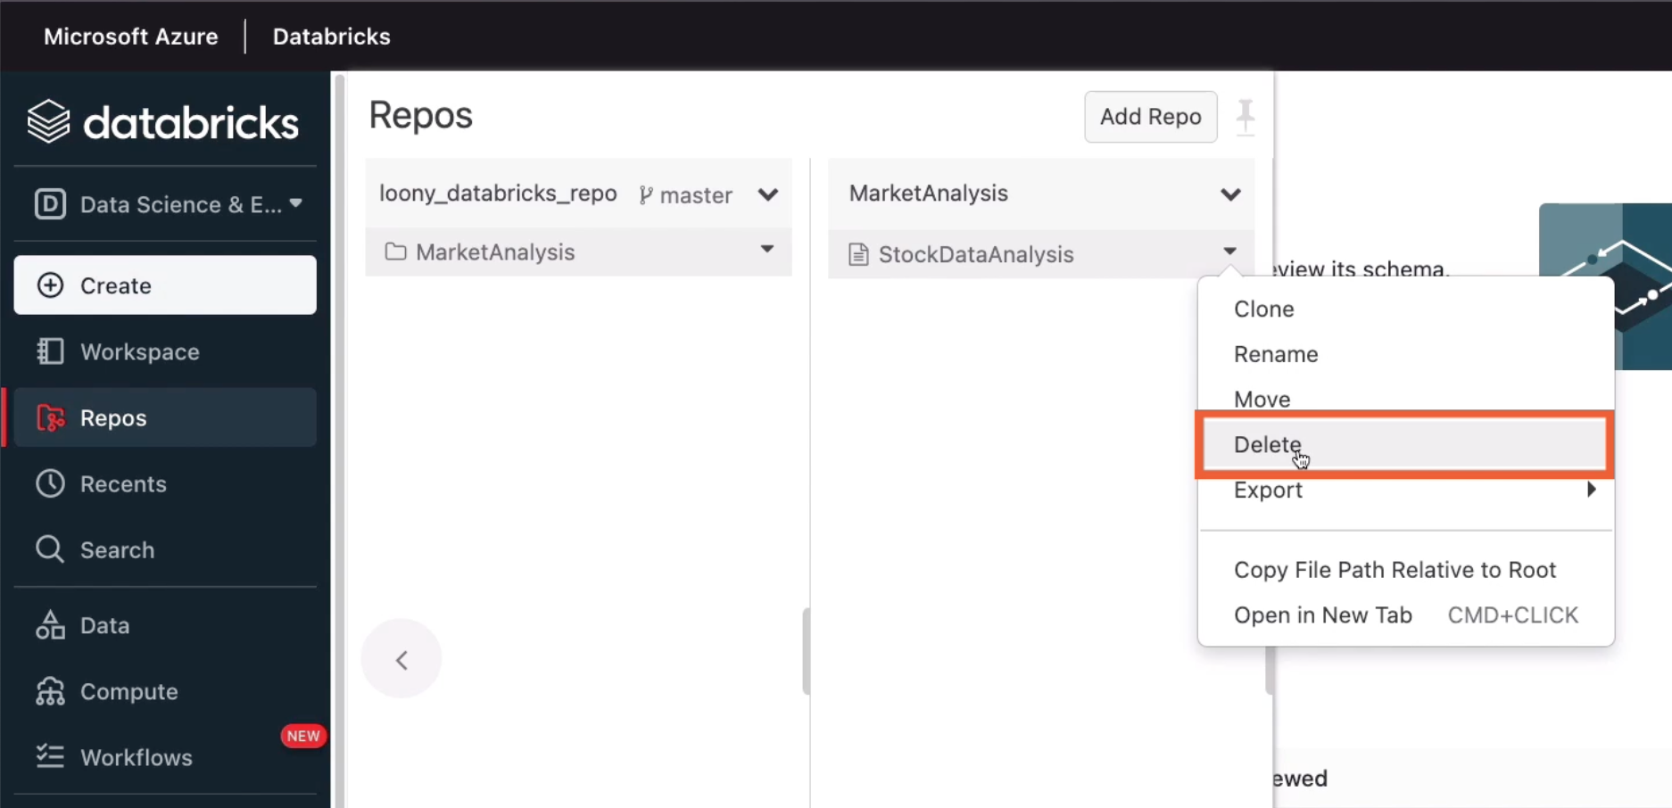

The change is only taking effect in the local repo, but to make sure that the notebook, the corresponding Python source is removed from the remote repository as well, we need to head up to one level from this particular view

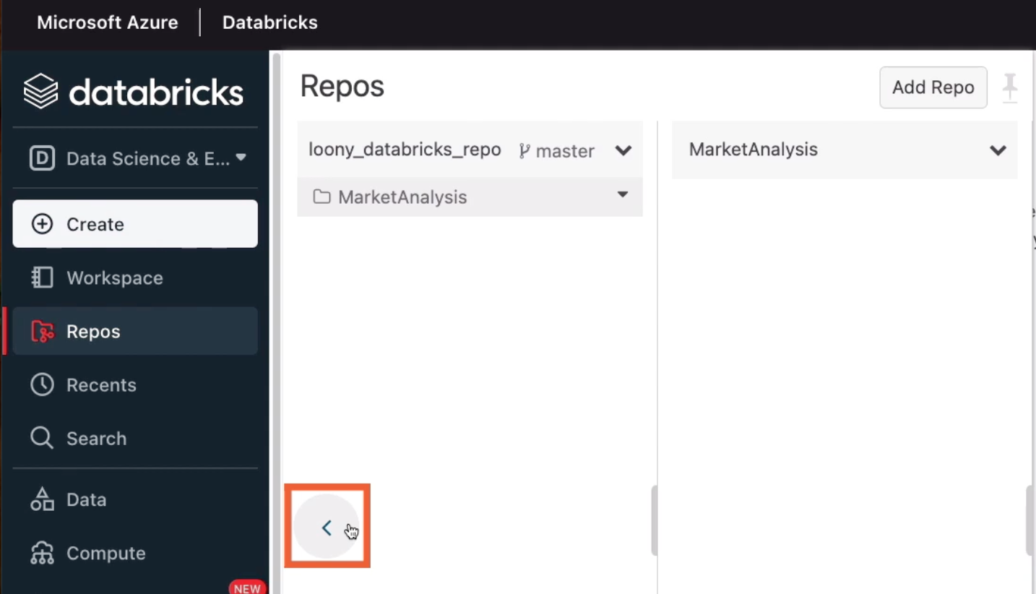

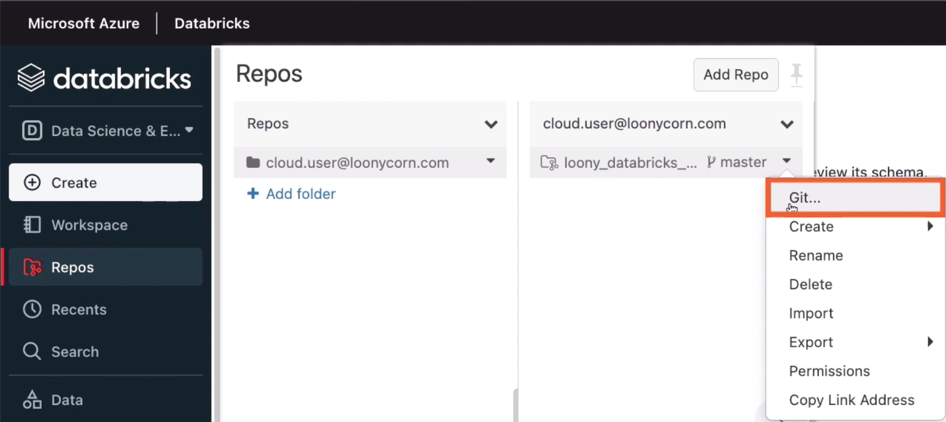

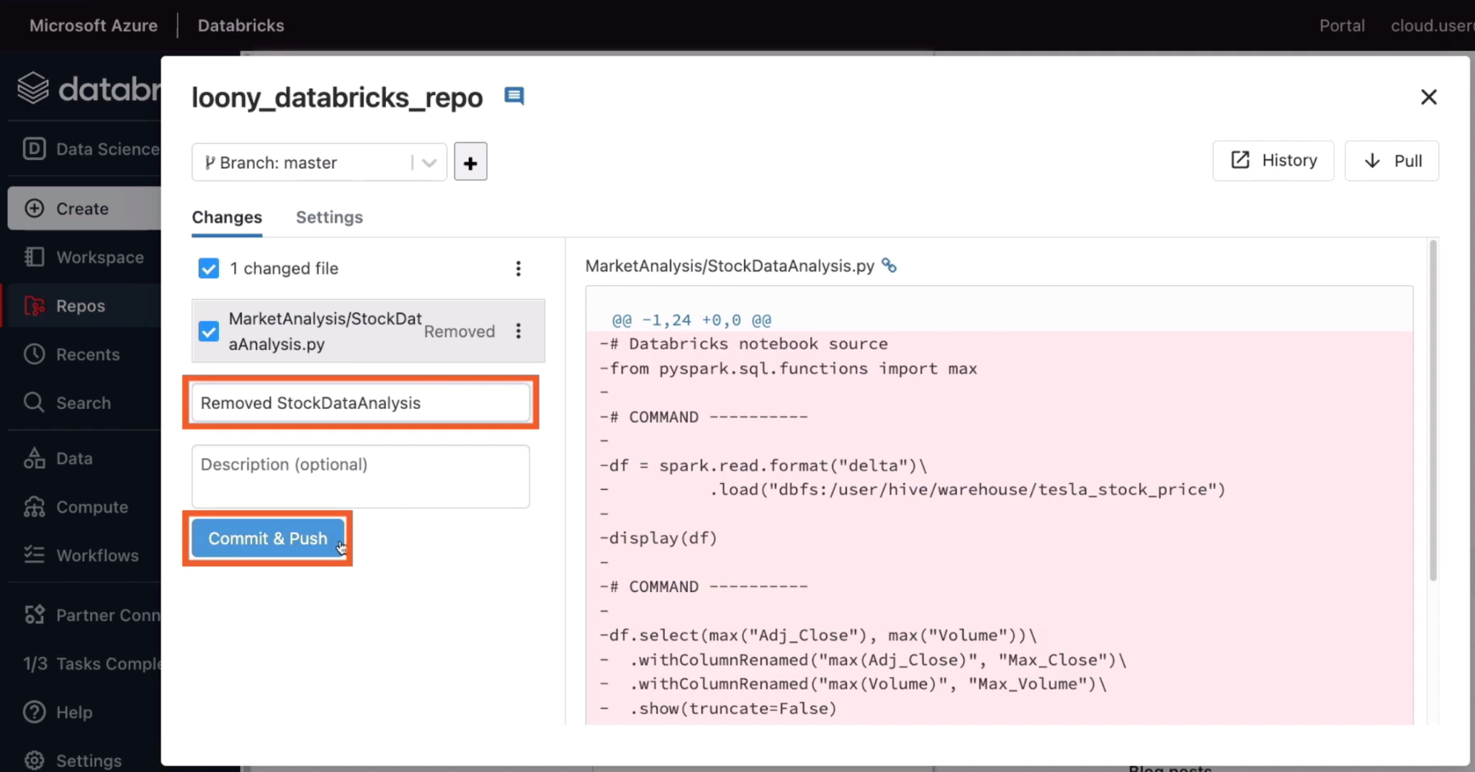

# **Updating a Dashboard with a Scheduled Notebook**

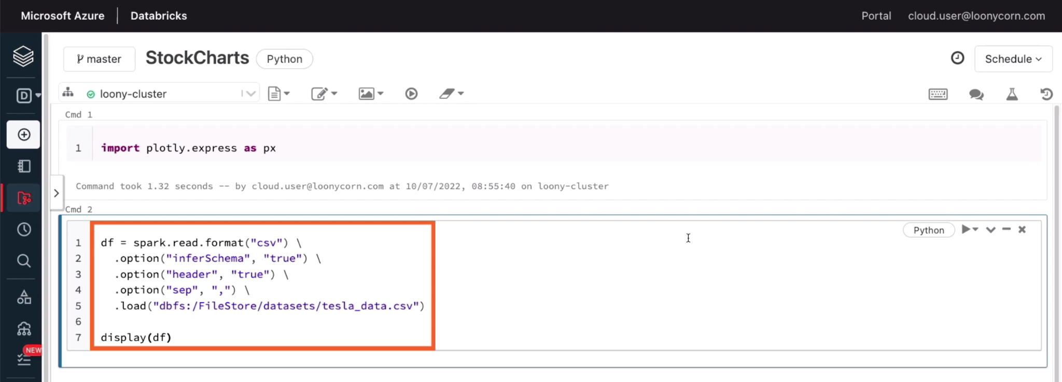

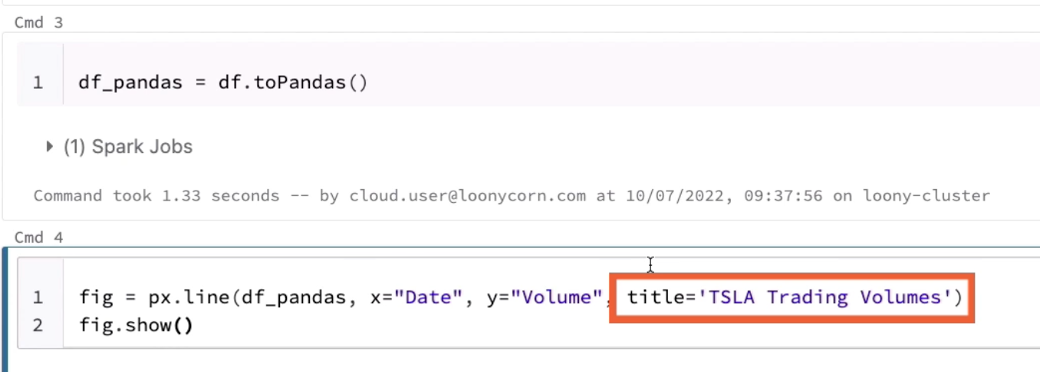

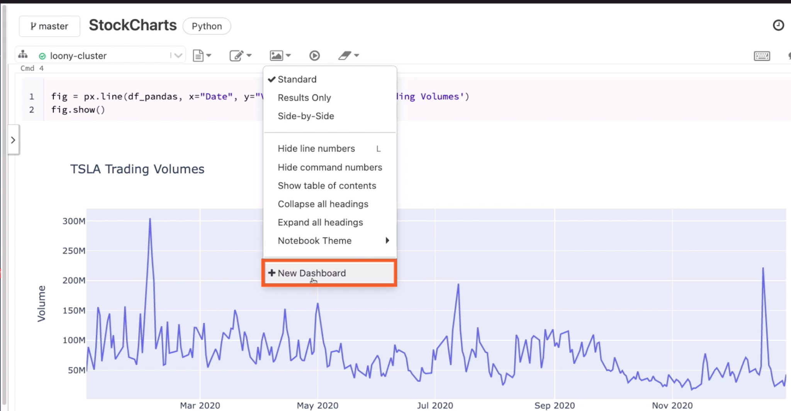

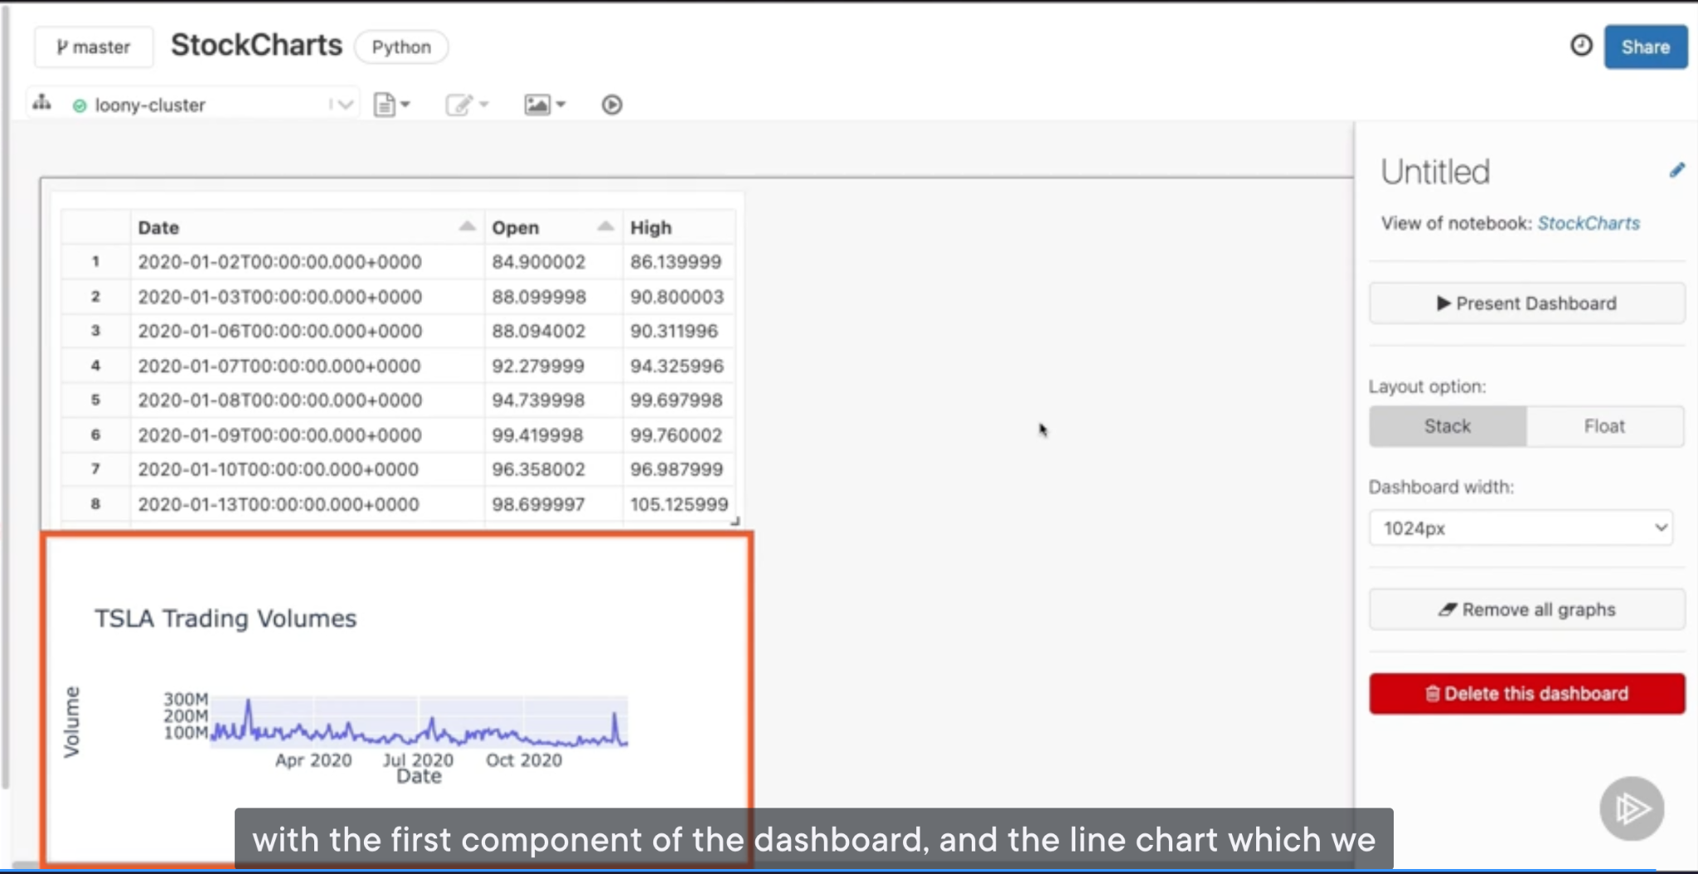

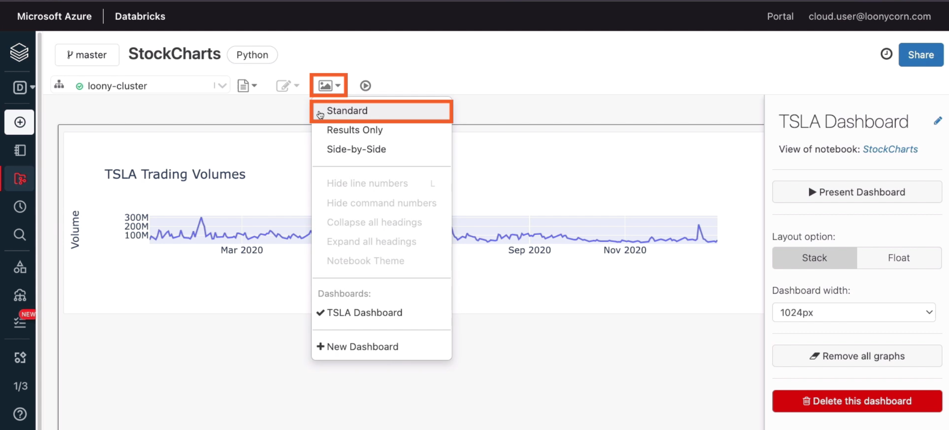

It will redirect to the notebook and you can add more visualization:

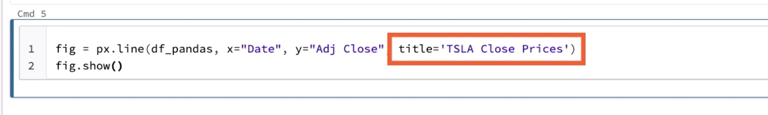

The new visualization has not been automatically included. So we head back over to Standard view

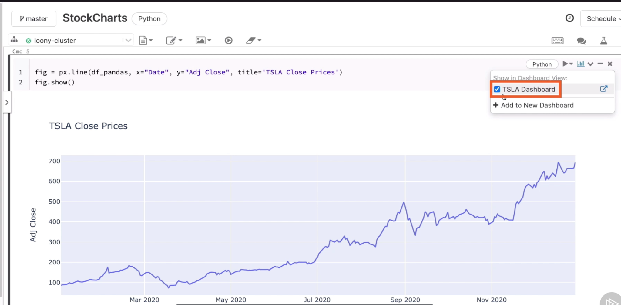

Now we will explore how this notebook can be set to refresh on a periodic basis

First head over to the Standard view, the top right of notebook is the option to schedule the notebook’s execution job. A job in Databricks represents an execution of some kind of task, whether the task is defined in the form of Python code as it is in this notebook, or in the form of SQL queries.

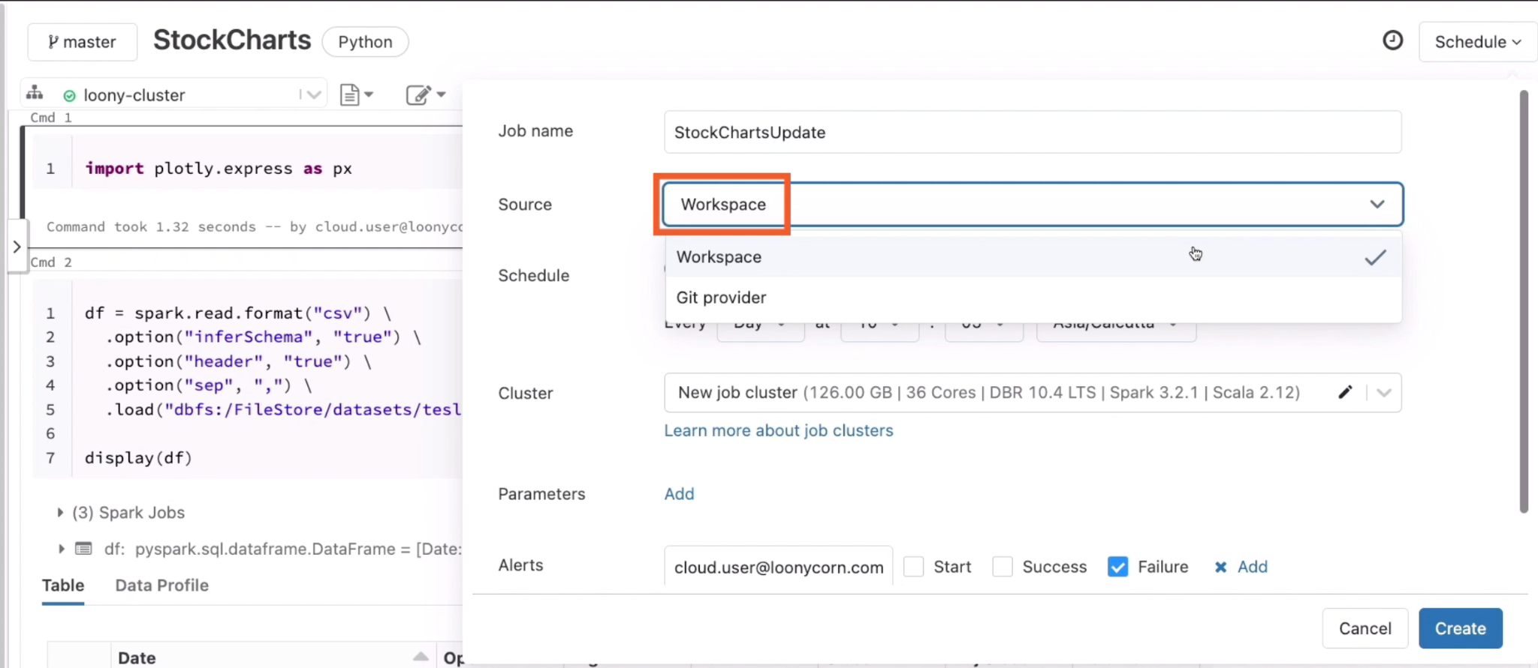

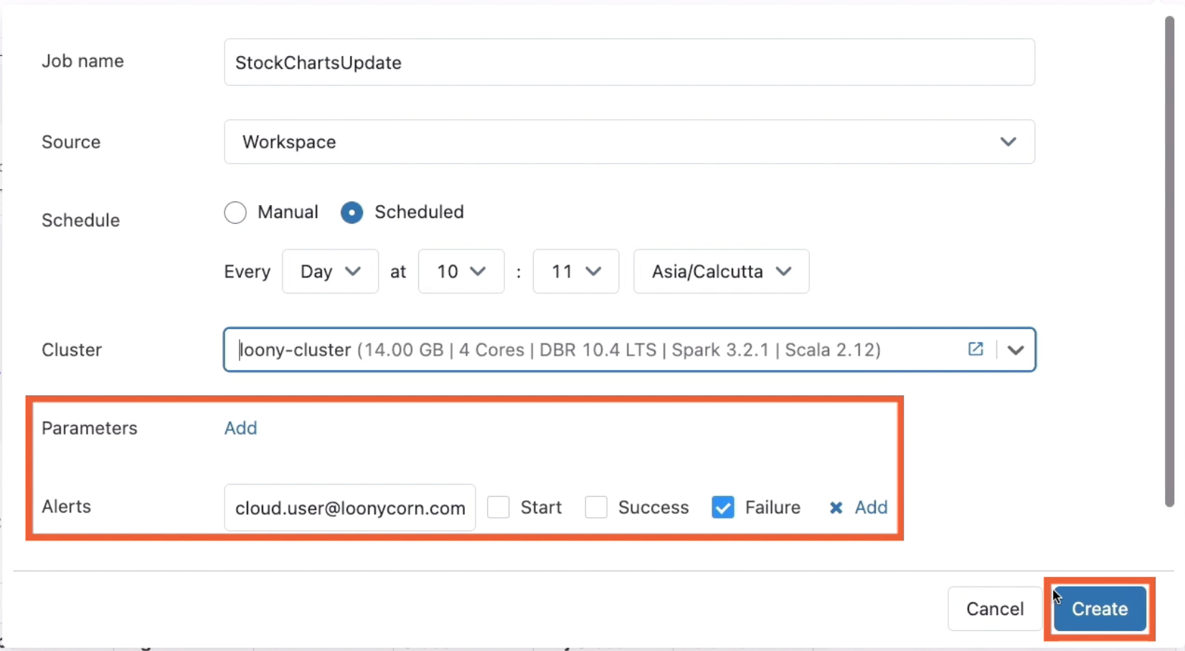

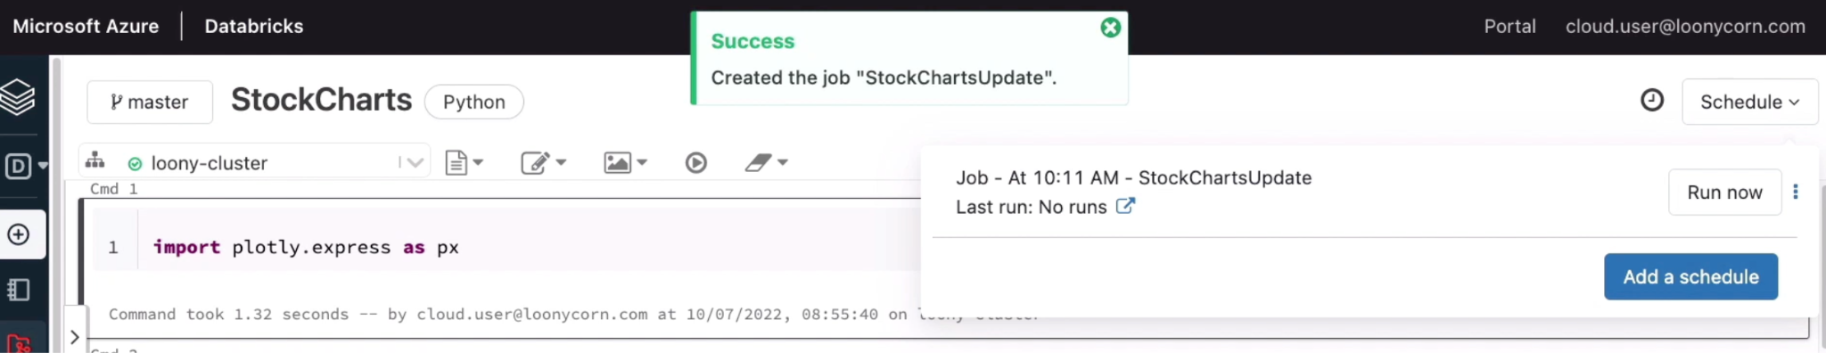

Head over to Workflows, this is where the different jobs can be accessed

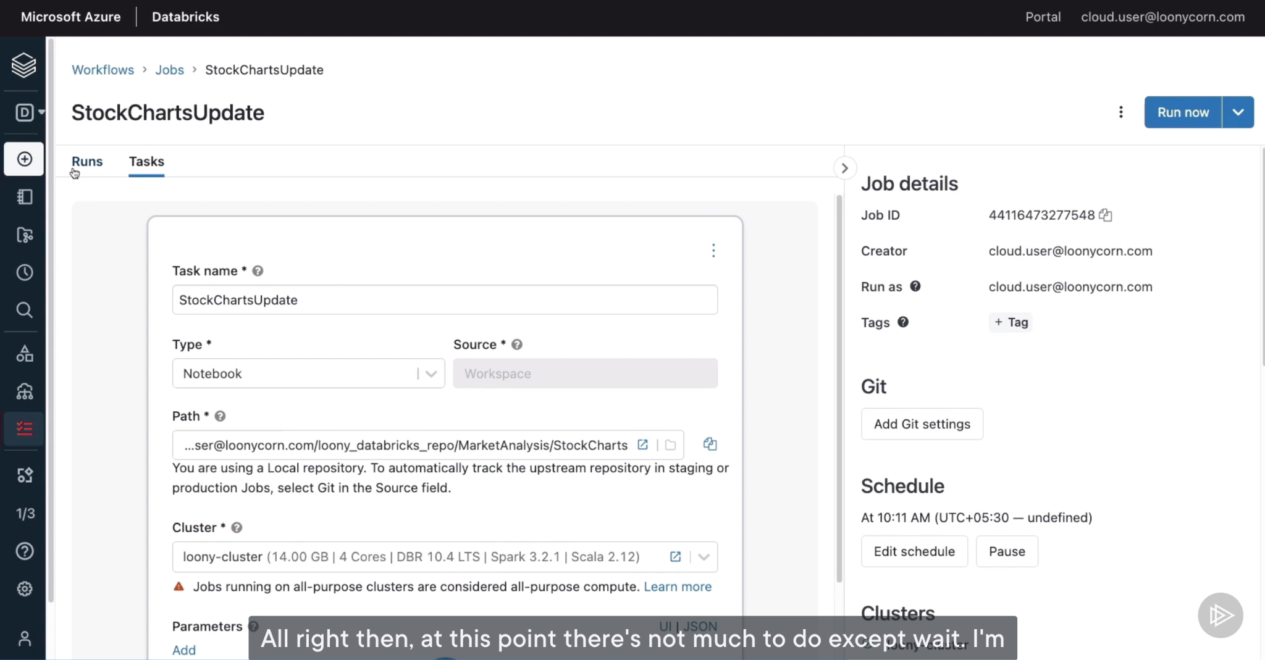

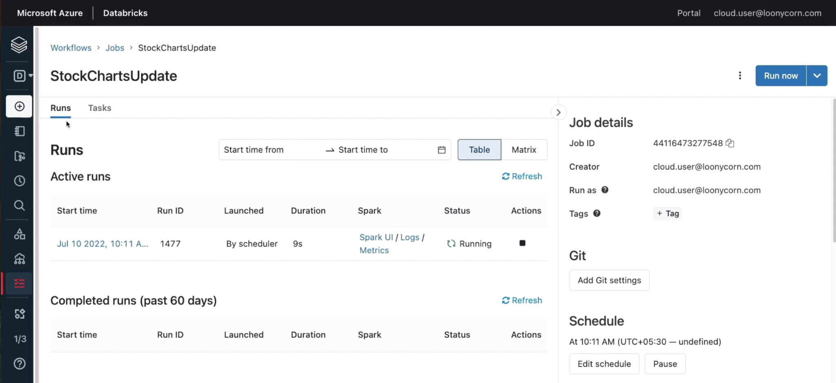

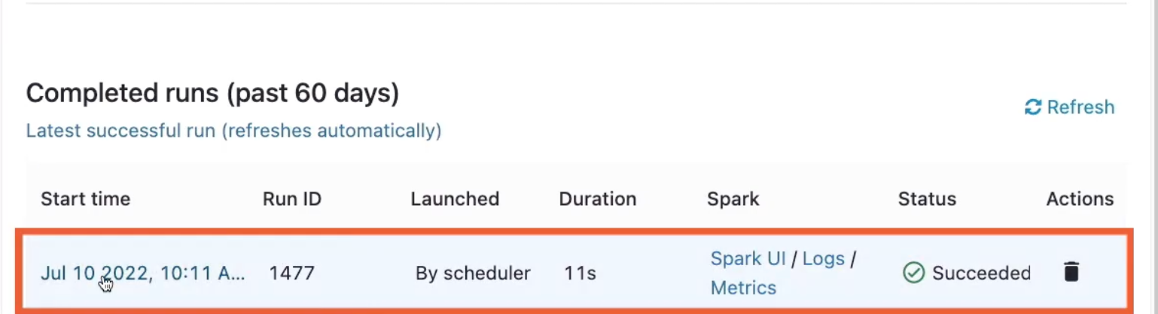

Click on the completed job, you can see the notebook content

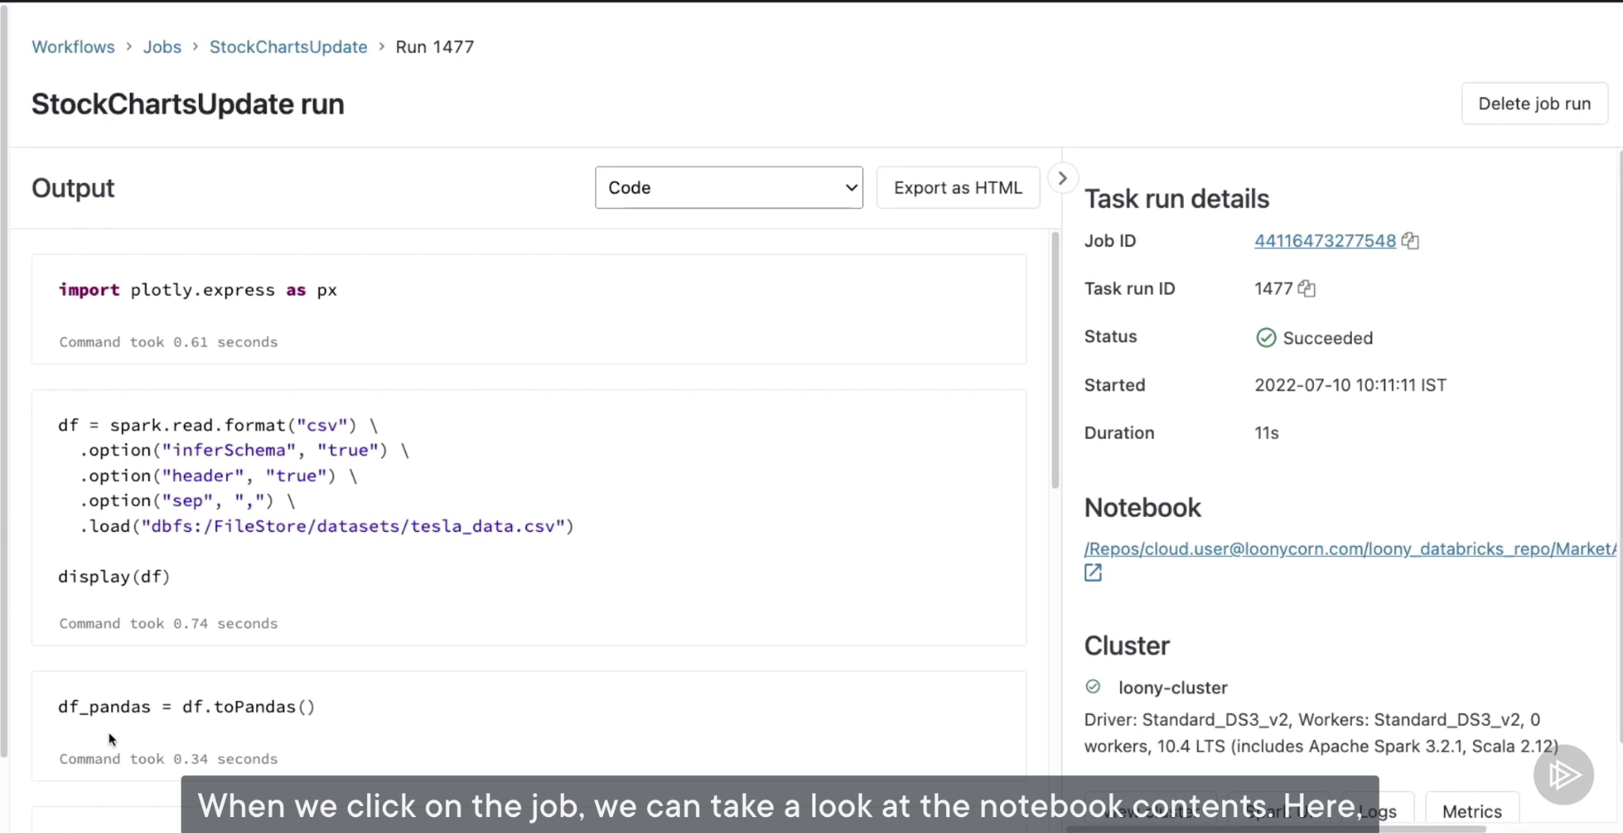

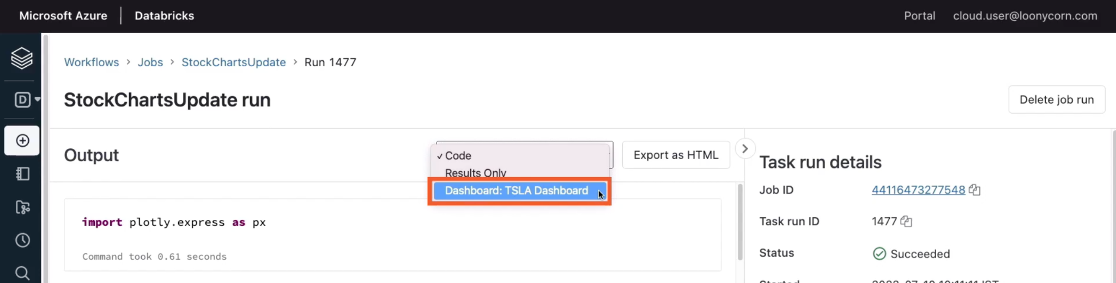

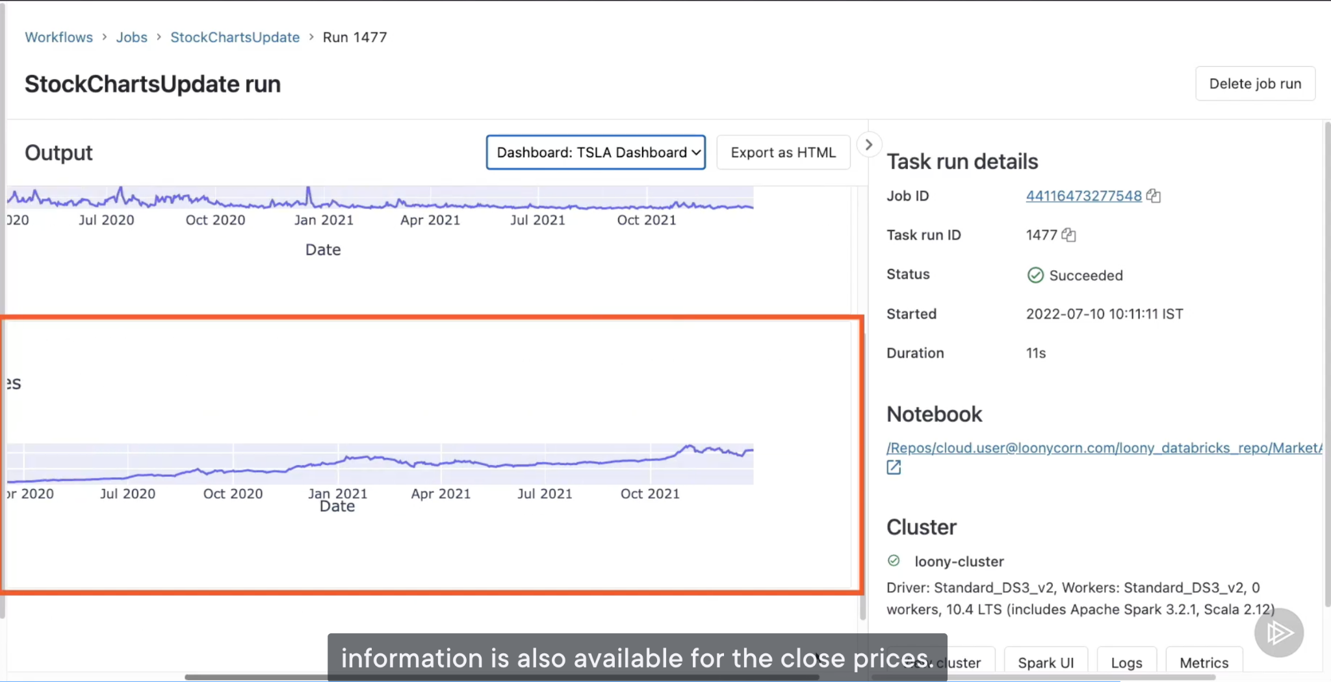

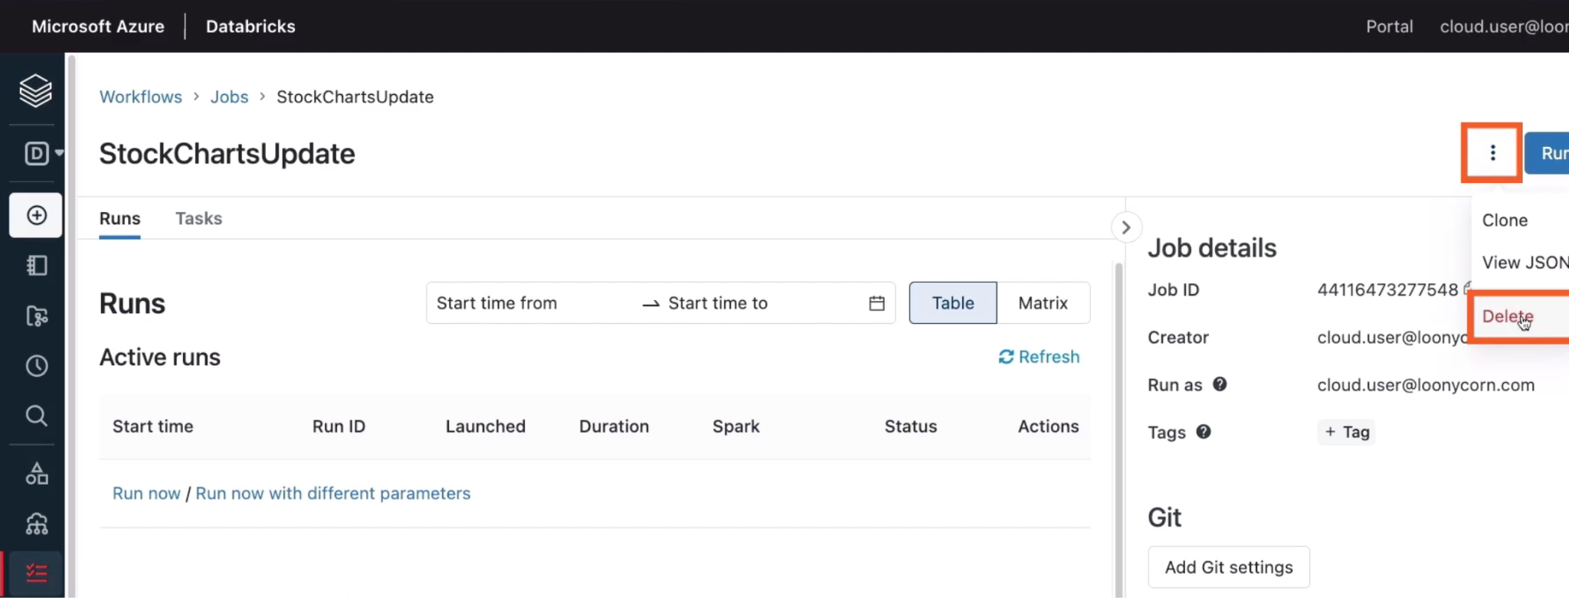

# Setting up a Job Cluster

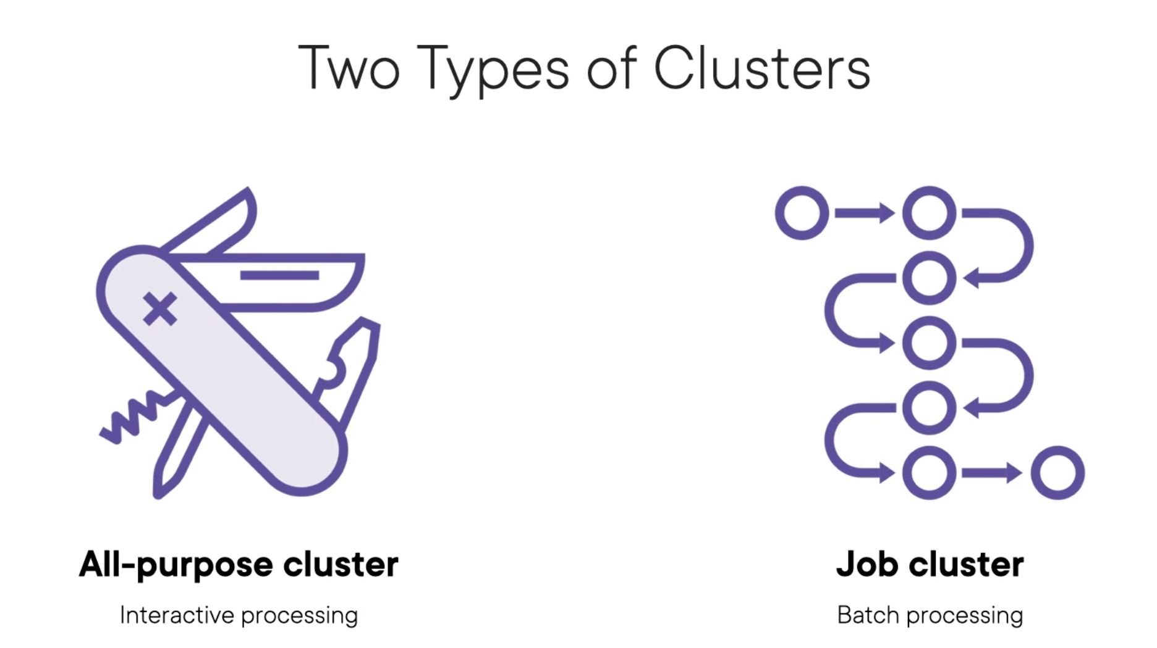

As users, we have a little more control over all-purpose clusters

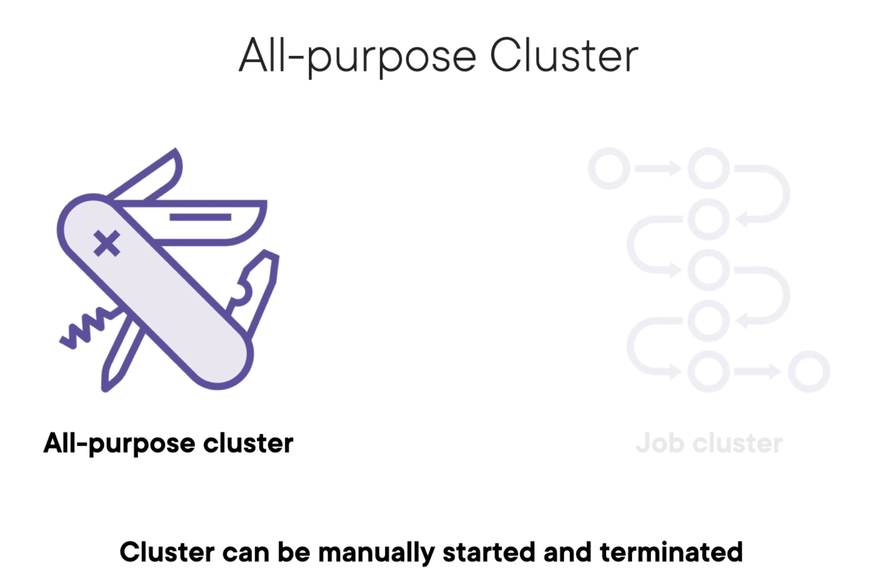

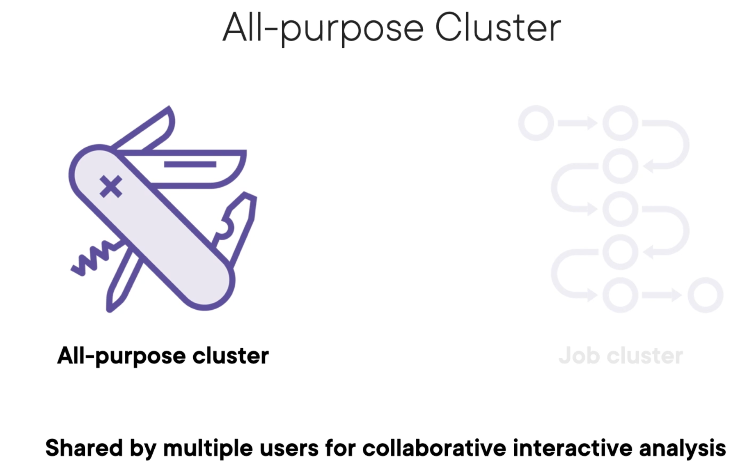

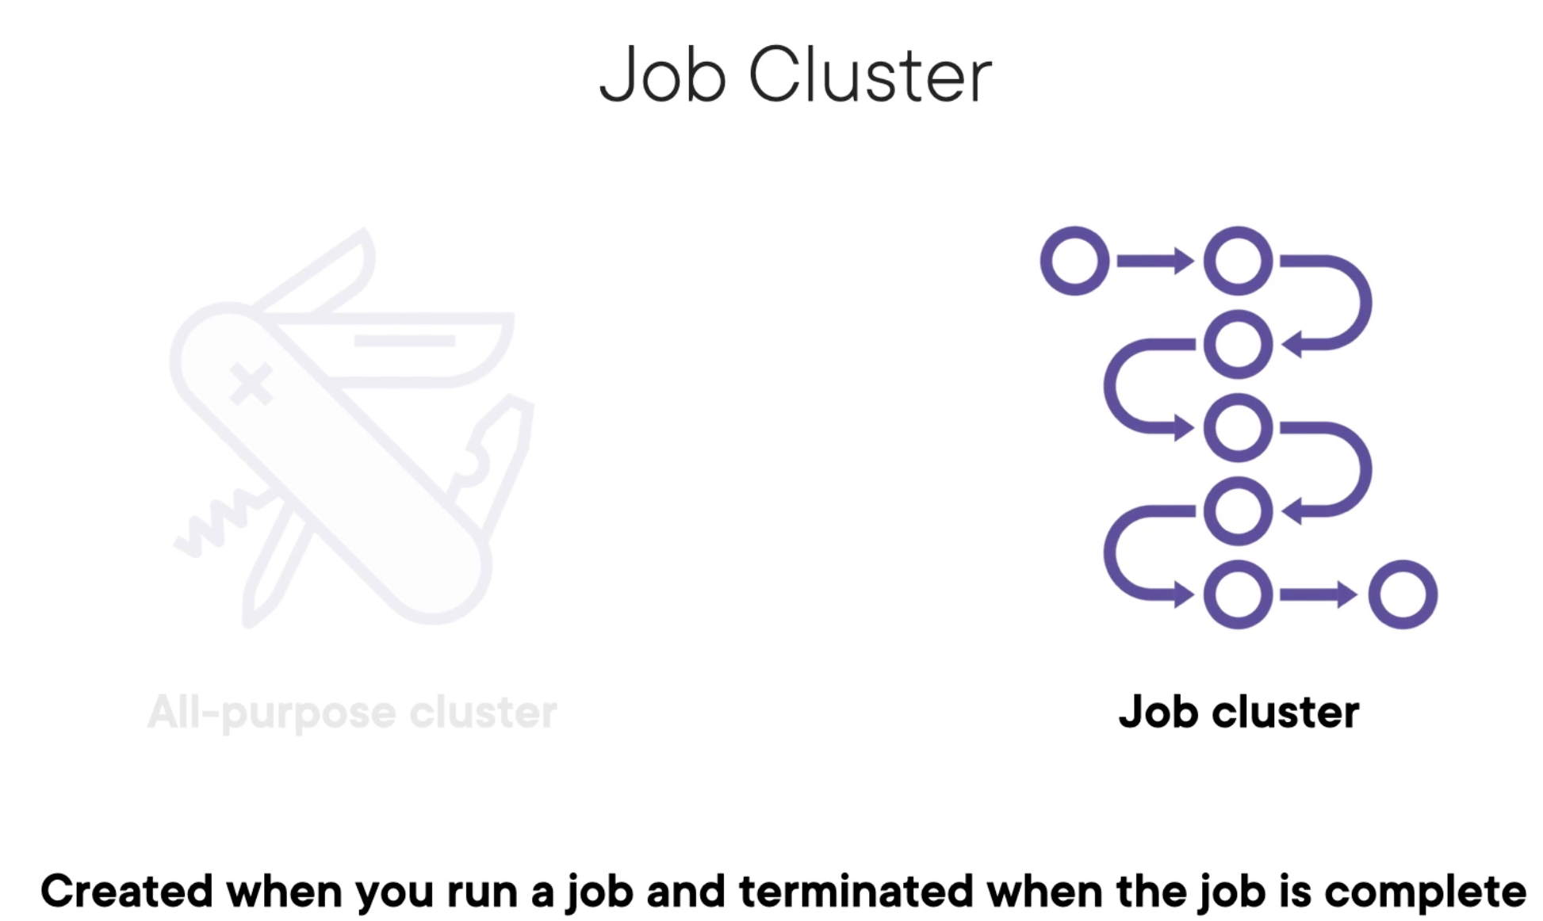

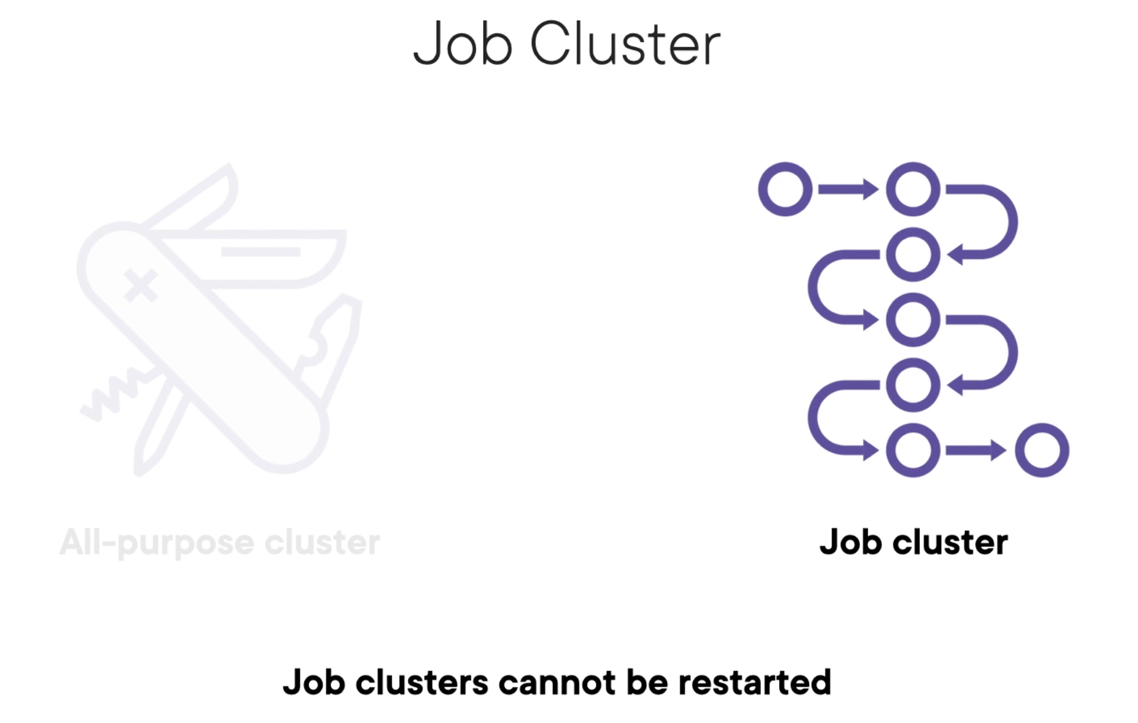

Head over to “Workflows”->”create jobs”:

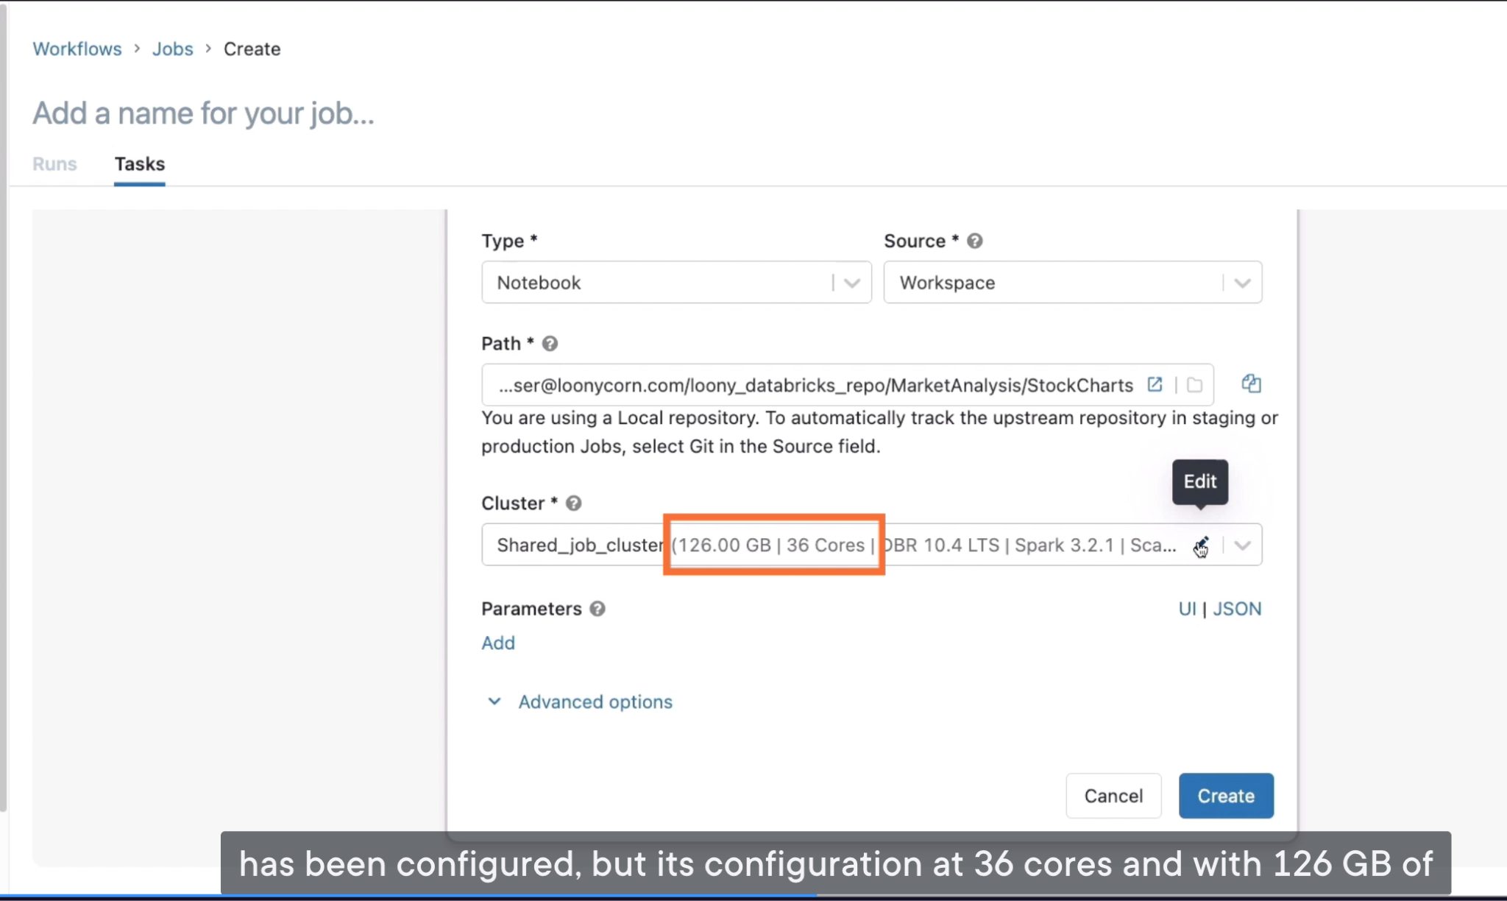

A job cluster is not always on, but it is provisioned once a job associated with it has been started

After the job execution is complete, the cluster is terminated.

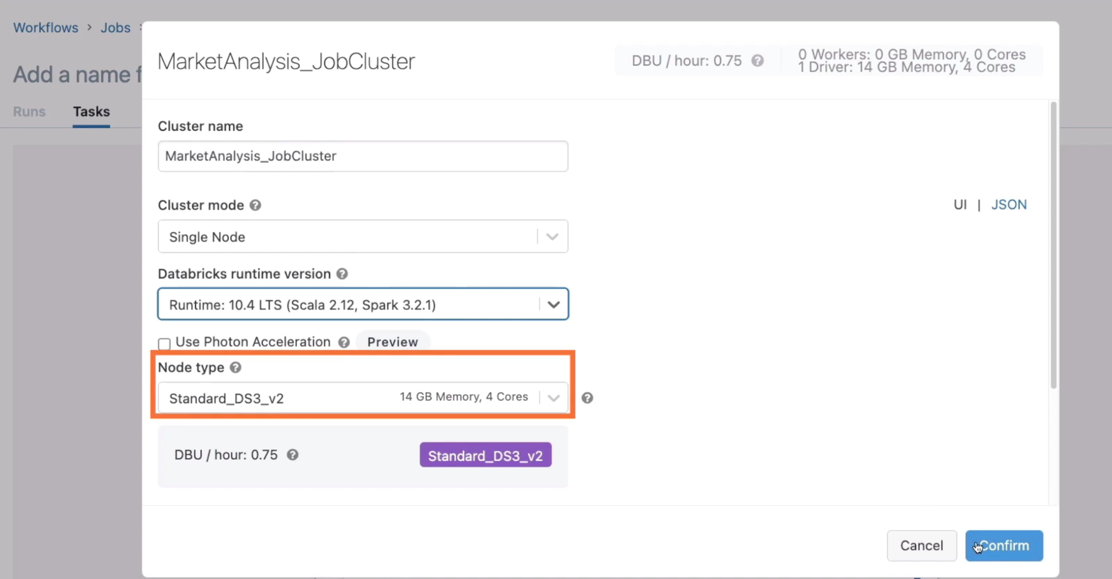

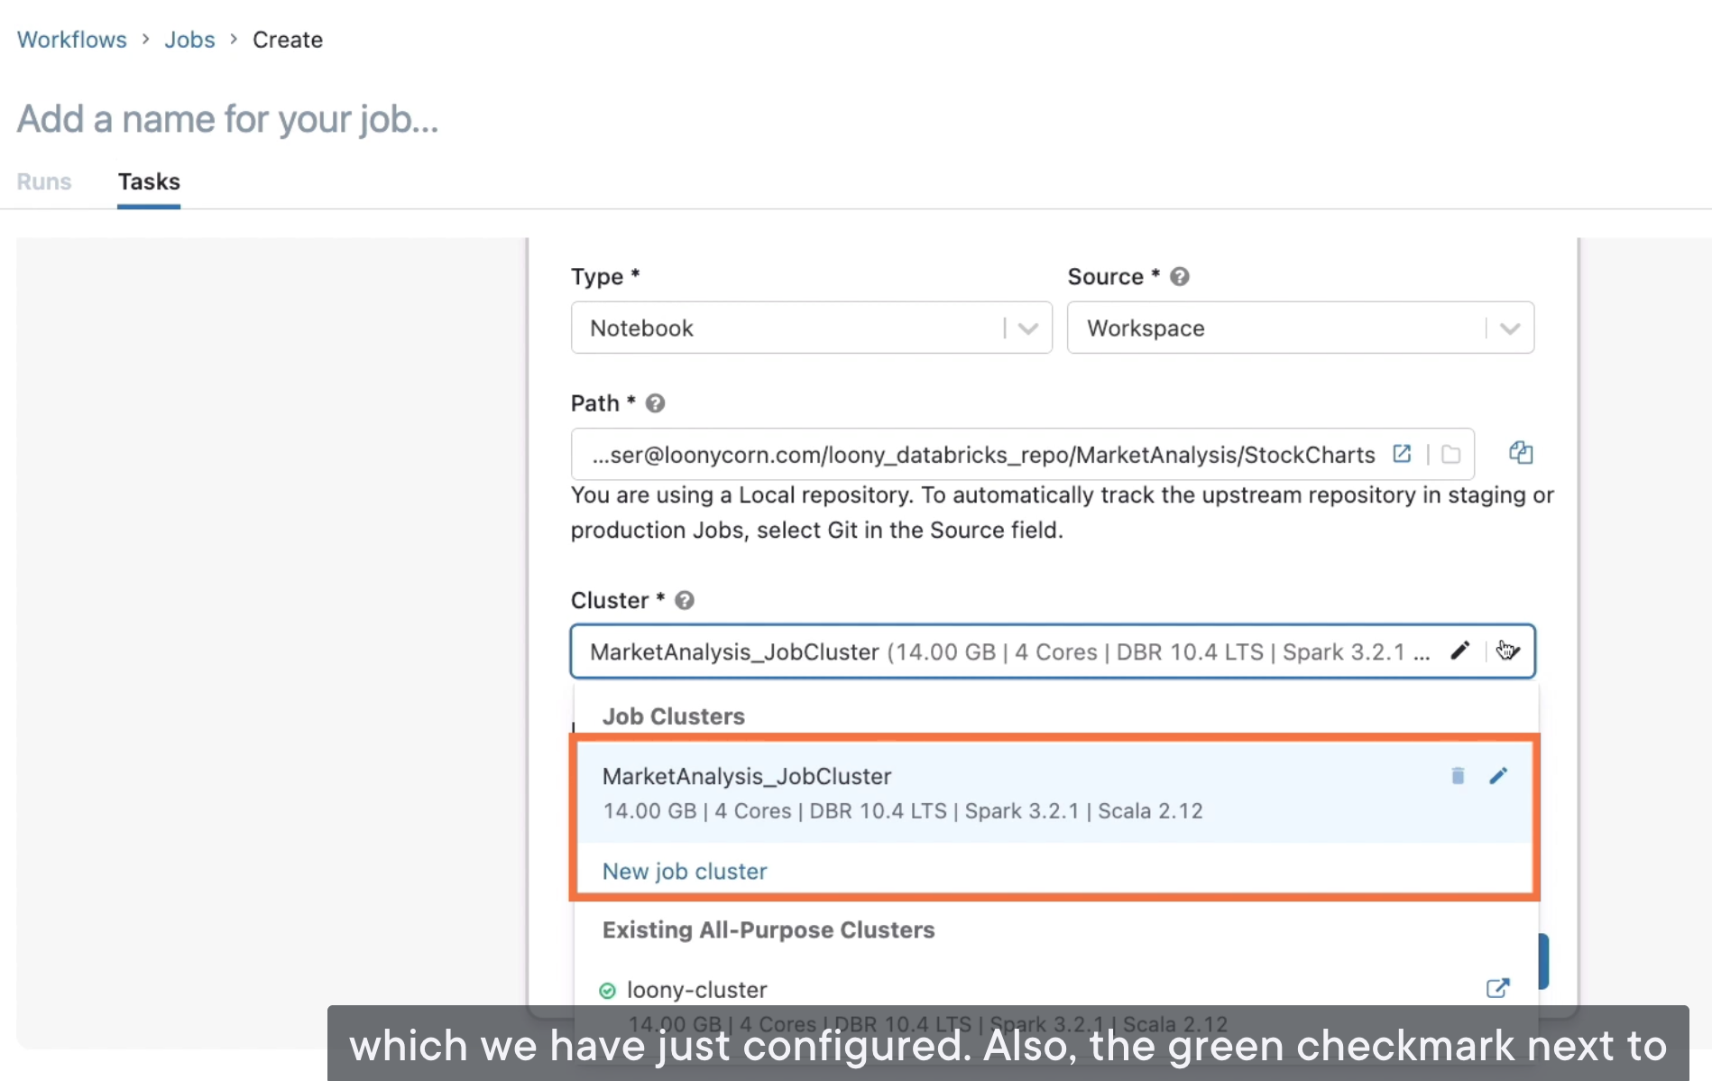

The green checkmark means the all-purpose cluster is in the running state.

But this new job cluster is yet to be provisioned, and that will only happen once we launch the job

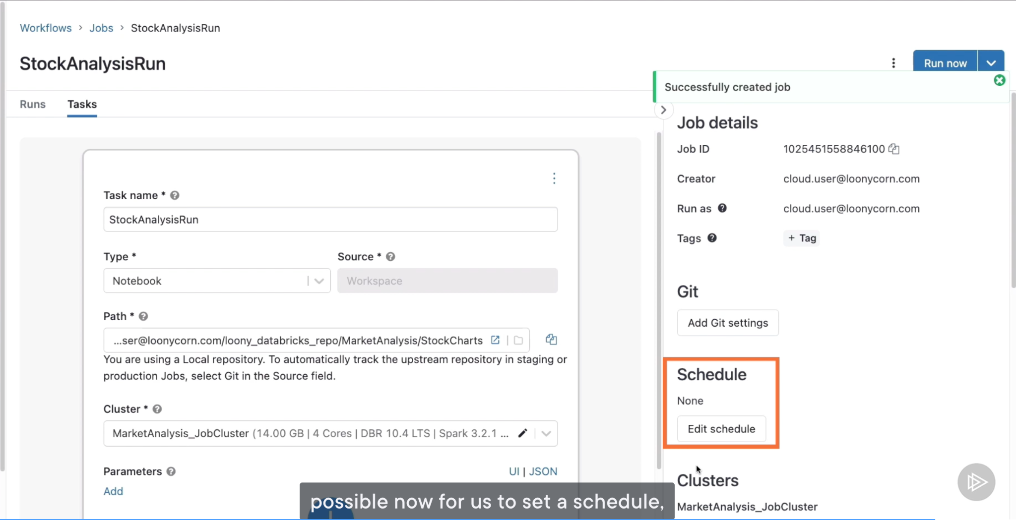

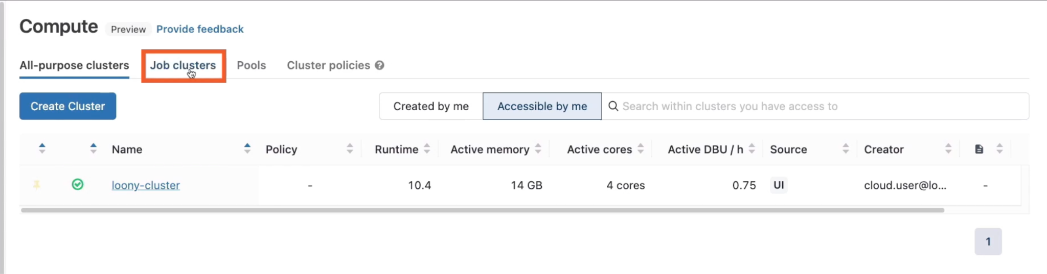

Job clusters only show up once the job has been launched, and the cluster has been provisioned or terminated after a run

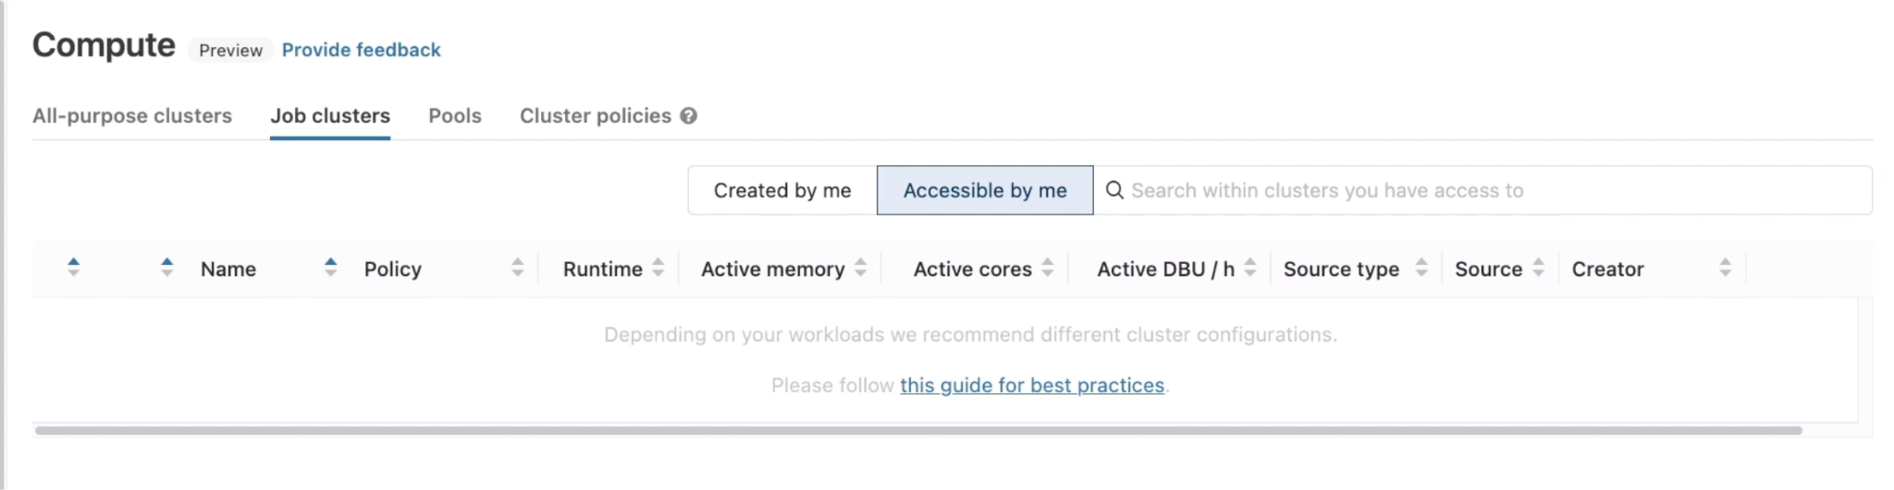

Hit “Run now”, then a notification will pop up, and then under “Active runs”, you’ll observe that the job is currently being executed. Now the cluster is being provisioned for me

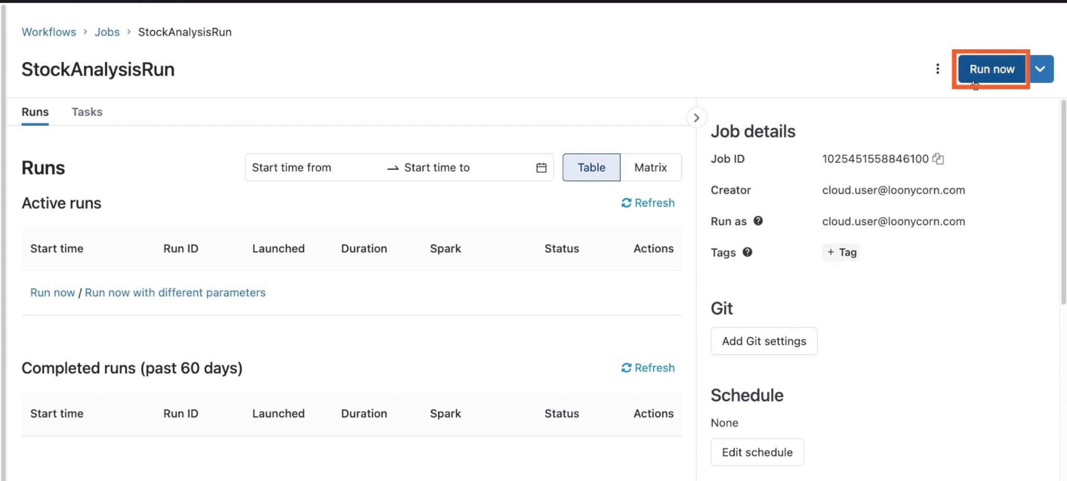

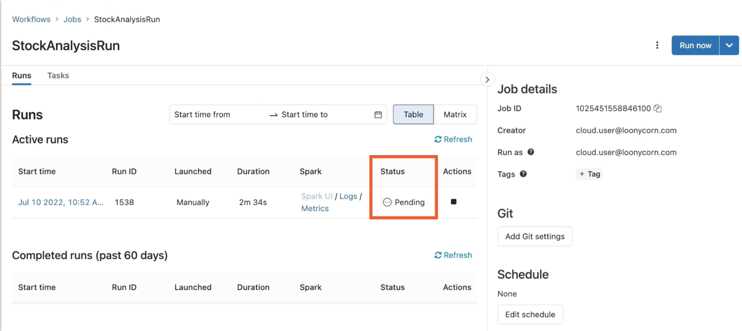

You will note that this job cluster beginning with job, now shows up in here

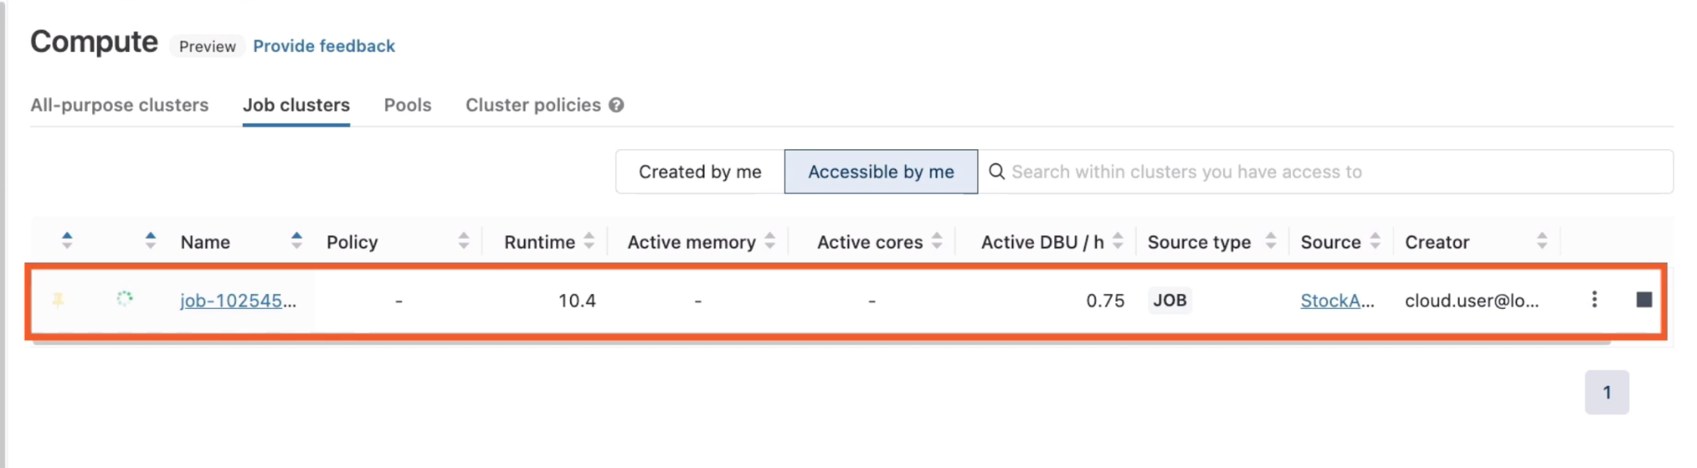

Job status change from pending to running. This is where the provisioning of the job cluster is complete and notebook is running on the cluster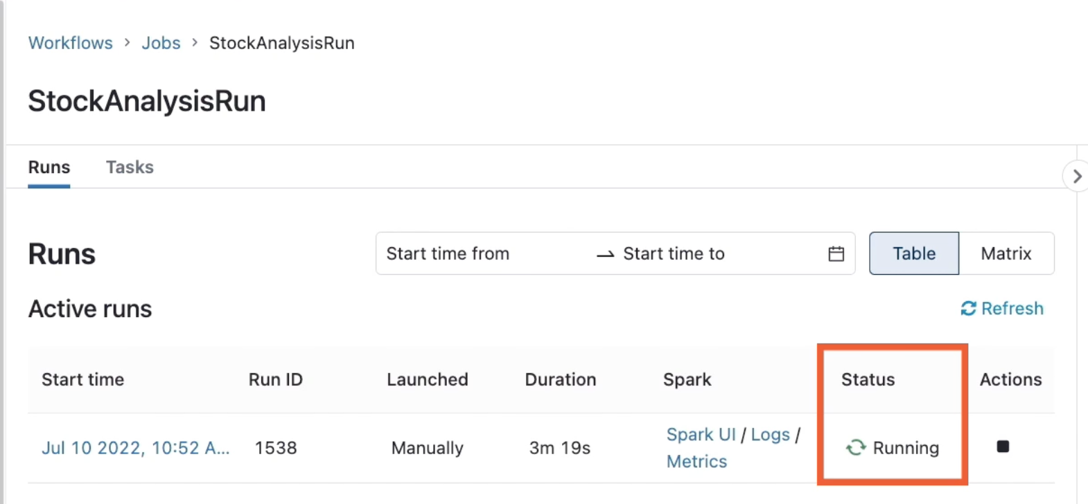

When the run is completed, we check compute->Job clusters:

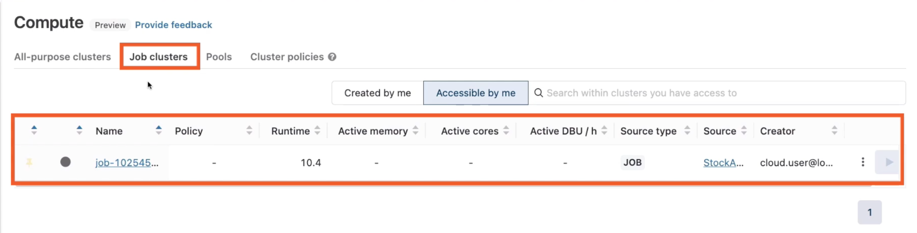

# **Monitoring Databricks Clusters**

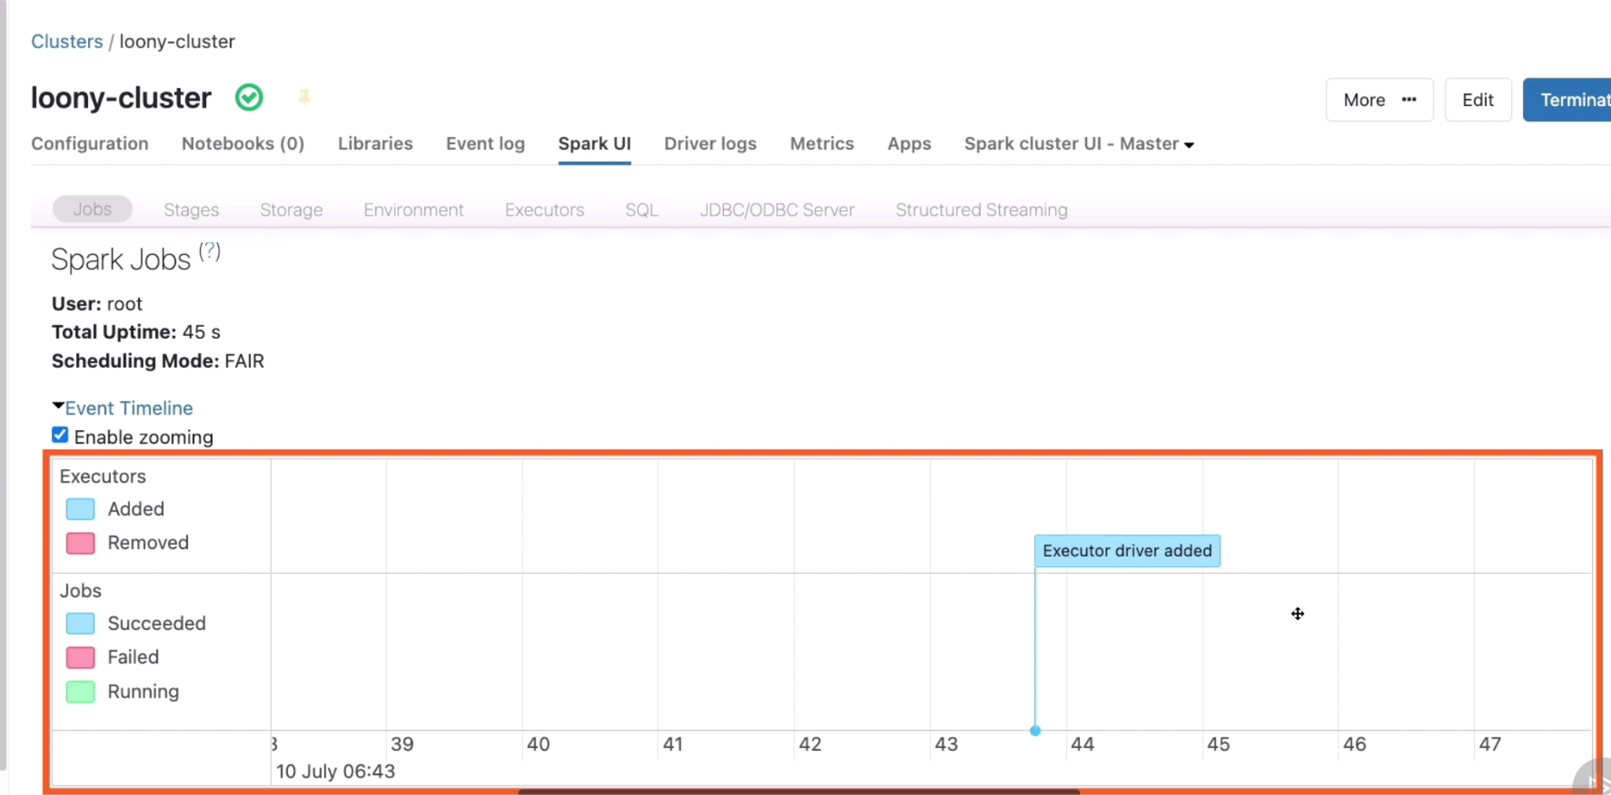

Go to Executors, which give us more granular details

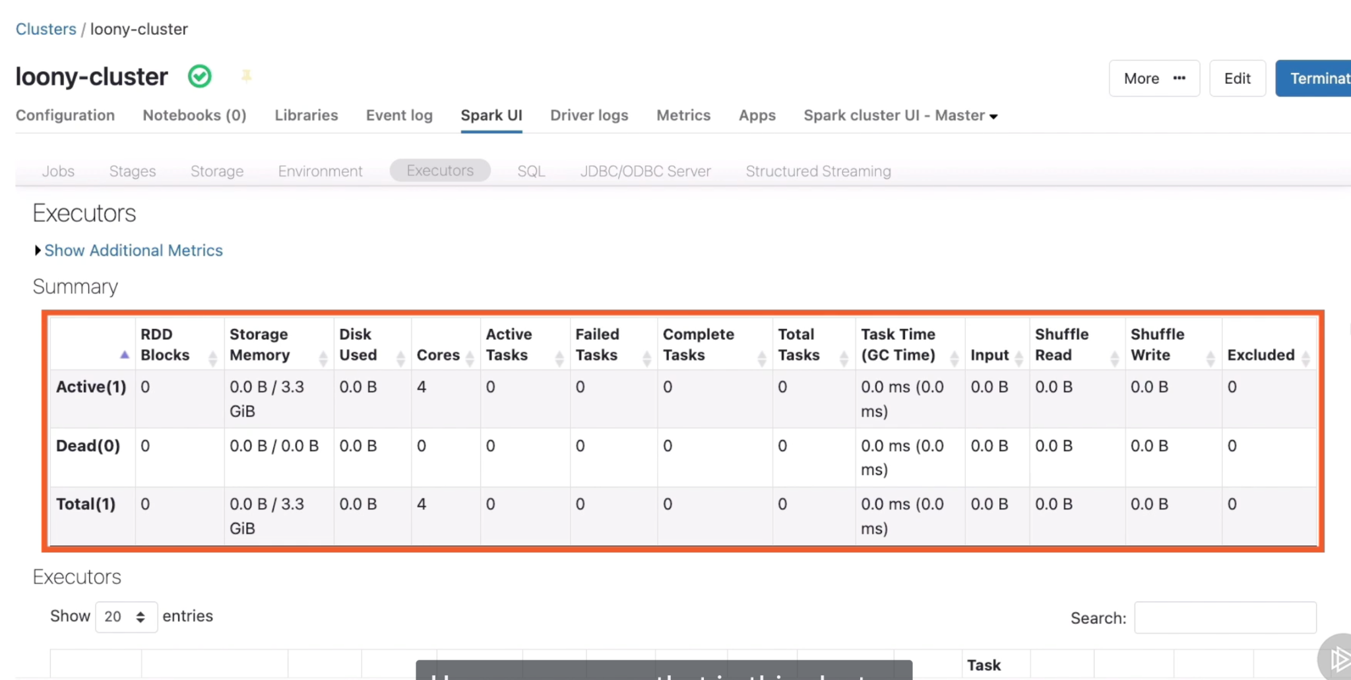

Go to Driver logs, this is where we can see outputs that been generated by our jobs

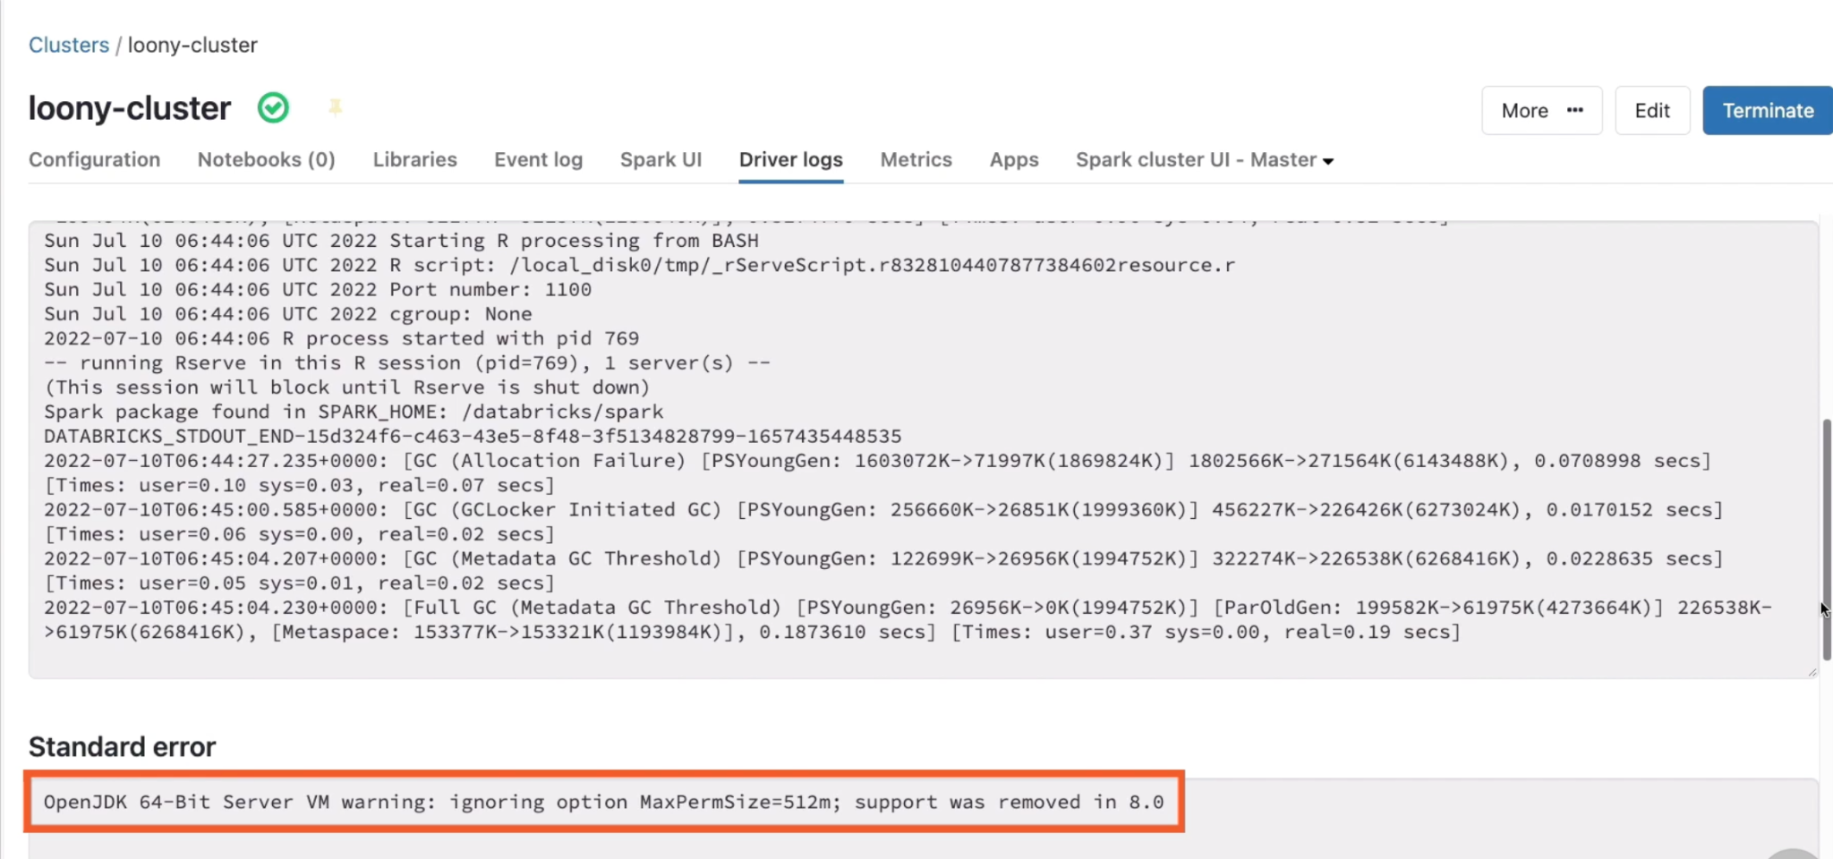

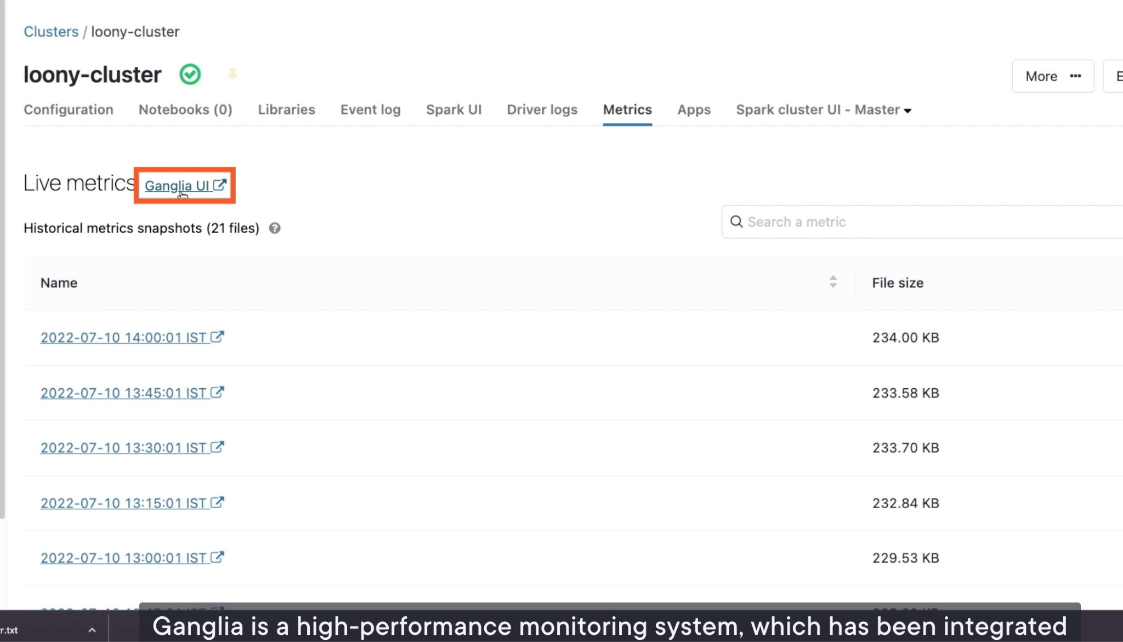

If this bright yellow portion was small, You could consider expanding the cluster to either include more nodes, or change the node types to one which include greater memory

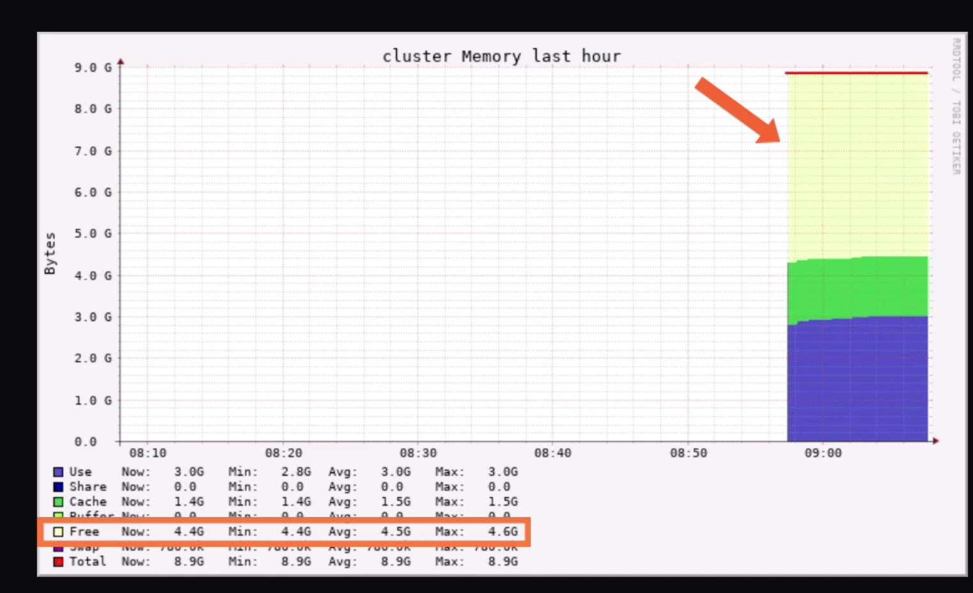

# **Changing Job Configurations**

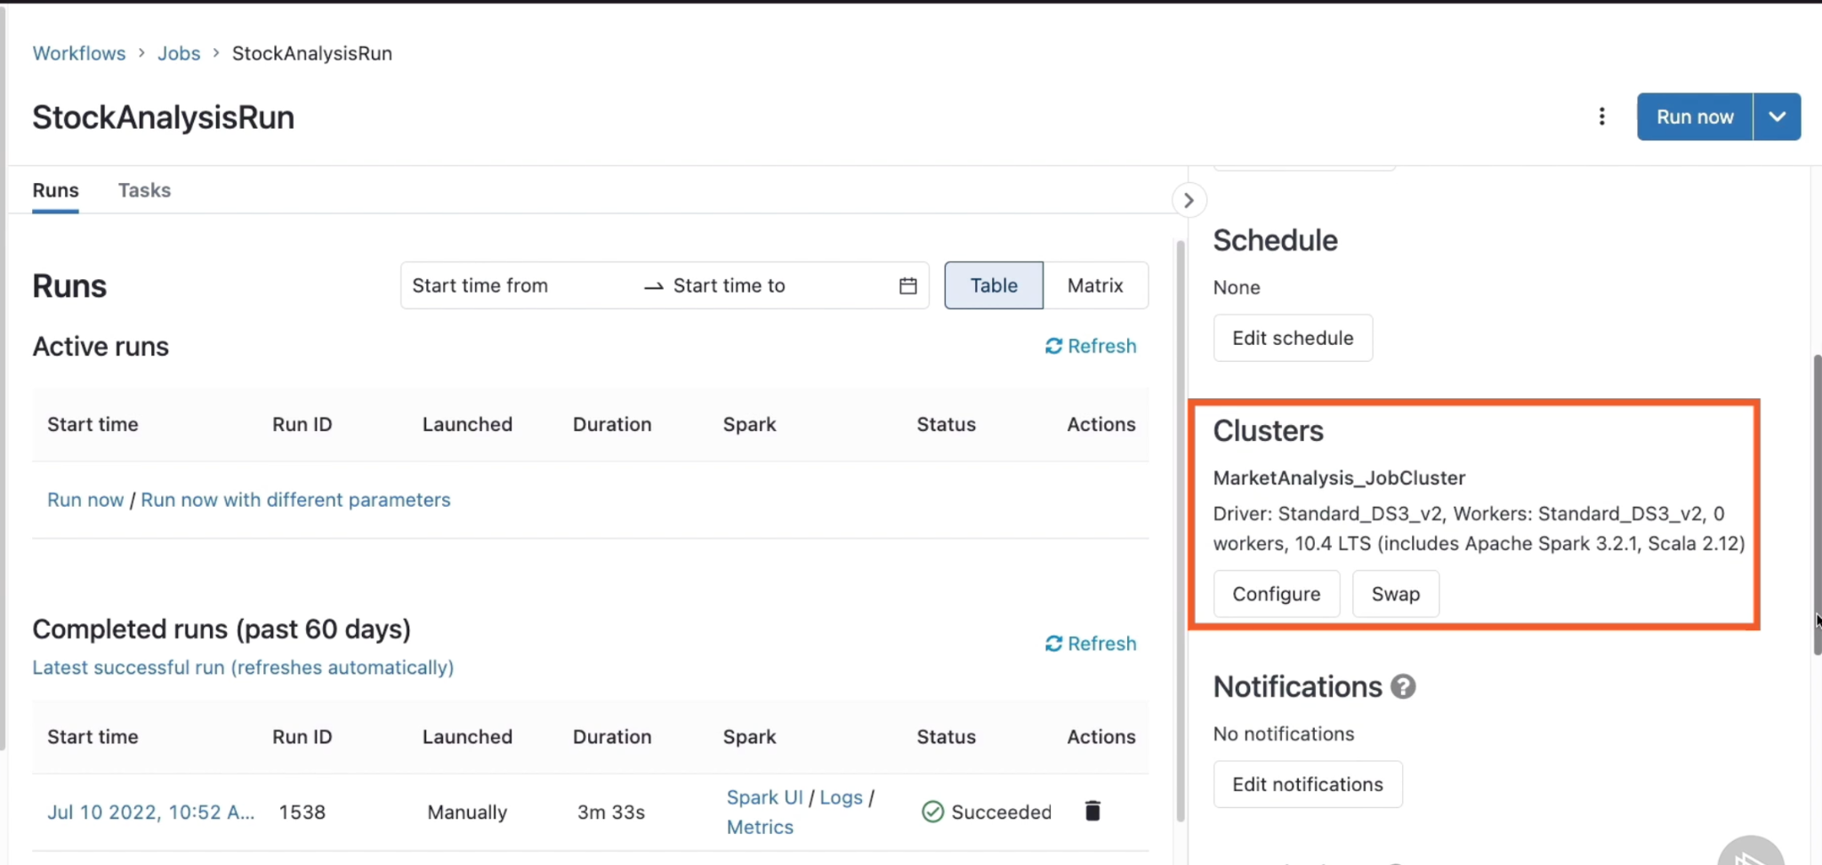

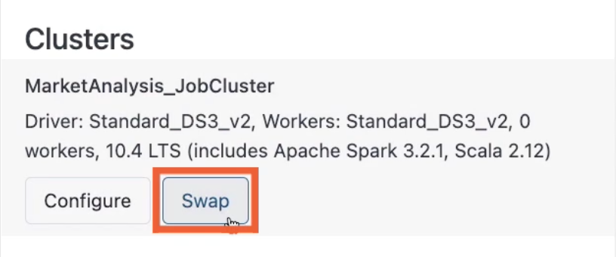

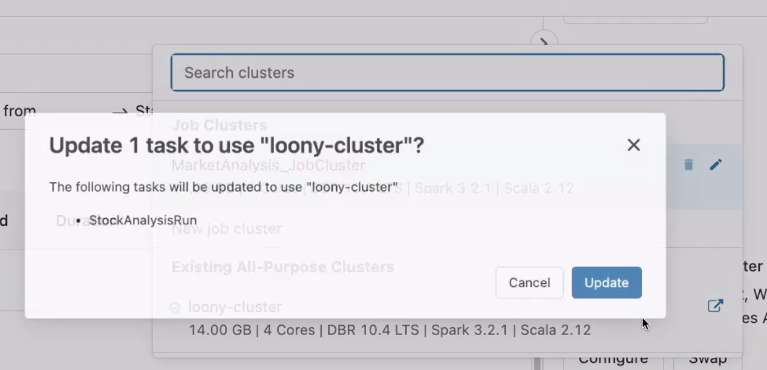

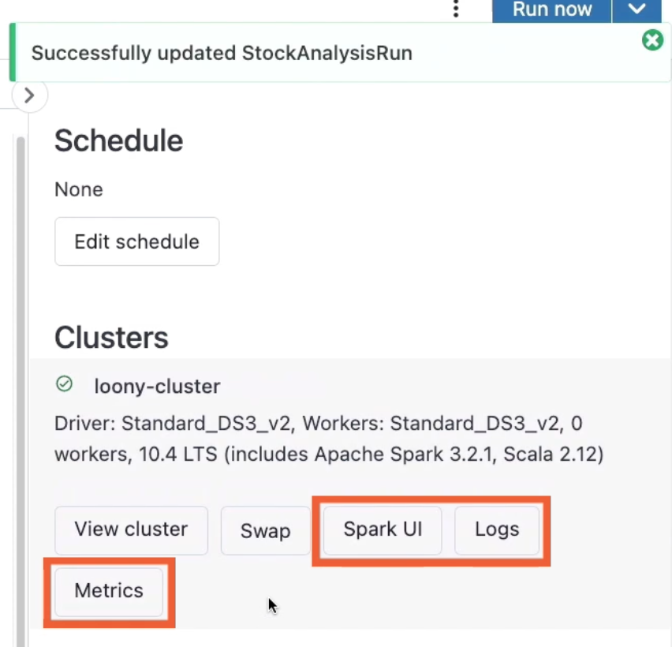

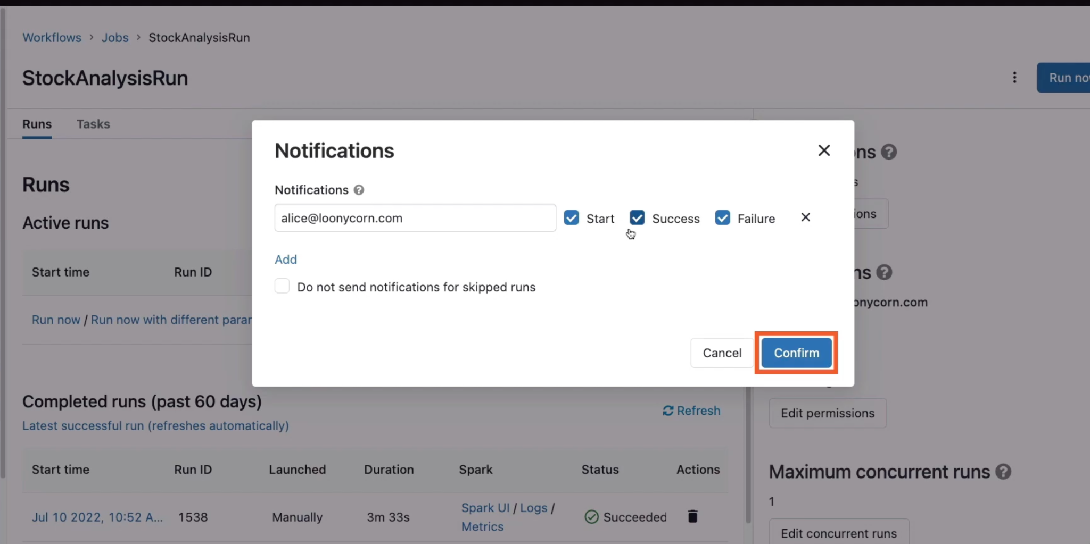

# **Creating an Instance Pool**

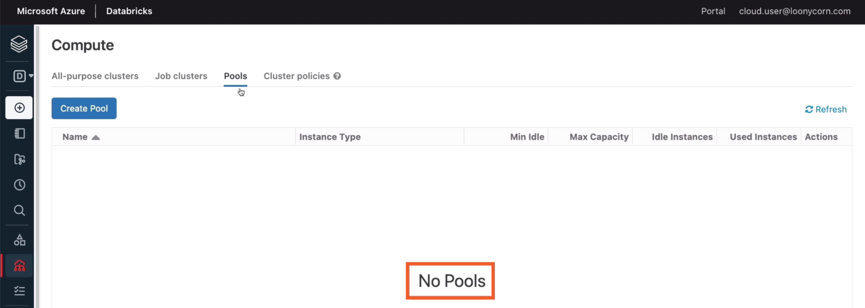

We can config the minimum number of instances, which will be up and idle. By setting this to a value of 2, we ensure that there are at least 2 nodes are available to any cluster which wishes to expand.

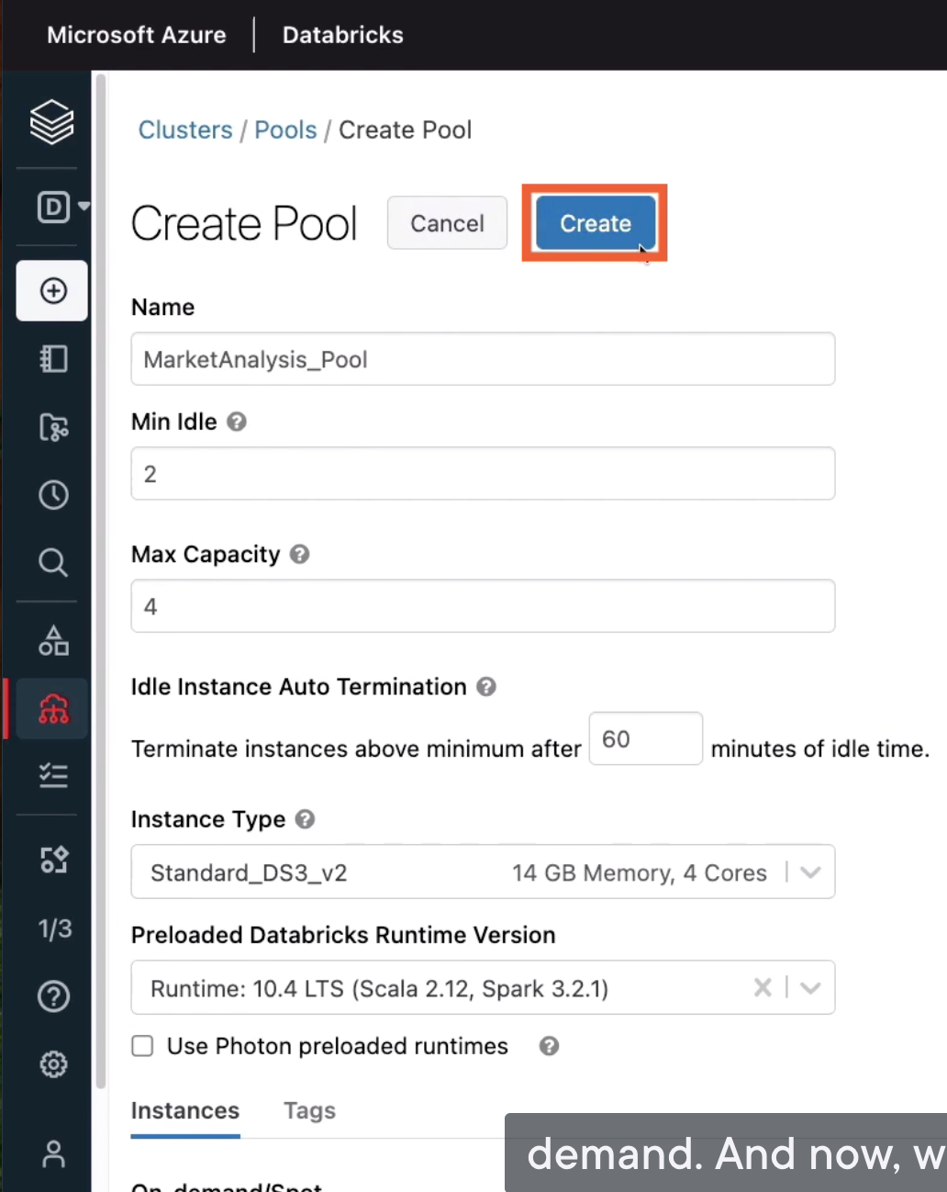

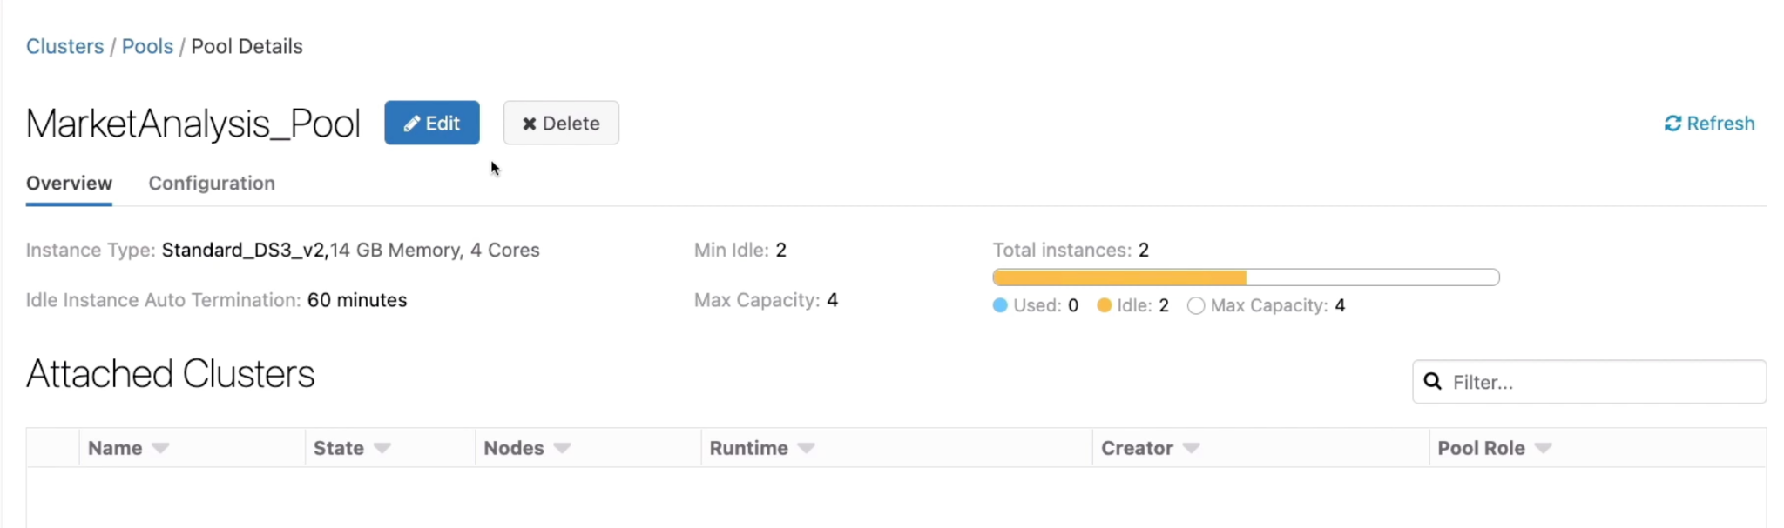

# Running Jobs on an Instance Pool

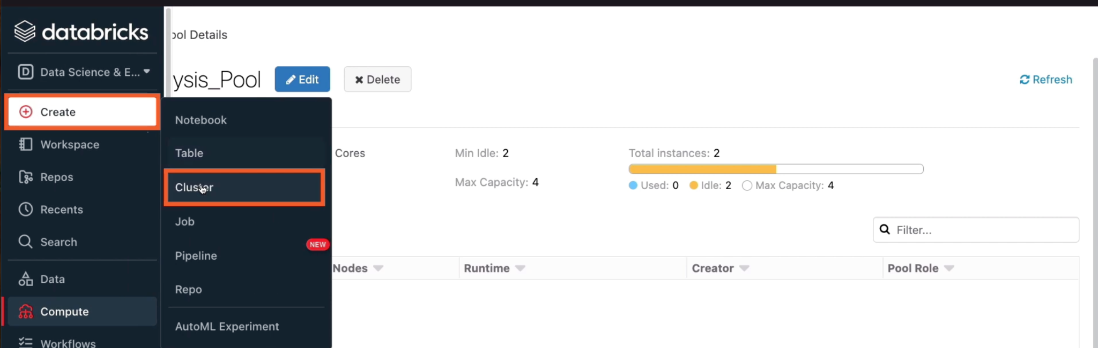

Worker type: we can configure a specific type of node for the workers in this cluster, we could also point to an instance pool, which is already configured with a type

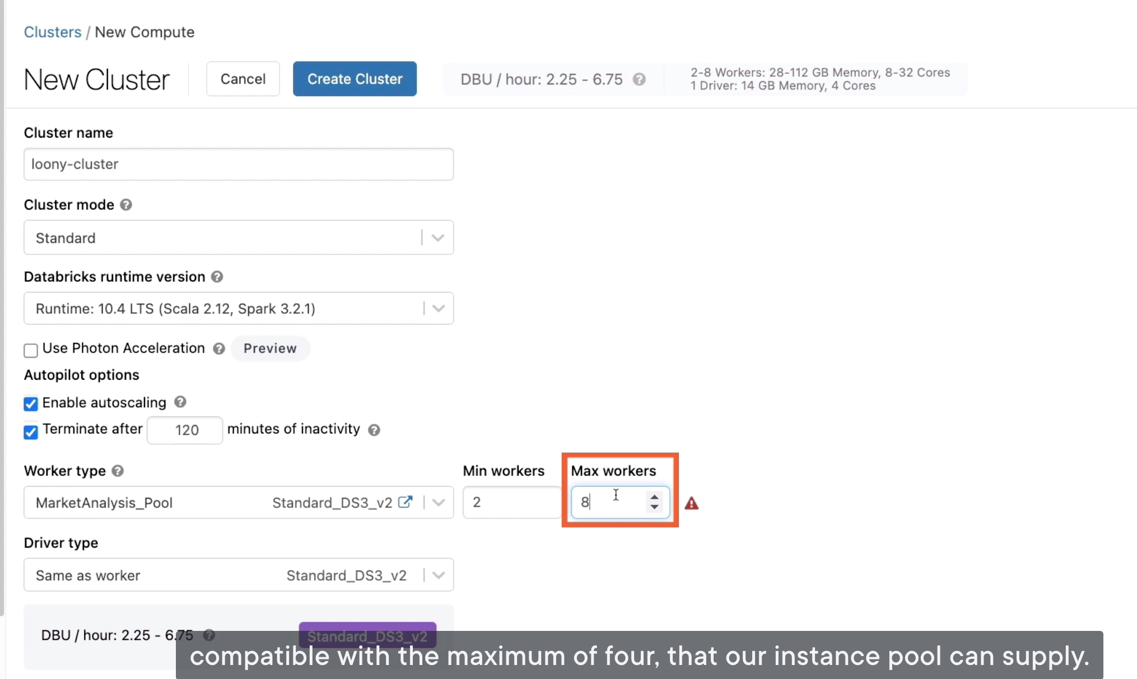

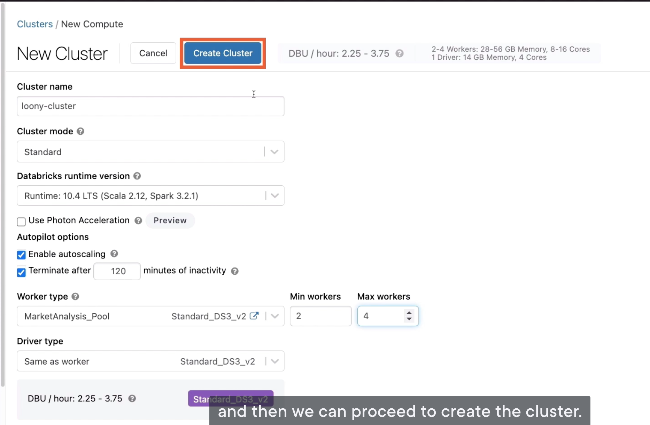

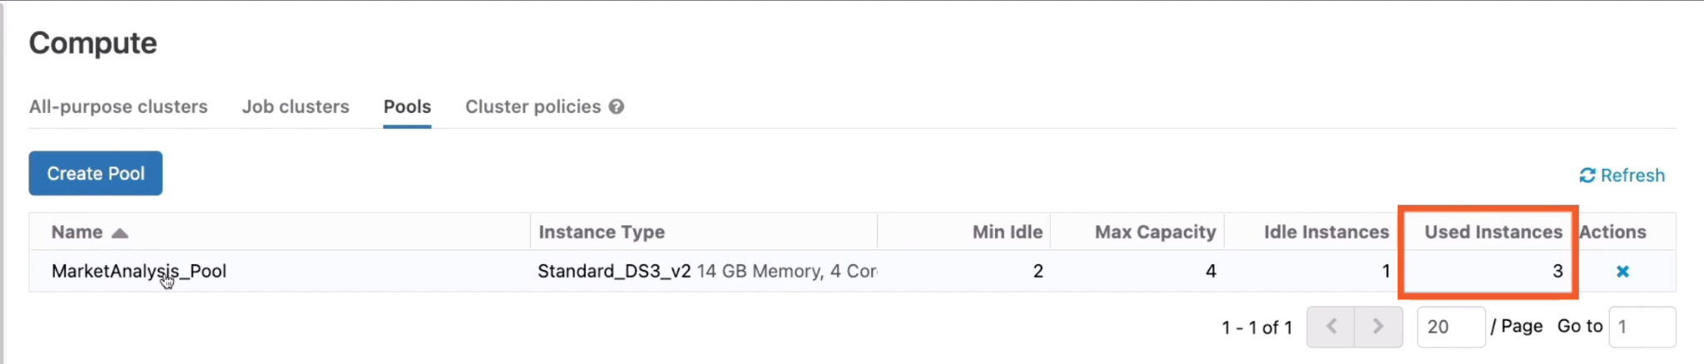

Click on the pool name, wee see under attached clusters, there is loony-cluster has expanded to 3 nodes, which has been sourced from the instance pool

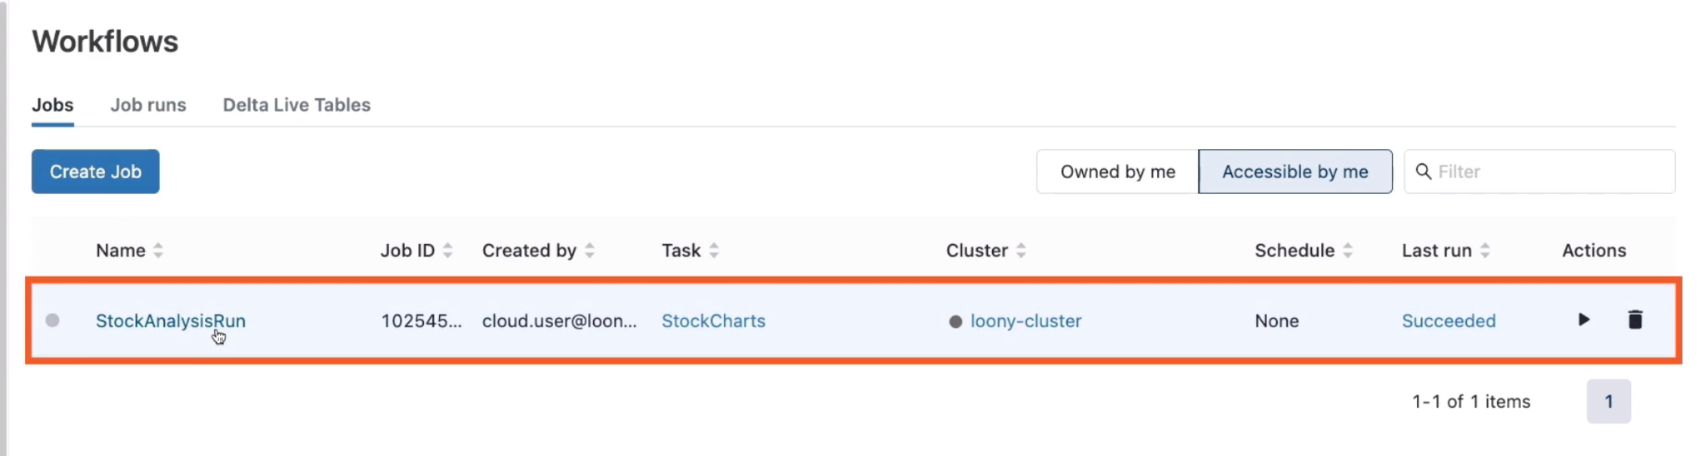

Click on the job, then click Swap under Clusters, and we choose the new loony-cluster

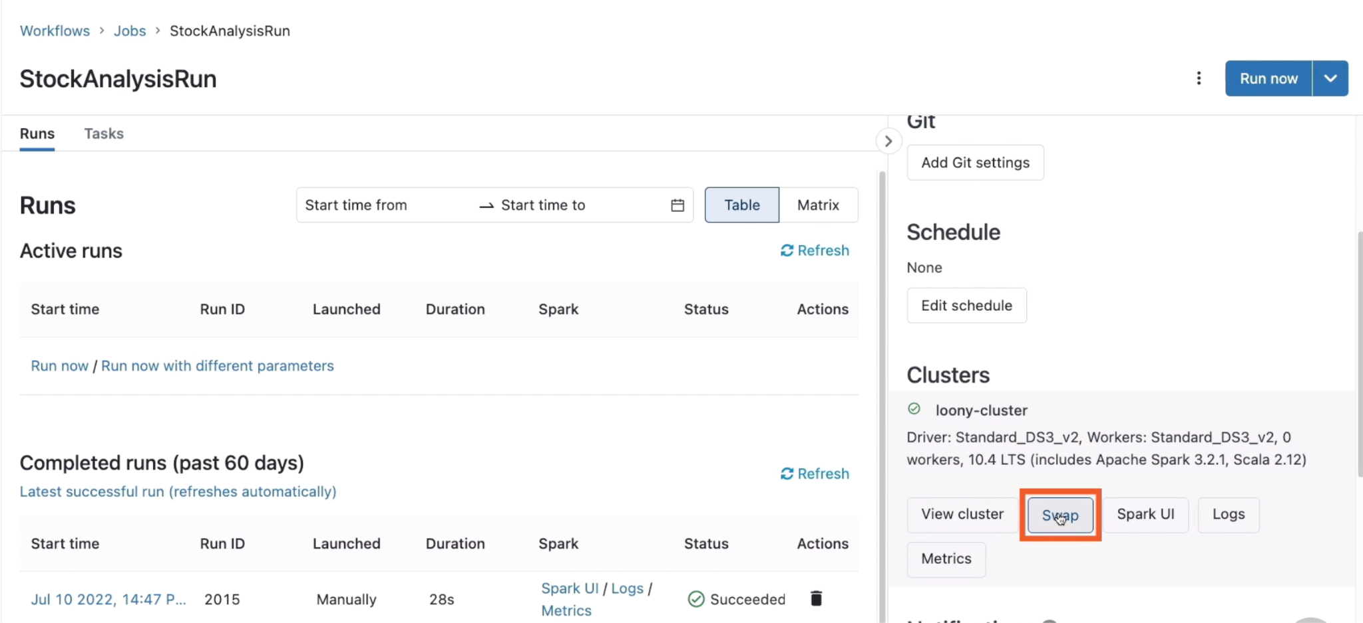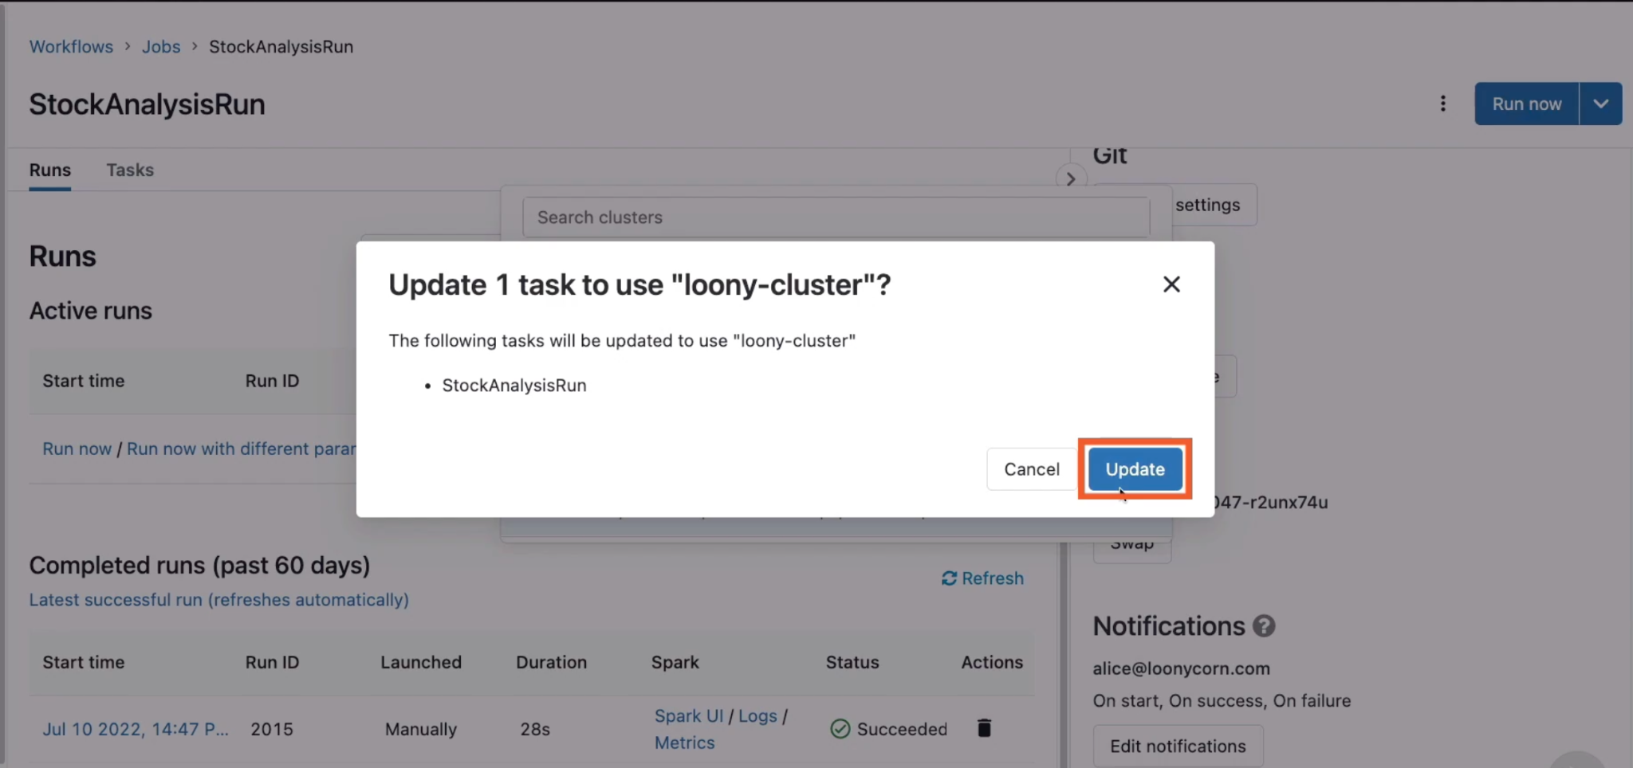

Hit Run Now, then hight the completed job, you can see the cluster is from pool

